**Date:** November 2013

Financial Industry Business Ontology – Business Entities

*Request for Comments*

*____________________________________________________*

**OMG Document Number: finance/2013-11-01**

**Standard document URL: http://www.omg.org/spec/EDMC-FIBO/FIBO-BE/0.1/PDF**

**Associated File(s)*: as indicated in inventory file finance/2013-11-02**

_________________________________________________

Copyright © 2013, EDM Council  
Copyright © 2013, Object Management Group, Inc.

USE OF SPECIFICATION - TERMS, CONDITIONS & NOTICES

The material in this document details an Object Management Group specification in accordance with the terms, conditions and notices set forth below. This document does not represent a commitment to implement any portion of this specification in any company's products. The information contained in this document is subject to change without notice.

LICENSES

The companies listed above have granted to the Object Management Group, Inc. (OMG) a nonexclusive, royalty-free, paid up, worldwide license to copy and distribute this document and to modify this document and distribute copies of the modified version. Each of the copyright holders listed above has agreed that no person shall be deemed to have infringed the copyright in the included material of any such copyright holder by reason of having used the specification set forth herein or having conformed any computer software to the specification.

Subject to all of the terms and conditions below, the owners of the copyright in this specification hereby grant you a fully-paid up, non-exclusive, nontransferable, perpetual, worldwide license (without the right to sublicense), to use this specification to create and distribute software and special purpose specifications that are based upon this specification, and to use, copy, and distribute this specification as provided under the Copyright Act; provided that: (1) both the copyright notice identified above and this permission notice appear on any copies of this specification; (2) the use of the specifications is for informational purposes and will not be copied or posted on any network computer or broadcast in any media and will not be otherwise resold or transferred for commercial purposes; and (3) no modifications are made to this specification. This limited permission automatically terminates without notice if you breach any of these terms or conditions. Upon termination, you will destroy immediately any copies of the specifications in your possession or control.

PATENTS

The attention of adopters is directed to the possibility that compliance with or adoption of OMG specifications may require use of an invention covered by patent rights. OMG shall not be responsible for identifying patents for which a license may be required by any OMG specification, or for conducting legal inquiries into the legal validity or scope of those patents that are brought to its attention. OMG specifications are prospective and advisory only. Prospective users are responsible for protecting themselves against liability for infringement of patents.

GENERAL USE RESTRICTIONS

Any unauthorized use of this specification may violate copyright laws, trademark laws, and communications regulations and statutes. This document contains information which is protected by copyright. All Rights Reserved. No part of this work covered by copyright herein may be reproduced or used in any form or by any means--graphic, electronic, or mechanical, including photocopying, recording, taping, or information storage and retrieval systems--without permission of the copyright owner.

DISCLAIMER OF WARRANTY

WHILE THIS PUBLICATION IS BELIEVED TO BE ACCURATE, IT IS PROVIDED "AS IS" AND MAY CONTAIN ERRORS OR MISPRINTS. THE OBJECT MANAGEMENT GROUP AND THE COMPANIES LISTED ABOVE MAKE NO WARRANTY OF ANY KIND, EXPRESS OR IMPLIED, WITH REGARD TO THIS PUBLICATION, INCLUDING BUT NOT LIMITED TO ANY WARRANTY OF TITLE OR OWNERSHIP, IMPLIED WARRANTY OF MERCHANTABILITY OR WARRANTY OF FITNESS FOR A PARTICULAR PURPOSE OR USE. IN NO EVENT SHALL THE OBJECT MANAGEMENT GROUP OR ANY OF THE COMPANIES LISTED ABOVE BE LIABLE FOR ERRORS CONTAINED HEREIN OR FOR DIRECT, INDIRECT, INCIDENTAL, SPECIAL, CONSEQUENTIAL, RELIANCE OR COVER DAMAGES, INCLUDING LOSS OF PROFITS, REVENUE, DATA OR USE, INCURRED BY ANY USER OR ANY THIRD PARTY IN CONNECTION WITH THE FURNISHING, PERFORMANCE, OR USE OF THIS MATERIAL, EVEN IF ADVISED OF THE POSSIBILITY OF SUCH DAMAGES.

The entire risk as to the quality and performance of software developed using this specification is borne by you. This disclaimer of warranty constitutes an essential part of the license granted to you to use this specification.

RESTRICTED RIGHTS LEGEND

Use, duplication or disclosure by the U.S. Government is subject to the restrictions set forth in subparagraph (c) (1) (ii) of The Rights in Technical Data and Computer Software Clause at DFARS 252.227-7013 or in subparagraph (c)(1) and (2) of the Commercial Computer Software - Restricted Rights clauses at 48 C.F.R. 52.227-19 or as specified in 48 C.F.R. 227-7202-2 of the DoD F.A.R. Supplement and its successors, or as specified in 48 C.F.R. 12.212 of the Federal Acquisition Regulations and its successors, as applicable. The specification copyright owners are as indicated above and may be contacted through the Object Management Group, 140 Kendrick Street, Needham, MA 02494, U.S.A.

TRADEMARKS

MDA®, Model Driven Architecture®, UML®, UML Cube logo®, OMG Logo®, CORBA® and XMI® are registered trademarks of the Object Management Group, Inc., and Object Management Group™, OMG™ , Unified Modeling Language™, Model Driven Architecture Logo™, Model Driven Architecture Diagram™, CORBA logos™, XMI Logo™, CWM™, CWM Logo™, IIOP™ , MOF™ , OMG Interface Definition Language (IDL)™ , and OMG SysML™ are trademarks of the Object Management Group. All other products or company names mentioned are used for identification purposes only, and may be trademarks of their respective owners.

COMPLIANCE

The copyright holders listed above acknowledge that the Object Management Group (acting itself or through its designees) is and shall at all times be the sole entity that may authorize developers, suppliers and sellers of computer software to use certification marks, trademarks or other special designations to indicate compliance with these materials.

Software developed under the terms of this license may claim compliance or conformance with this specification if and only if the software compliance is of a nature fully matching the applicable compliance points as stated in the specification. Software developed only partially matching the applicable compliance points may claim only that the software was based on this specification, but may not claim compliance or conformance with this specification. In the event that testing suites are implemented or approved by Object Management Group, Inc., software developed using this specification may claim compliance or conformance with the specification only if the software satisfactorily completes the testing suites

**OMG’s Issue Reporting Procedure**

All OMG specifications are subject to continuous review and improvement. As part of this process we encourage readers to report any ambiguities, inconsistencies, or inaccuracies they may find by completing the Issue Reporting Form listed on the main web page http://www.omg.org, under Documents, Report a Bug/Issue (http://www.omg.org/technology/agreement.)

Table of Contents

0. Submission-Specific Material v

0.1 Submission Preface v

0.2 Copyright Waiver v

0.3 Submission Team v

0.4 General Requirements v

0.4.1 EDM Council Involvement with the OMG vi

0.4.2 This FIBO Specification (FIBO for Business Entities) vi

0.5 Future Changes to this Specification vi

0.5.1 What is “Content”? vi

1 Scope 1

1.1 Overview 1

1.2 Scope of Financial Industry Business Ontologies for Business Entities 1

1.2.1 How This Specification fits with the overall FIBO 1

1.2.2 Business Scope 1

1.2.3 Relation to Existing Business Entity Standards 2

1.3 Definitions 2

1.3.1. Definitions Policy 2

2 Conformance 3

2.1 Applications for which Conformance Points Exist 3

2.2 Conformance Points 3

2.3 Operational Ontology Conformance 3

3 References 4

3.1 Normative References 4

3.2 Non Normative References 5

3.3 Changes to Adopted OMG Specifications 5

4 Terms and Definitions 6

5 Symbols and Abbreviations 7

5.1 Symbols 7

5.2 Abbreviations 7

6 Additional Information 7

6.1 How to Read this Specification 7

6.1.1 Audience 7

6.2 Acknowledgements 8

6.3 Interpreting the Business Model Content 10

6.3.1 Introduction 10

6.3.2 The Model 10

6.3.3 Interpretation 10

7 Introduction 15

7.1 Audiences 15

7.1.1 Audience for this Section 15

7.1.2 Reading this Standard 15

7.2 Specification Overview 15

7.2.1 Non Technical Overview 15

7.2.2 Technical Overview 15

7.4 Business Usage Scenarios 16

7.4.1 Business Entities Usage Scenarios 16

8 Architecture 17

8.1 Overview 17

8.2 The Foundations Models 17

8.3 Ontology Architecture and Namespaces 17

9 Model Content Reports 22

9.1 Overview 22

9.1.1 Interpreting This Section 22

9.2. Module: Legal Entities 24

9.2.1 Ontology: Legal Persons 24

9.2.2 Ontology: Formal Business Organizations 30

9.2.3 Ontology: Corporate Bodies 37

9.2.4 Ontology: LEI Related Entities 43

9.3. Module: Corporations 48

9.3.1 Ontology: Corporations 48

9.4. Module: Partnerships 56

9.4.1 Ontology: Partnerships 57

9.5 Module: Trusts 66

9.5.1 Ontology: Trusts 66

9.6. Module: Ownership and Control 75

9.6.1 Ontology: Ownership Parties 76

9.6.2 Ontology: Control Parties 83

9.6.3 Ontology: Corporate Ownership 100

9.6.4 Ontology: Corporate Control 106

9.6.5 Ontology: Executives 115

9.7 Module: Functionally Defined Business Entities 129

9.7.1 Ontology: Functional Entities 130

Annex A: Deliverables Included with this RFC 138

Preface

**About the Object Management Group**

**OMG**

Founded in 1989, the Object Management Group, Inc. (OMG) is an open membership, not-for-profit computer industry standards consortium that produces and maintains computer industry specifications for interoperable, portable, and reusable enterprise applications in distributed, heterogeneous environments. Membership includes Information Technology vendors, end users, government agencies, and academia.

OMG member companies write, adopt, and maintain its specifications following a mature, open process. OMG’s specifications implement the Model Driven Architecture® (MDA®), maximizing ROI through a full-lifecycle approach to enterprise integration that covers multiple operating systems, programming languages, middleware and networking infrastructures, and software development environments. OMG’s specifications include: UML® (Unified Modeling Language™); CORBA® (Common Object Request Broker Architecture); CWM™ (Common Warehouse Metamodel); and industry-specific standards for dozens of vertical markets.

More information on the OMG is available at http://www.omg.org/.

**OMG Specifications**

As noted, OMG specifications address middleware, modeling and vertical domain frameworks. A Specifications Catalog is available from the OMG website at:

*http://www.omg.org/technology/documents/spec_catalog.htm*

Specifications within the Catalog are organized by the following categories:

**OMG Modeling Specifications**

* UML

MOF

XMI

CWM

Profile specifications

**OMG Middleware Specifications**

* CORBA/IIOP

IDL/Language Mappings

Specialized CORBA specifications

CORBA Component Model (CCM)

**Platform Specific Model and Interface Specifications**

* CORBAservices

CORBAfacilities

OMG Domain specifications

OMG Embedded Intelligence specifications

OMG Security specifications

All of OMG’s formal specifications may be downloaded without charge from our website. (Products implementing OMG specifications are available from individual suppliers.) Copies of specifications, available in PostScript and PDF format, may be obtained from the Specifications Catalog cited above or by contacting the Object Management Group, Inc. at:

OMG Headquarters  
140 Kendrick Street  
Building A, Suite 300  
Needham, MA 02494  
USA  
Tel: +1-781-444-0404  
Fax: +1-781-444-0320  
Email: *pubs@omg.org*

Certain OMG specifications are also available as ISO standards. Please consult [*http://www.iso.org*](http://www.iso.org/)

**Typographical Conventions**

The type styles shown below are used in this document to distinguish programming statements from ordinary English. However, these conventions are not used in tables or section headings where no distinction is necessary.

Times/Times New Roman - 10 pt.: Standard body text

**Helvetica/Arial - 10 pt. Bold:** OMG Interface Definition Language (OMG IDL) and syntax elements.

**Courier - 10 pt. Bold:** Programming language elements.

Helvetica/Arial - 10 pt: Exceptions

NOTE: Terms that appear in italics are defined in the glossary. Italic text also represents the name of a document, specification, or other publication.

# Submission-Specific Material

## Submission Preface

The EDM Council, on behalf of its members and other industry participants, is pleased to present a standard set of terms and definitions for legal entities, business entities and the relationships among these.

Chapter 0 of this document contains information specific to the OMG submission process and is not part of the proposed specification. The proposed specification starts with Clause 1 “Scope”. All clauses are normative unless explicitly marked as informative. The section numbering scheme, starting with Clause 1, represents the final numbering scheme and will remain stable throughout the submission process.

## Copyright Waiver

The entity listed above: (i) grants to the Object Management Group, Inc. (OMG) a nonexclusive, royalty-free, paid up, worldwide license to copy and distribute this document and to modify this document and distribute copies of the modified version, and (ii) grants to each member of the OMG a nonexclusive, royalty-free, paid up, worldwide license to make up to fifty (50) copies of this document for internal review purposes only and not for distribution, and (iii) has agreed that no person shall be deemed to have infringed the copyright in the included material of any such copyright holder by reason of having used any OMG specification that may be based hereon or having conformed any computer software to such specification.

## Submission Team

The FIBO RFCs are being submitted by the EDM Council, a membership organization in the financial sector, on behalf of its members. There is therefore not a consortium or FIBO-specific submission team; instead all submissions are by the EDM Council as representative of the community of its members.

Contact:

Mike Bennett, Head of Semantics and Standards

EDM Council Inc.,

10101 East Bexhill Drive, Kensington, MD, USA

[mbennett@edmcouncil.org](mailto:mbennett@edmcouncil.org)

## 0.4 General Requirements

The FIBO initiative started out as a collaborative project within the Enterprise Data Management Council, with the stated aims of:

1. Defining common terms, definitions and business relationships (i.e. common semantics) for the financial services industry, and
2. Presenting this for review, validation, completion and sign-off by industry subject matter experts (i.e. presentation)

The two business requirements for common semantics and for visual and textual presentation of these to industry subject matter experts led to the creation of the “Semantics Repository”, with the additional strong mandate to “keep the philosophy out of sight”, meaning that the repository was built along semantic web principles but with the more technical views of semantic web notations kept out of sight of industry subject matter experts.

This initial Semantics Repository was built using an early version of the Object Management Group’s standard Ontology Definition Metamodel (ODM) which at the time was in draft. Certain features of the then draft of ODM were not amenable to the stated EDM Council requirement to present the subject matter to business experts without the intrusion of technical modeling language constructs, and so considerable modification and customization of that ODM draft was undertaken. The resultant model, which was maintained within the Sparx Enterprise Architect modeling tool, was displayed on a custom-built website in the form of tables and diagrams at varying levels of detail and complexity, but free of semantic web notation.

This project brings the content developed within the above modeling framework and refactors it to the latest version of the ODM standard. Many of the customizations which the EDM Council undertook for the reasons described above have parallels in the most recent versions of ODM (versions 1.0 and the upcoming version 1.1) and so it was deemed possible to retain the commitments made to business consumers of the content while upgrading the model to a fully conformant rendition of ODM.

### 0.4.1 EDM Council Involvement with the OMG

The EDM Council is submitting the Semantics Repository as a series of specifications under the FIBO umbrella for the following reasons:

* To leverage the OMG to manage these standards within a well-founded process as provided by the OMG;
* To bring our application of the OMG’s Ontology Definition Metamodel (ODM) standard up to date, based on our earlier usage and adaptation of what was an early draft of that specification.

### 0.4.2 This FIBO Specification (FIBO for Business Entities)

This FIBO specification is intended to be viewed and used alongside the FIBO Foundations specification, and contains the “Semantics Repository” material specific to business entities and legal entities.

Historically this section of the Semantics Repository, unlike those for securities, derivatives, market data/pricing and so on, started out as a set of “Foundational” terms.

In the foundational ontologies, the stated intention has been and remains to try to identify suitable industry bodies, academic research or formal standards which could be regarded as the authoritative source for business meanings in a given set of terms. In the case of business entities and legal entities, there was no formal body that was obviously dealing with the formal semantics of these concepts. With this in mind, along with industry initiatives towards a common, global “Legal Entity Identifier” standard within the financial services industry, it was decided that this area of content should be taken on by the EDM Council on behalf of its own community, on the basis that the most difficult and immediate problems to do with business entities and legal entities semantics are those faced by the financial services community itself. As an example, part of the LEI initiative has been the stated aim to go beyond a “dumb” identifier of the entities themselves, to set up databases of legal entities with their networks of relationships of ownership and control. This information is necessary for global regulatory oversight of the financial industry.

## 0.5 Future Changes to this Specification

It is anticipated that aspects of this specification may need to be updated on an ongoing basis:

* Content: for the content in this specification it is expected that this will need to be extended and refined on an ongoing basis;
* Conformance: it is anticipated that additional conformance points may be added to the ones in this specification on a more regular basis as new ways of applying the content of this and other FIBO content specifications are identified, for example operational ontologies may introduce new ways of applying this content, which may be determined to be conformant.

### 0.5.1 What is “Content”?

For the purposes of this and other FIBO specifications, “Content” is defined in Section 4 of this document as "Subject matter or meta-content", while “Subject matter" is defined as "Information about things in the universe of discourse; the essential facts, data, or ideas that constitute the basis of spoken, written, or artistic expression or representation; often : the substance as distinguished from the form especially of an artistic or literary production."

All content in the FIBO specifications is subject matter in the form of ontologies, that is models in which the model content has as its referent some feature of the business domain. This is described in further detail in the Conformance section of this specification, under “Model Theoretic Conformance”.

# Scope

This specification is a model of business concepts that are represented by finance industry terms as used in official regulatory and financial organization documents on the subject of Business Entities.

## 1.1 Overview

This specification is part of a family of specifications called the Financial Industry Business Ontology (FIBO).

FIBO is a modularized formal model of the concepts represented by finance industry terms as used in official financial organization documents such as contracts, product/service specifications and governance and regulatory compliance documents. This is referred to as a *Business Conceptual Model* as distinct from models or descriptions of data or IT implementations.

The scope of *finance industry* encompasses a broad range of organizations that manage money, including [credit unions](http://en.wikipedia.org/wiki/Credit_union), [banks](http://en.wikipedia.org/wiki/Bank), [credit card](http://en.wikipedia.org/wiki/Credit_card) companies, [insurance](http://en.wikipedia.org/wiki/Insurance) companies, [consumer finance](http://en.wikipedia.org/wiki/Consumer_finance) companies, [stock brokerages](http://en.wikipedia.org/wiki/Brokerage_firm), [investment funds](http://en.wikipedia.org/wiki/Investment_management) and some [government sponsored enterprises](http://en.wikipedia.org/wiki/Government_sponsored_enterprise).

The FIBO for Business Entities specification covers two considerations: the content of the model as a set of business concepts, and the presentation of this content for business domain expert review as described in FIBO Foundations (finance/2013-09-02) ([Foundations]). The latter requirement is important both for the use of the content as a formal business conceptual model within a technology development lifecycle, and for extension of this model content.

Extension of this model may be undertaken either by individual firms, or as part of the submission of model content for future versions of this specification.

This specification describes the content of FIBO for Business Entities. The [Foundations] specification describes the modeling notation which has been employed and the requirements for presentation of this material to domain experts.

## 1.2 Scope of Financial Industry Business Ontologies for Business Entities

### 1.2.1 How This Specification fits with the overall FIBO

This specification describes a set of ontologies of and relating to business entities, including legal entities and specific forms of entity, within the overall framework and heading of the Financial Industry Business Ontology (FIBO). The ontology content described in this specification is developed and maintained using the same modeling framework as all FIBO ontologies. It uses, either by extension or by reference, a sub-set of the “Foundational” mid-level ontologies described in [Foundations].

### 1.2.2 Business Scope

The business scope of this specification is all terms relating to and descriptive and/or definitive of a range of business entities and legal entities that are considered by financial industry firms, regulators and other industry participants to be of relevance in the financial services domain.

The scope of the concepts in this specification is those common to

* Legal entities,
* Formal organizations,
* Terms definitive of or descriptive of companies incorporated by the issuance of shares and other forms of incorporated entity,
* Terms which define the existence of other kinds of legal entity,
* Terms specific to trusts,
* Terms defining the relationships for example of ownership and control between and among the kinds of organization listed above.
* Entities defined not by their legal structure but according to their role or function, including but not limited to banks, non-profit entities, government bodies, non-government and quasi-non government organizations, international bodies and the like.

### 1.2.3 Relation to Existing Business Entity Standards

The model defined in this specification is a “business conceptual model” as described in Section 1.2 of the [Foundations] specification. A business conceptual model in the sense used here is one which represents things in the business domain as distinct from data descriptions for data about those things, and which does not reflect the technical constraints of any given application. As such this specification is intended to be complementary to technical standards in the financial services industry, most of which were developed and are framed (positioned) either as logical data models or as physical message schemas.

To the extent that logical data model or physical message standards include content relating to business entities, this specification defines the semantics of those data and message elements. The W3C standard Organization Ontology deals with a sub-set of business entities concepts, relating specifically to organizations – please refer to [W3C Organization Ontology] in the References section.

## 1.3 Definitions

The human readable definitions have been constructed by and with the input of business subject matter experts.

Many definitions have been derived from definitions of data elements corresponding to those terms in industry data or messaging standards. These have been adapted where necessary to ensure that they are descriptive of the thing or fact itself and not of data elements for data about those things or facts, and have then been reviewed by industry subject matter experts to ensure that such adaptation accurately captures the sense of the business concept. In cases where the definition in a data or message standard was incomplete, context-specific or tautologous, a fresh definition was framed by the industry subject matter experts who participated in these reviews, or a third party definition was proposed and adopted.

### 1.3.1. Definitions Policy

In some cases, definitions have been obtained from third party sources. The policy for arriving at definitions for the FIBO industry terms was as follows (and remains so for future iterations and extensions):

1. In the absence of a definition endorsed by the subject matter experts for a term, “Barrons DICTIONARY OF FINANCE AND INVESTMENT TERMS, 8th Edition John Downes and Jordan Elliot Goodman” shall be used.

2. If a term and its acceptable definition is not in the Barrons Dictionary, then http://www.investopedia.com/dictionary/ shall be the authoritative source, subject to licensing requirements being met.

3. If a term and its acceptable definition is not in either the Barrons Dictionary or the investopedia dictionary, then http://www.bankersalmanac.com/addcon/dictionary/ shall be the authoritative source.

4. If a term has no acceptable definition in these Financial Industry sources or does not exist in these Financial Industry sources then http://www.merriam-webster.com shall be the authoritative source.

5. When there is a conflict with the definition of a Financial Industry term with the same term in another Industry, the Financial Industry definition will be used within FIBO.

In all cases the source from which the definition was obtained, or from which it was adapted, is recorded in annotation metadata for that concept.

# Conformance

**Audience:** Technical, semantic technology and standards audiences.

## 2.1 Applications for which Conformance Points Exist

This chapter defines conformance points for the following types of artifacts:

* Technical applications of FIBO such as logical data models, XML schemas, operational ontologies, code, and other technical artifacts
* Extensions of FIBO
* Representations of FIBO for business consumption
  + In diagrams
  + In spreadsheets or tables

Conformance of technical applications of FIBO is the most important conformance point, because it addresses the core issue of what it means to conform to the ontologies that FIBO defines.

Note that in addition to conformant applications, there are a number of scenarios in which someone may make use of the FIBO ontologies as a business conceptual model while applying their own design to meet their requirements. It is not possible to define specific conformance points for each of the possible ways in which one may legitimately develop a conventional database application or an operational OWL ontology that would be a good application.

## 2.2 Conformance Points

This specification has the following conformant points for the above applications:

* Conformant extension: as described in FIBO [Foundations] for conformant extensions to model content
* Operational ontologies: conformance may be asserted for
  + This entire specification (FIBO-Full conformance)
  + Ontology conformance – subject to the ontology dependencies;
* The content of this specification may be rendered conformant with the model presentation conformance points described under “Conformant Presentation of model Content” in [Foundations] both for diagrams and for tabular reports.
* Spreadsheets may assert conformance to the “tabular presentation” conformance point described under “Conformant Presentation of model Content” in [Foundations] without reference to other material.

## 2.3 Operational Ontology Conformance

An OWL ontology is conformant to this specification if:

* It uses individual ontologies in this specification along with imports of any ontologies that are shown as imported by the ontologies in this specification; or
* It uses some sub-set of the terms contained in individual ontologies in this specification, along with imports of any ontologies that are shown as imported by the ontologies in this specification and the terms which are used in the ontology make reference to the terms which are in the imported ontologies; there is no need to import ontology which contain only terms which are not referred to by the terms that are used in the operational ontology.

When asserting conformance in terms of this conformance point, the operational ontology should identify and name to which of the individual ontologies in this specification the application is conformant.

For detailed descriptions of the above conformance points and others, please refer to [Foundations].

# References

## 3.1 Normative References

The following normative documents contain provisions which, through reference in this text, constitute provisions of this specification. For dated references, subsequent amendments to, or revisions of, any of these publications do not apply.

|  |  |
| --- | --- |
| **Reference** | **Description** |
| [Dublin Core] | DCMI Metadata Terms, Issued 2013-06-14 by the Dublin Core Metadata Initiative. Available at <http://www.dublincore.org/documents/dcmi-terms/>. |
| [FIBO Foundations] | Financial Industry Business Ontology (FIBO) – Foundations. Available specification, finance/2013-09-02.Available at <http://www.omg.org/cgi-bin/doc?finance/2013-09-02> |
| [ISO 1087] | ISO 1087-1:2000 Terminology — Vocabulary — Part 1: Theory and application |
| [MOF Core] | Meta Object Facility (MOF™) Core, v2.4.1. OMG Available Specification, formal/2011-08-07. Available at <http://www.omg.org/spec/MOF/2.4.1/>. |
| [MOF XMI] | MOF 2/XMI (XML Metadata Interchange) Mapping Specification, v2.4.1. OMG Available Specification, formal/2011-08-09. Available at <http://www.omg.org/spec/XMI/2.4.1/>. |
| [ODM 1.0] | Ontology Definition Metamodel (ODM), v1.0. Available Specification, formal/2009-05-01. Available at <http://www.omg.org/spec/ODM/1.0/>. |
| [ODM 1.1] | Convenience Specification for the Ontology Definition Metamodel (ODM), v1.1, available specification, ptc/13-08-03. Available at <http://www.omg.org/cgi-bin/doc?ptc/13-08-03> |
| [OMG AB Specification Metadata] | OMG Architecture Board recommendations for specification of ontology metadata, Available at http://www.omg.org/techprocess/ab/SpecificationMetadata/ |
| [OWL 2] | OWL 2 Web Ontology Language Quick Reference Guide (Second Edition), W3C Recommendation 11 December 2012. Available at <http://www.w3.org/TR/2012/REC-owl2-quick-reference-20121211/>. |
| [RDF 1.1] | RDF 1.1 Concepts and Abstract Syntax, W3C Last Call Working Draft. Latest version Available at <http://www.w3.org/TR/2013/WD-rdf11-concepts-20130723/> |
| [RDF Concepts] | Resource Description Framework (RDF): Concepts and Abstract Syntax. Graham Klyne and Jeremy J. Carroll, Editors. W3C Recommendation, 10 February 2004. Latest version is available at http://www.w3.org/TR/rdf-concepts/. |
| [RDF Schema] | RDF Vocabulary Description Language 1.0: RDF Schema. Dan Brickley and R.V. Guha, Editors. W3C Recommendation, 10 February 2004. Latest version is available at http:// [www.w3.org/TR/rdf-schema/](http://www.w3.org/TR/rdf-schema/). |
| [SKOS] | SKOS Simple Knowledge Organization System Reference, W3C Recommendation 18 August 2009. Available at <http://www.w3.org/TR/2009/REC-skos-reference-20090818/>. |
| [UML2] | Unified Modeling Language™ (UML®), version 2.4.1. OMG Specification, formal/2011-08-06. Available at <http://www.omg.org/spec/UML/2.4.1/>. |
| [Unicode] | *The Unicode Standard, Version 3*, The Unicode Consortium, Addison-Wesley, 2000. ISBN 0-201-61633-5, as updated from time to time by the publication of new versions. (See http:// www.unicode.org/unicode/standard/versions/ for the latest version and additional information on versions of the standard and of the Unicode Character Database). |
| [UTF-8] | RFC 3629: UTF-8, a transformation format of ISO 10646. F. Yergeau. IETF, November 2003, <http://www.ietf.org/rfc/rfc3629.txt> |
| [W3C Datatypes in RDF and OWL] | XML Schema Datatypes in RDF and OWL, W3C Working Group Note 14 March 2006, Available at <http://www.w3.org/TR/2006/NOTE-swbp-xsch-datatypes-20060314/>. |
| [XML Schema Datatypes] | XML Schema Part 2: Datatypes. W3C Recommendation 02 May 2000. Latest version is available at <http://www.w3.org/TR/xmlschema-2/>. |

## 3.2 Non Normative References

The following informative documents are referenced throughout this text or in parts of the Annexes:

|  |  |
| --- | --- |
| **Reference** | **Description** |
| [ODM 1.1 RTF Report] | ODM 1.1 RTF Report, November 2013. Available from the ODM 1.1 RTF as document number ptc/13-08-01. Available at <http://www.omg.org/cgi-bin/doc?ptc/13-08-01> |
| [OMV] | Ontology Metadata Vocabulary (OMV) - <http://omv2.sourceforge.net/> (a standard giving metadata for ontology-level information) |
| [W3C Organization Ontology] | W3C Organization Ontology. Available at: http://www.w3.org/TR/vocab-org/ |

## 3.3 Changes to Adopted OMG Specifications

This specification does not change or replace any OMG specifications.

# Terms and Definitions

For the purposes of this specification, the following terms and definitions apply.

**Content**

1. Subject matter or meta-content.

Business conceptual model

1. A model which represents and only represents business subject matter without reference to the design of any solution or data model representation.

Ontology

1. A formalization of a conceptualization. For the purposes of this specification the formalization is in OWL, using ODM as a means to render this, and the conceptualization is that of business subject matter.

**Operational Ontology**

1. An ontology which is intended for use within some application.

**Subject matter**

1. Information about things in the universe of discourse; the essential facts, data, or ideas that constitute the basis of spoken, written, or artistic expression or representation; often : the substance as distinguished from the form especially of an artistic or literary production.

Taxonomy

1. A set of terms which stand in some classification relation to one another.

# Symbols and Abbreviations

## Symbols

There are no symbols introduced by this specification.

## 5.2 Abbreviations

The following abbreviations are used throughout this specification:

* LEI – Legal Entity Identifier
* OWL – Web Ontology Language
* ODM – Ontology Definition Metamodel
* RDF – Resource Definition Framework
* SME – Subject Matter Expert
* UML – Unified Modeling Language
* URI – Uniform Resource Identifier
* URL – Uniform Resource Locator
* XMI – XML Metadata Interchange
* XML – eXtensible Markup Language

Additional symbols and abbreviations that are used only in annexes to this specification are given in those annexes.

# Additional Information

## How to Read this Specification

### Audience

This specification has the following audiences:

* The standards community
* The finance industry business community
* The regulatory community
* Technical architects
* Semantic Modelers

#### Standards Community

This audience is intended to be able to follow and validate the way in which this specification sets out the arrangements for the production and maintenance of model content, and the production of business facing reports and diagrams representing parts of that content.

#### The Finance Industry Business Community

As noted in the section on conformance (section 2) this specification includes detailed requirements for the production of diagrams and reports which are intended for consumption by business subject matter experts. This specification also contains material addressed at this audience, this being an informative annex on “Interpreting Model Content”. This audience is not intended to read and understand the remaining parts of this specification.

#### The Regulatory Community

As for Finance Industry Business Community.

#### Technical Architects

These include but are not limited to:

* + Tooling vendors and developers
  + Other content providers / enriched content providers
  + Business Analysts – anyone who use the model on site, whether they are a modeler, a metadata analyst, etc.
  + Technology Management

The bulk of the “Architecture” section is intended to be read and understood by these audiences and by the ‘Semantic Modelers’ audience.

#### Semantic Modelers

Much of the material in this specification is intended to be read and understood by semantic modelers. This includes the 'Conformance' section (Section 2) and the ‘Architecture’ section (Section 8).

## 6.2 Acknowledgements

The following organization submitted this specification:

* Enterprise Data Management Council

The following companies have provided significant expertise and resources in the development of its content and architecture:

* Adaptive Inc.
* Australia and New Zealand Banking Group
* AVOX/DTCC
* Bank of America
* Barclays Capital
* BBH
* Bloomberg
* Business Semantics
* CIBC
* Citigroup Inc.
* Credit Suisse Group AG
* CUSIP
* The Federal National Mortgage Association (Fannie Mae)
* David Frankel Consulting
* FacetApp
* Fidelity
* GoldenSource Corporation
* HSBC Holdings plc
* JPMorgan Chase & Co.
* The Manufacturers Life Insurance Company
* Michigan State University
* Model Driven Solutions
* Model Systems
* Morgan Stanley
* MphasiS
* National Australia Bank
* No Magic
* Nomos Software
* Nordea Bank
* Oakland University
* OntoAge
* OpenFinance
* PricewaterhouseCoopers LLP
* Revelytix
* Sallie Mae
* SAP
* Semantic Arts
* State Street
* Sungard
* SWIFT
* Tahoe Blue
* Thematix Partners LLC
* Thomson Reuters
* UBS AG
* University of British Columbia
* University College Cork
* Wells Fargo
* Wizdom Systems, Inc.

## 6.3 Interpreting the Business Model Content

**Intended Audiences***: Business Subject Matter experts*

### 6.3.1 Introduction

The model content is intended by read and understood by business domain experts with knowledge of business entities and legal concepts. It requires no knowledge of modeling theory, technical modeling languages, technology development or data modeling.

The following knowledge is required to interpret the model content:

* Set theory
* Logic
* Business (commerce, law, finance)

### 6.3.2 The Model

#### 6.3.2.1 What the Model Contains

The model described in this specification contains elements called 'Things', Simple Properties about those things in the form of unstructured information, and Relationship Properties in the form of relationships between one 'Thing' and another. Things, Simple Properties and Relationship Properties all have as a minimum the definition for the term that they represent, plus additional information on usage, review history, sources of terms and definitions and so forth.

#### 6.3.2.2 Model Views

Whereas the information given in this specification conveys all of the model content, the diagrams and tables that are created for a business audience will not show all of this information, but only a sub-set. This sub-section describes those formats and views, and is to be read by a business audience to understand what those views show. This sub-section contains no technical language about OWL or other modeling constructs but uses the plain English alternative terms for those concepts.

The content of the model is rendered in two basic forms: visual information in the form of diagrams, and textual information in the form of tables. The diagrams are available in varying levels of detail and are created to show different sets of terms and relationships across or within sections of the model. The textual information is created as web based tabular reports and as spreadsheets. These contain basic information of term, definition and synonym and in some cases will contain additional information about the types of thing or the types of information to which facts in the model refer. Business tables and spreadsheets do not show relationships between relationships as such information would be difficult to visualize in the tabular format.

Diagrams and tables reflect the information retained in the underlying model repository directly. For example, if two 'Thing' elements have a relationship between them and they appear on the same diagram, the relationship between them will always appear.

#### 6.3.2.3 Business Diagrams

Business diagrams reflect any set of terms in the model, within or across sections of the content. These may be rendered with varying levels of detail. Diagrams created during reviews of the subject matter will typically contain a greater range of terms than diagrams created for presentation to the wider community of potential users.

### 6.3.3 Interpretation

The model conveys 'Things' and 'Facts'. Facts are in two forms:

* 'Simple Properties': these are a statement about something which is framed in terms of some simple type of information, such as textual entries, yes/no answers, dates, numbers and selections of textual information
* 'Relationship Properties': these are a statement about something which is framed in terms of something else, that other thing also being framed as a kind of 'Thing'.

In addition, there are relationships which represent additional set theory concepts, notably logical unions, mutual exclusivity.

Each 'Thing' also has a 'Parent' relationship, with the sense of 'is a', shown as an upward point arrow on the diagrams. This relationship indicates that the thing from the non-arrowed end is “a kind of” the thing at the end with the arrow.

These concepts are described in the sections which follow.

#### 6.3.3.1 Thing

A Thing is a set theory construct. This is shown on the diagrams as a box with a name. On some diagrams, additional textual entries in the box show the Simple Properties about that thing.

A Thing is defined as the set of individuals which are defined according the facts (properties) given for that kind of thing. Membership of the set is defined in the sense that any individual in the world of which the stated facts are true or applicable, is a member of that set. In terms of logical theory, these sets are defined intensionally. It is also possible to define a set explicitly as a list of its members (in logical theoretic terms, an extensional definition) but this is not used in practice in the model.

#### 6.3.3.2 Inheritance: the Parent 'is a' relationship

Each Thing in the model has one or more parent Things. The relationship between the Thing and its parent may be interpreted as an 'is a' form of relationship, meaning that the thing of which the parent relationship is shown is a kind of the thing to which the arrow in the Parent relationship is pointing.

This relationship formally indicates that the thing that has the Parent, inherits all of the facts about that parent. In addition, this relationship is transitive, meaning that the parent relationships of the parent are passed on to the child term. For example, if a share is a security and a security is a transferable contract then a share is a transferable contract.

The relationships of this type create a formal inheritance structure called a Taxonomy. Taxonomies in this sense may be single inheritance (as is often seen in technical model designs) or multiple inheritance. In the FIBO models these are multiple inheritance, meaning that types of thing (such as types of contract) may be classified in more than one way. So for example an interest rate swap is both a swap and an interest rate derivative.

As an example of multiple inheritance, one might say that in terms of the Linnaeus Taxonomy of Species, a whale is a mammal, while one may also create a set of taxonomic classifications based on habitat, in terms of which a whale may also be a marine animal.

On a technical note, the Parent relationship is functionally identical to the relationship known as 'Generalization' in the UML modeling language.

#### 6.3.3.3 Simple Properties

Simple Properties are assertions about things in a class, which may be framed in terms of some simple type of information.

Types of information about which Simple Properties are asserted are:

* Text
* Date
* Number
* Whole number
* Yes/no answer
* Selection of textual descriptors

To a technical person these may easily be identified with what are called 'datatypes'. However these represent the types of information not data as such. A special case is the selection of possible answers - this refers to a list of entries (see Selection Lists).

#### 6.3.3.4 Relationship Properties

A Relationship Property is defined as a fact about something which is framed in terms of a relationship to some other thing.

These are indicated on the diagrams as a blue arrowed line. Some diagrams additionally show a box attached to this blue line; this is used to indicate relationships between those Relationship Properties, which are shown as lines between those boxes.

Relationship Properties are of the form subject-relationship-object where the subject is the Thing from which the line is drawn and the object is the thing to which the blue arrow points.

The label on the line is the verb itself, while the attached box indicates the full name of the Relationship Property. Relationship Properties are unique across the model and each belongs to one Thing only.

There are additional pieces of information about these Relationship Properties, such as whether they are symmetric, transitive and so on. The use and interpretation of these refinements to Relationship Properties are beyond the scope of this explanatory sub-section.

#### 6.3.3.5 Logical Unions

Logical unions indicate that any individual which is a member of any of the classes of 'Thing' of which the union is a union, are members of that union.

The Union is shown as a box on the diagrams, similar to the boxes used for classes of 'Thing' but without the coloring given for archetypes (no Union has an archetype), that is these have the default gold box appearance of an OWL Class.

Membership of the union is indicated by a purple relationship similar in appearance to the Parent / 'is a' relationship. The Union (set) shown at the top of the arrow is thereby indicated as being a logical union of all the sets indicated as classes of Thing at the bottom of the purple arrows.

Relationship Properties may refer to unions in the same way that they refer to other classes of Thing.

#### 6.3.3.6 Mutually Exclusive sets

Given that each thing is a set of potential members defined by their properties (facts), it is possible for any one thing in the world to be defined as being a member of more than one set, if the properties asserted for one set are not related to the properties asserted for another set.

Where membership of one set necessarily precludes membership of another set (that is, where a set is defined such as to specifically exclude members of another set), this is shown by a red line on the diagrams, labeled 'mutually exclusive'.

Where classes of 'Thing' are not indicated as being mutually exclusive (or have parents which belong to classes of Thing which are mutually exclusive), then any individual in the domain of discourse (the world) may belong to both sets.

This is formally known as a 'disjoint' relationship.

#### 6.3.3.7 Relationship Properties hierarchies

Relationship Properties are themselves disposed in a hierarchy similar to that given for the classes of 'Thing'. These are indicated on more advanced diagrams by a green upward pointing line in the same style as the Parent relationship line. The Relationship Property to which the arrow points represents a more general meaning, of which the Relationship Property at the bottom of the relationship represents a narrower definition of the same meaning.

The narrowing of these meanings frequently occurs in conjunction with the narrowing of the meanings of classes of 'Thing' in the taxonomy. For example, types of bond are classified (a narrowing or specialization of the meaning of 'bond') according to, among other things, a narrowing of the relationship 'issued by' with the latter relationships being distinguished form one another by the nature of the kind of party which is the issuer.

This is formally known as a “sub property of' relationship.

#### 6.3.3.8 Inverse relationships

These are only shown on diagrams that show the Relationship Properties with their boxes, i.e. diagrams that show relationships between relationships.

Relationship Properties in the model are all one-directional, by virtue of their being framed as 'subject-verb-object' triples. In the business domain, meaningful terms and definitions may exist in either direction between one class of thing and another (for example, a bank has a customer versus a person has an account at the bank.

These are indicated as a red dotted arrowed line between one relationship and the relationship to which it is the inverse.

In theoretical terms, this relationship only applies between relationships which are known as 'functional' relationships. An explanation of this is beyond the scope of this sub-section.

#### 6.3.3.9 Selection Lists

A list of possible entries for a simple type is displayed as a box on the diagrams, with a list of the possible entries. These are displayed as text, and generally refer to lists of possible textual values for the Simple Property.

It should be noted that these do not or should not represent lists of kinds of 'Thing' - those would be represented as a taxonomy of actual things. This is an important difference between this and a data model, since many data models have similar selection lists, called 'enumerations' in the data modeling world, which may represent kinds of thing or classifications of the thing which has these as a property.

#### 6.3.3.10 Selections of Things

This is a class or set of things of which the members are explicitly listed (in theoretical terms, an extensional definition of the class).

These are not used at present in the model but are provided for in the modeling notation.

#### 6.3.3.11 Restrictions

A restriction is a way of describing a set of things based on their having specific classes of thing participating in a nominated property (identified by an “on property” relation). The restriction may be based on how many of that class of thing they must have for the property (known as “cardinality”), for example “at least two of something participate in the relationship *involved party*” and optionally on the type of those things (for example “at least two of something participate in the relationship *involved party* and these may only be taken from *legal person*”).

Alternatively, the restriction may be framed in terms of whether all participants in the relationship must be a certain type of thing (labeled as “with only”); or in terms of whether out of all such relationships, there must be some (one or more) which are of a certain type of thing (labelled as “with some”). For example the restriction “there must be at least one thing in the relationship *involved party* that is a *Corporation*” would be framed using a “with some” restriction.

A restriction is applied to a type of thing in one of two ways:

* The restriction is necessary to qualify for membership of the type. For example the type *Foo* *Corporation* could have a necessary restriction on property *executive officer* such that there must be at least two things participating in that relationship which are of the type *Natural Person*. This is not sufficient though – many other types of entity could also have executive officers that are natural persons. This is depicted using “subclass”.
* The restriction is sufficient to qualify for membership of the type. For example the type Shareholder could have a sufficient restriction on property *assets owned* such that there must be at least one thing in this relationship which is of type *Corporate Equity.* That means that mere possession of an equity instrument is enough to qualify as a Shareholder. Sufficient does also imply necessary. This is depicted using “equivalent to”.

There is a special case of the “cardinality” type of restriction - “at least 0” - which is used to indicate that the set of things is expected to make use of the property but there is no requirement for it to be there.

Finally, a restriction itself represents a set, or type of thing, so it can itself be further restricted. For example if we wanted to ensure that the executive officers for *Foo Corporation* have a masters degree we might recast the restriction above to be a restriction on property *has* *executive officer* such that there must be at least two occurrences of this relationship which themselves are subject to another restriction, which is: {the restriction on property *has degree* so that it has at least one occurrence where it is of the type *Masters Degree*}.

# Introduction

## Audiences

Readers are encouraged to read Section 6.1 on the different intended audiences for this standard.

### 7.1.1 Audience for this Section

The audience for this section is anyone who wishes to understand this standard, whether from a business or technical standpoint.

### 7.1.2 Reading this Standard

Technical audiences (in both conventional and semantic technology) are directed at the “Architecture” section (Section 8).

Business audiences (financial industry participants, regulators and others) are directed at this Introduction and at Annex A on interpreting model content (Annex B).

The business content defined in this standard is intended to be presented both in a business-facing format and in a complete, technical format. The latter is intended for consumption by technical and standards audiences only. This specification defines the content of the standard and the ways in which it is to be presented to business readers.

## Specification Overview

### 7.2.1 Non Technical Overview

**Audience:** Business.

This specification provides a model of business entities terms, definitions and relationships. The model contains no technical design content and is a representation of the business entities concepts. This specification describes the technical arrangements by which this has been brought about, the requirements to be placed upon semantic modelers who are to extend this content locally or to propose updates to the model, and the requirements by which the content of this and future extensions are to be presented to business domain participants, so that they may understand and review the model content without the need for any formal technical training.

### 7.2.2 Technical Overview

**Audience:** Technical architects.

The model content is developed and maintained using the Unified Modeling Language as a modeling tool framework, but with all model content built using the formal constructs of the Web Ontology Language (OWL). This is achieved using the OMG's Ontology Definition Metamodel (ODM) specification.

The use of the ODM specification in this specification is limited to a specific sub-set of OWL constructs, and is also limited to the range of UML base classes that is allowed for each of the OWL constructs that are used, as defined in the FIBO [Foundations] specification.

The model content is made available as serialized ODM UML in the form of XMI files (“ODM XMI”, as serialized UML in the form of XMI files (“UML XMI”) and as OWL files in the RDF/XML syntax. The deliverables are listed in Annex A.

## 7.4 Business Usage Scenarios

### 7.4.1 Business Entities Usage Scenarios

A number of business scenarios will be supported by this RFC. These include:

* Legal Entity Identification
  + The ownership and control hierarchies which complement the (dumb) LEI will be maintained somewhere; the FIBO for Business Entities contains the semantics of these relationships and would form a conceptual model from which to build this supporting utility
* Transaction tracking
* Counterparty Credit Risk

# Architecture

**Intended Audiences:** Technologists, Semantic Technologists, Standards Implementers.

## 8.1 Overview

The architecture of FIBO is described in the FIBO [Foundations] specification.

Please also refer to the Scope section (Section 1) and the Definitions (Section 4) for detailed treatment of the terms and concepts referred to.

## 8.2 The Foundations Models

This specification makes reference to specific sets of terms in the FIBO [Foundations] specification.

As a consequence of the modeling principles, the model requires ontologies of things which are not specific to business entities. These include legal concepts like contracts, business concepts such as service provision, as well as an extensive set of concepts for times, dates, mathematical constructs, events and activities, and so on.

These terms are maintained in the "Foundations" material described in the FIBO [Foundations] specification.

## 8.3 Ontology Architecture and Namespaces

As described in the FIBO Foundations specification in section 8.2, the ontology architecture for FIBO is designed to facilitate reuse and ontology evolution to the degree possible. An approach to the foundational terminology, including basic terminology describing business entities, that provides very high-level, abstract conceptual knowledge designed to facilitate mapping is an important design goal. The basic building blocks for the Business Entities (BE) Ontology, building on the architecture provided in Foundations, are shown in Figure 8-1, below.

As shown in the diagram, the BE ontologies are divided up into a number of *modules*. These include: Corporations, Legal Entities, Ownership and Control, Partnerships, and Trusts.

The BE modules will ultimately depend on (1) Basic Terminology and Ontology Metadata (in light gray in the figure), (2) Foundations, and (3) a number of external modules, representing concepts for Natural Language, Geopolitical Entities (for example ISO 3166 Country codes, regional and municipal designations), Postal Addressing (from standards such as US Publication 28), and concepts defining dates, times, calendars, and schedules. A sample set of these anticipated external resources are given in the dark gray layer in the figure.



Figure 8-1. Business Entities Ontology Architecture

The namespaces and their well-known prefixes corresponding to external elements required for use of FIBO Business Entities include all of those listed in the FIBO Foundations specification, as well as those required for the use of Foundations itself. Table 8-2 lists those prefixes and namespaces considered external to Foundations. Table 8-3 provides those required for use of Foundations (repeated here for convenience).

Table 8-2. Prefix and Namespaces for referenced/external vocabularies

|  |  |  |
| --- | --- | --- |
| Namespace Prefix | | Namespace |
| **rdf** | **http://www.w3.org/1999/02/22-rdf-syntax-ns#** | |
| **rdfs** | http://www.w3.org/2000/01/rdf-schema# | |
| **owl** | http://www.w3.org/2002/07/owl# | |
| **xsd** | http://www.w3.org/2001/XMLSchema# | |
| **dct** | http://purl.org/dc/terms/ | |
| **skos** | http://www.w3.org/2004/02/skos/core# | |
| **sm** | http://www.omg.org/techprocess/ab/SpecificationMetadata/ | |

Table 8-3. Prefix and Namespaces for FIBO Foundations

|  |  |
| --- | --- |
| Namespace Prefix | Namespace |
| **fibo-fnd-acc-aeq** | http://www.omg.org/spec/EDMC-FIBO/FND/Accounting/AccountingEquity/ |
| **fibo-fnd-acc-cur** | http://www.omg.org/spec/EDMC-FIBO/FND/Accounting/CurrencyAmount/ |
| **fibo-fnd-aap-agt** | http://www.omg.org/spec/EDMC-FIBO/FND/AgentsAndPeople/Agents/ |
| **fibo-fnd-aap-ppl** | http://www.omg.org/spec/EDMC-FIBO/FND/AgentsAndPeople/People/ |
| **fibo-fnd-agr-agr** | http://www.omg.org/spec/EDMC-FIBO/FND/Agreements/Agreements/ |
| **fibo-fnd-agr-ctr** | http://www.omg.org/spec/EDMC-FIBO/FND/Agreements/Contracts/ |
| **fibo-fnd-gao-gl** | http://www.omg.org/spec/EDMC-FIBO/FND/GoalsAndObjectives/Goals/ |
| **fibo-fnd-gao-obj** | http://www.omg.org/spec/EDMC-FIBO/FND/GoalsAndObjectives/Objectives/ |
| **fibo-fnd-law-jur** | http://www.omg.org/spec/EDMC-FIBO/FND/Law/Jurisdiction/ |
| **fibo-fnd-law-lcap** | http://www.omg.org/spec/EDMC-FIBO/FND/Law/LegalCapacity/ |
| **fibo-fnd-law-cor** | http://www.omg.org/spec/EDMC-FIBO/FND/Law/LegalCore/ |
| **fibo-fnd-org-fm** | http://www.omg.org/spec/EDMC-FIBO/FND/Organizations/FormalOrganizations/ |
| **fibo-fnd-org-lg** | http://www.omg.org/spec/EDMC-FIBO/FND/Organizations/LegitimateOrganizations/ |
| **fibo-fnd-org-org** | http://www.omg.org/spec/EDMC-FIBO/FND/Organizations/Organizations/ |
| **fibo-fnd-oac-ctl** | http://www.omg.org/spec/EDMC-FIBO/FND/OwnershipAndControl/Control/ |
| **fibo-fnd-oac-own** | http://www.omg.org/spec/EDMC-FIBO/FND/OwnershipAndControl/Ownership/ |
| **fibo-fnd-pty-pty** | http://www.omg.org/spec/EDMC-FIBO/FND/Parties/Parties/ |
| **fibo-fnd-pty-rl** | http://www.omg.org/spec/EDMC-FIBO/FND/Parties/Roles/ |
| **fibo-fnd-plc-adr** | http://www.omg.org/spec/EDMC-FIBO/FND/Places/Addresses/ |
| **fibo-fnd-plc-cty** | http://www.omg.org/spec/EDMC-FIBO/FND/Places/Countries/ |
| **fibo-fnd-plc-loc** | http://www.omg.org/spec/EDMC-FIBO/FND/Places/Locations/ |
| **fibo-fnd-rel-rel** | http://www.omg.org/spec/EDMC-FIBO/FND/Relations/Relations/ |
| **fibo-fnd-utl-av** | http://www.omg.org/spec/EDMC-FIBO/FND/Utilities/AnnotationVocabulary/ |
| **fibo-fnd-utl-bt** | http://www.omg.org/spec/EDMC-FIBO/FND/Utilities/BusinessFacingTypes/ |

As described in the [Foundations] specification, the namespace approach taken for FIBO is based on OMG guidelines and is constructed as follows:

* A standard prefix http://www.omg.org/spec/
* The family name, EDMC-FIBO
* The abbreviation for the specification: in this case BE
* The module name
* The ontology name

Note that the URI/IRI strategy for the ontologies in FIBO takes a “slash” rather than “hash” approach, in order to accommodate server-side applications. Though not technically necessary, this specification does mandate namespace prefixes to be used. These are constructed as follows with the components separate by “-“:

* The specification family name fibo
* The specification abbreviation: be
* An abbreviation for the module name
* An abbreviation for the ontology name

The namespaces and prefixes corresponding to FIBO Business Entities ontologies are summarized in Table 8-4 for convenience. These are given in alphabetical order, by module, rather than with any intent to show imports relationships.

Table 8-4. Prefix and Namespaces for FIBO Business Entities

|  |  |
| --- | --- |
| Namespace Prefix | Namespace |
| **fibo-be-oac-cpty** | **http://www.omg.org/spec/EDMC-FIBO/BE/OwnershipAndControl/ControlParties/** |
| **fibo-be-le-cb** | **http://www.omg.org/spec/EDMC-FIBO/BE/LegalEntities/CorporateBodies/** |
| **fibo-be-oac-cctl** | **http://www.omg.org/spec/EDMC-FIBO/BE/OwnershipAndControl/CorporateControl/** |
| **fibo-be-oac-cown** | **http://www.omg.org/spec/EDMC-FIBO/BE/OwnershipAndControl/CorporateOwnership/** |
| **fibo-be-corp-corp** | **http://www.omg.org/spec/EDMC-FIBO/BE/Corporations/Corporations/** |
| **fibo-be-le-fbo** | **http://www.omg.org/spec/EDMC-FIBO/BE/LegalEntities/FormalBusinessOrganizations/** |
| **fibo-be-oac-exec** | **http://www.omg.org/spec/EDMC-FIBO/BE/OwnershipAndControl/Executives/** |
| **fibo-be-fct-fct** | **http://www.omg.org/spec/EDMC-FIBO/BE/FunctionalEntities/FunctionalEntities/** |
| **fibo-be-le-lp** | **http://www.omg.org/spec/EDMC-FIBO/BE/LegalEntities/LegalPersons/** |
| **fibo-be-le-lei** | **http://www.omg.org/spec/EDMC-FIBO/BE/LegalEntities/LEIEntities/** |
| **fibo-be-oac-opty** | **http://www.omg.org/spec/EDMC-FIBO/BE/OwnershipAndControl/OwnershipParties/** |
| **fibo-be-ptr-ptr** | **http://www.omg.org/spec/EDMC-FIBO/BE/Partnerships/Partnerships/** |
| **fibo-be-tr-tr** | **http://www.omg.org/spec/EDMC-FIBO/BE/Trusts/Trusts/** |

# 9 Model Content Reports

## 9.1 Overview

This section lists all the terms, definitions and relationships in the Business Entities models defined in this specification.

Please note that this section is not intended to be read by business subject matter experts; for this purpose, tabular reports or spreadsheets should be produced for this audience as described elsewhere in this specification.

### 9.1.1 Interpreting This Section

This section shows each of the components of the model with their OWL construct names where applicable. These are:

| **Construct Name** | **Description** |
| --- | --- |
| **Module:** | A grouping of ontologies with some common theme. These also share a namespace fragment in the corresponding OWL files. |
| **Ontology** | A single OWL ontology. |
| **Class of Thing** | An OWL Class, that is a set theoretic construct representing a common set of properties, possession of which would make any individual a member of this set. |
| **Relationship property** | The Class named as “Range” for the relationship represents something in terms of which the meaning of the relationship is framed.  Known as “object property” in OWL. |
| **Parent** | **“is a”** relationships - these have no definition. This relationship indicates that the Class is a sub-class of the Class to which the relationship is pointing. |
| **Simple property** | Some property framed in terms of some simple type of information such as text or a “yes or no” value.  Known as “datatype property” in OWL. |
| **Datatype Property Range** | The type of information in which the OWL Datatype Property is framed  Known as “Type” in the tables, where one column combines types of simple properties, and related things (ranges) of relationship properties  NOTE: for some simple properties, the range is a DataEnumeration (see below). |
| **Data Enumeration** | These item represent a selection of possible values, which are intended to be taken as literal (e.g. textual) values. A “Simple property” (OWL Datatype Property) may identify one of these as the Simple property Type; this means that any one of the values in the list may be a possible value for this property. |
| **Logical Union** | A logical union of Classes. The membership of the union is shown in this report in the “Related thing or type” column. |
| **Mutually exclusive** | Identifies two sets of which no one individual may be a member of both.  Known as “disjoint” in OWL. |
| **Definition** | The SKOS Definition annotation, giving the formal definition of the item |
| **Explanatory Note** | An annotation giving more detailed business facing explanations for concepts. |
| **Editorial Note** | The SKOS Editorial Note annotation, giving additional editorial narrative about the term and definition. |
| **Term Origin** | The origin of the concept in some external source, which was directly used as a point of reference in deriving the concept indicated. |
| **Definition Origin** | The origin of the written definition for the concept in some external source, which was directly used as a point of reference in deriving the concept indicated. |
| **Restriction** | A set theoretic construct representing the re-use or refinement of an existing relationship property. The restriction represents a set of things in the business domain, the set being everything which has the stated relationship restricted as shown. Restrictions may be a super-class of some class of thing (representing a necessary condition for membership of that class) or they may be shown as “equivalent to” that class of thing, meaning that the restriction represents necessary and sufficient conditions for membership of that class. |

## 9.2. Module: Legal Entities

Table 9-1. Legal Entities Module Metadata

|  |  |
| --- | --- |
| **Metadata Term** | **Value** |
| **sm:moduleName** | Legal Entities |
| **sm:moduleAbbreviation** | FIBO-BE-LE |
| **sm:moduleVersion** | 1.0 |
| **sm:moduleAbstract** | This module contains ontologies which define the basis for legal personhood and business entities generally. They include definition of the formal semantics of types of entities including those considered "Legal Entity" in the sense of the ISO Legal Entity Identifier (LEI) effort, relationships between entities, parts of organizations, membership, classification, address relations and so on.  It depends on and extends a number of the FIBO Foundations modules, particularly those describing formal organizations, ownership, and control relationships, and therefore on the ontologies that they depend on, either directly or indirectly. |

### 9.2.1 Ontology: Legal Persons

This ontology defines legal personhood concepts. A legal person as defined here is any natural person or organization which is capable of accruing liability on its own part.

Table 9-2. Legal Persons Ontology Metadata

|  |  |
| --- | --- |
| **Metadata Term** | **Value** |
| **sm:filename** | Legal Persons Ontology |
| **sm:fileAbbreviation** | fibo-be-le-lp |
| **OntologyIRI** | [http://www.omg.org/spec/EDMC-FIBO/BE/LegalEntities/LegalPersons/](http://www.omg.org/spec/EDMC-FIBO/BE/20131101/LegalEntities/LegalPersons/) |
| **owl:versionIRI** | <http://www.omg.org/spec/EDMC-FIBO/BE/20131101/LegalEntities/LegalPersons/> |
| **sm:dependsOn** | http://www.omg.org/techprocess/ab/SpecificationMetadata/  http://www.omg.org/spec/EDMC-FIBO/FND/ |

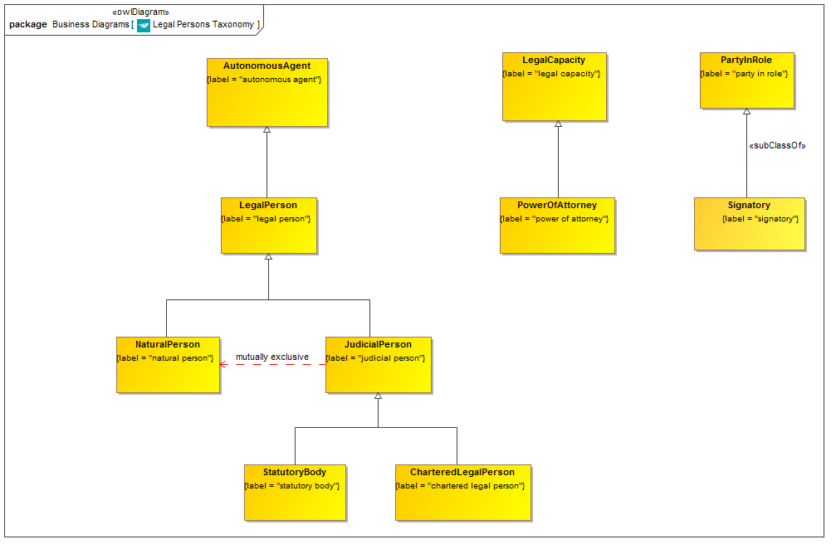

**Figure 9.2.1.1 Legal Persons Taxonomy**

This is the taxonomy of classes of “Thing” in the Legal Persons ontology along with the more general concepts of which they are a specialization.

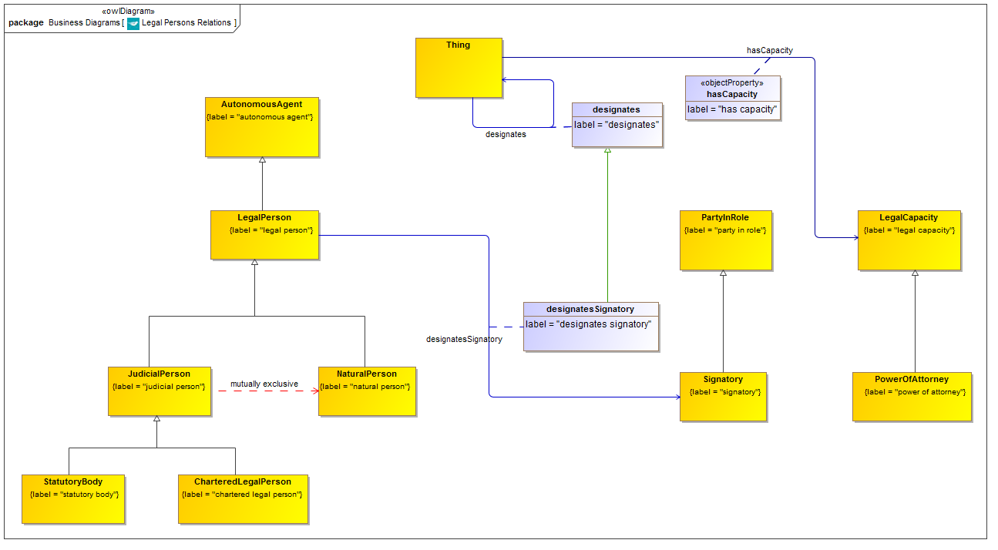

**Figure 9.2.1.2 Legal Persons with Relationship Properties**

Properties in this ontology and elsewhere which are refined and reused by property restrictions, as shown in the complete diagram which follows. The property “hasCapacity” is not a part of this ontology but is included in this diagram since it is one of the more important properties which are refined in the definition of legal persons.

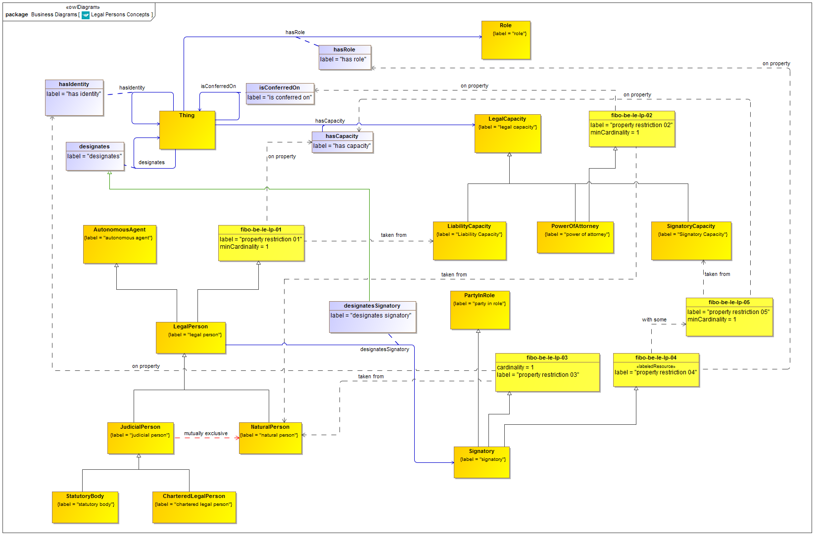

**Figure 9.2.1.3 Legal Persons Ontology (full diagram)**

This shows the completed ontology for Legal Persons. Properties defined in this ontology and elsewhere are refined or re-used to frame the properties essential to Legal Persons and their related concepts.

Table 9-3. Legal Persons Details

| **Concept Type** | **Name** | **Type Of Thing** | **Property** | **Definition** | **Parent** | **Mutually Exclusive With** | **Related Thing or Type** | **Inverse Of Property** | **Multiples** | **Editorial Note** | **Explanatory Note** | **Term Origin** | **Definition Source** |
| --- | --- | --- | --- | --- | --- | --- | --- | --- | --- | --- | --- | --- | --- |
| **Class** | **CharteredLegalPerson** | **chartered legal person** |  | a legal person created by a royal charter or decree | judicial person |  |  |  |  | In a monarchy or principality, the monarch typically vests the power to create such bodies, in an entity called (for example) the Privy Council. |  |  |  |
| **Class** | **JudicialPerson** | **judicial person** |  | Legal persons (lat. persona iuris) are of two kinds: natural persons (people) and judicial persons (also called juristic or artificial or fictitious persons, lat. persona ficta), i.e., groups of people, such as corporations, which are treated by law as if they were persons. While people acquire legal personhood when they are born, judicial persons do so when they are incorporated (registered) in accordance with law. | formal organization legal person | natural person |  |  |  |  |  |  |  |
| **Class** | **LegalPerson** | **legal person** |  | any entity which can incur legal obligation and can be sued at law | property restriction 01 autonomous agent |  |  |  |  |  | To have legal personality means to be capable of having legal rights and duties within a certain legal system, such as to enter into contracts, sue, and be sued. Legal personality is a prerequisite to legal capacity, the ability of any legal person to amend (enter into, transfer, etc.) rights and obligations. |  |  |
| Relationship Property | designatesSignatory | legal person | designates signatory | designates a party able to sign contracts on the part of the legal person | designates |  | signatory |  |  |  |  |  |  |
| **Class** | **NaturalPerson** | **natural person** |  | A person of maturity who in the eyes of the law is able to assume obligations. | adult legal person | judicial person incapacitated adult |  |  |  |  |  |  |  |
| **Class** | **PowerOfAttorney** | **power of attorney** |  | Written legal authority given by one party (the principal) to another (the agent or attorney-in-fact) to act on the principals behalf. It may be a (1) General power Of attorney that authorizes the agent to act generally on behalf of the principal, or (2) Special power of attorney that is limited to a specific act or situation. Decisions made and actions taken by an attorney in fact (within the scope of his or her authority) are legally binding on the principal. A power of attorney can remain in force only so long as the principal is alive and does not become disabled or incapacitated. Although it is often conferred on the principals attorney, one does not need to be an attorney at law to be an attorney-in-fact. | property restriction 02 legal capacity |  |  |  |  |  |  |  | http://www.businessdictionary.com/definition/power-of-attorney.html |
| **Class** | **Signatory** | **signatory** |  | Some agent who has the capacity to sign contracts on the part of some legal person | party in role property restriction 03 property restriction 04 |  |  |  |  |  |  |  |  |
| **Class** | **StatutoryBody** | **statutory body** |  | A legal person which is created and given legal personhood by act of statute. | judicial person |  |  |  |  |  |  |  |  |
| Property Restriction | fibo-be-le-lp-01 | property restriction 01 | has capacity | Set of things that have the property shown, in the multiples given, taken from the type of thing indicated. |  |  | Liability Capacity |  | min 1 |  |  |  |  |
| Property Restriction | fibo-be-le-lp-02 | property restriction 02 | is conferred on | Set of things that have the property shown, in the multiples given, taken from the type of thing indicated. |  |  | natural person |  | min 1 |  |  |  |  |
| Property Restriction | fibo-be-le-lp-03 | property restriction 03 | has identity | Set of things that have the property shown, in the multiples given, taken from the type of thing indicated. |  |  | natural person |  | exactly 1 |  |  |  |  |
| Property Restriction | fibo-be-le-lp-04 | property restriction 04 | has role | Set of things with the property shown, where at least one participant in that relationship must be taken from the type of thing indicated. |  |  | property restriction 05 |  | must be some |  |  |  |  |
| Property Restriction | fibo-be-le-lp-05 | property restriction 05 | has capacity | Set of things that have the property shown, in the multiples given, taken from the type of thing indicated. |  |  | Signatory Capacity |  | min 1 |  |  |  |  |

### 9.2.2 Ontology: Formal Business Organizations

This ontology defines formal business organizations and related concepts. The ontology covers parts of organizations, membership, classification, address relations and other properties which are applicable to formal business organizations generally. The concept of a formal business organization forms the basis for articulation of types of organization, both incorporated and non-incorporated, in other FIBO-BE ontologies.

Table 9-4. Formal Business Organizations Ontology Metadata

|  |  |
| --- | --- |
| **Metadata Term** | **Value** |
| **sm:filename** | Formal Business Organizations Ontology |
| **sm:fileAbbreviation** | fibo-be-le-fbo |
| **OntologyIRI** | <http://www.omg.org/spec/EDMC-FIBO/BE/LegalEntities/FormalBusinessOrganizations/> |
| **owl:versionIRI** | <http://www.omg.org/spec/EDMC-FIBO/BE/20131101/LegalEntities/FormalBusinessOrganizations/> |
| **sm:dependsOn** | http://www.omg.org/spec/EDMC-FIBO/BE/LegalEntities/LegalPersons/ |

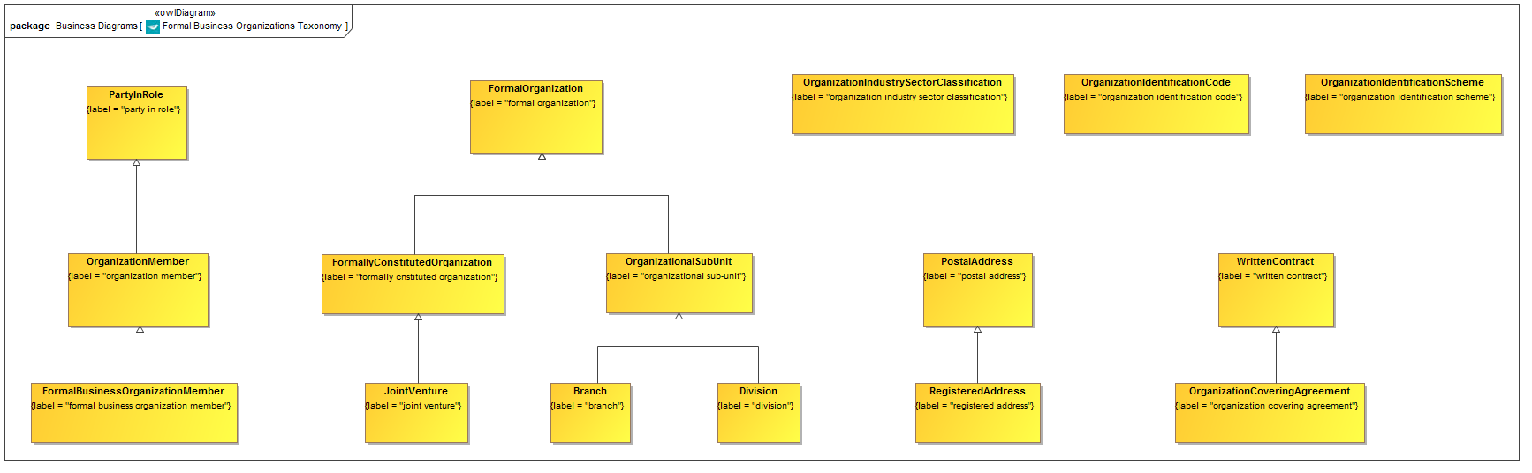

**Figure 9.2.2.1 Formal Business Organizations Taxonomy**

This is the taxonomy of classes of “Thing” in the Formal Business Organizations ontology along with the more general concepts of which they are a specialization.

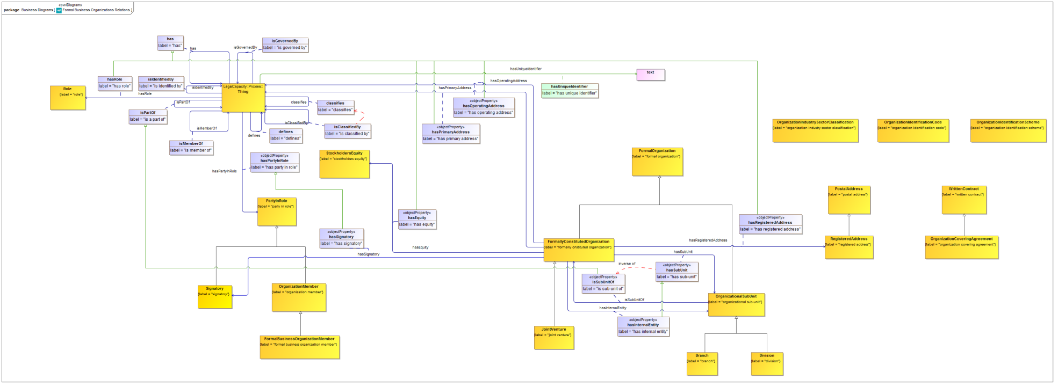

**Figure 9.2.2.2 Formal Business Organizations with Relationship Properties**

Properties in this ontology and elsewhere which are refined and reused by property restrictions, as shown in the complete diagram which follows.

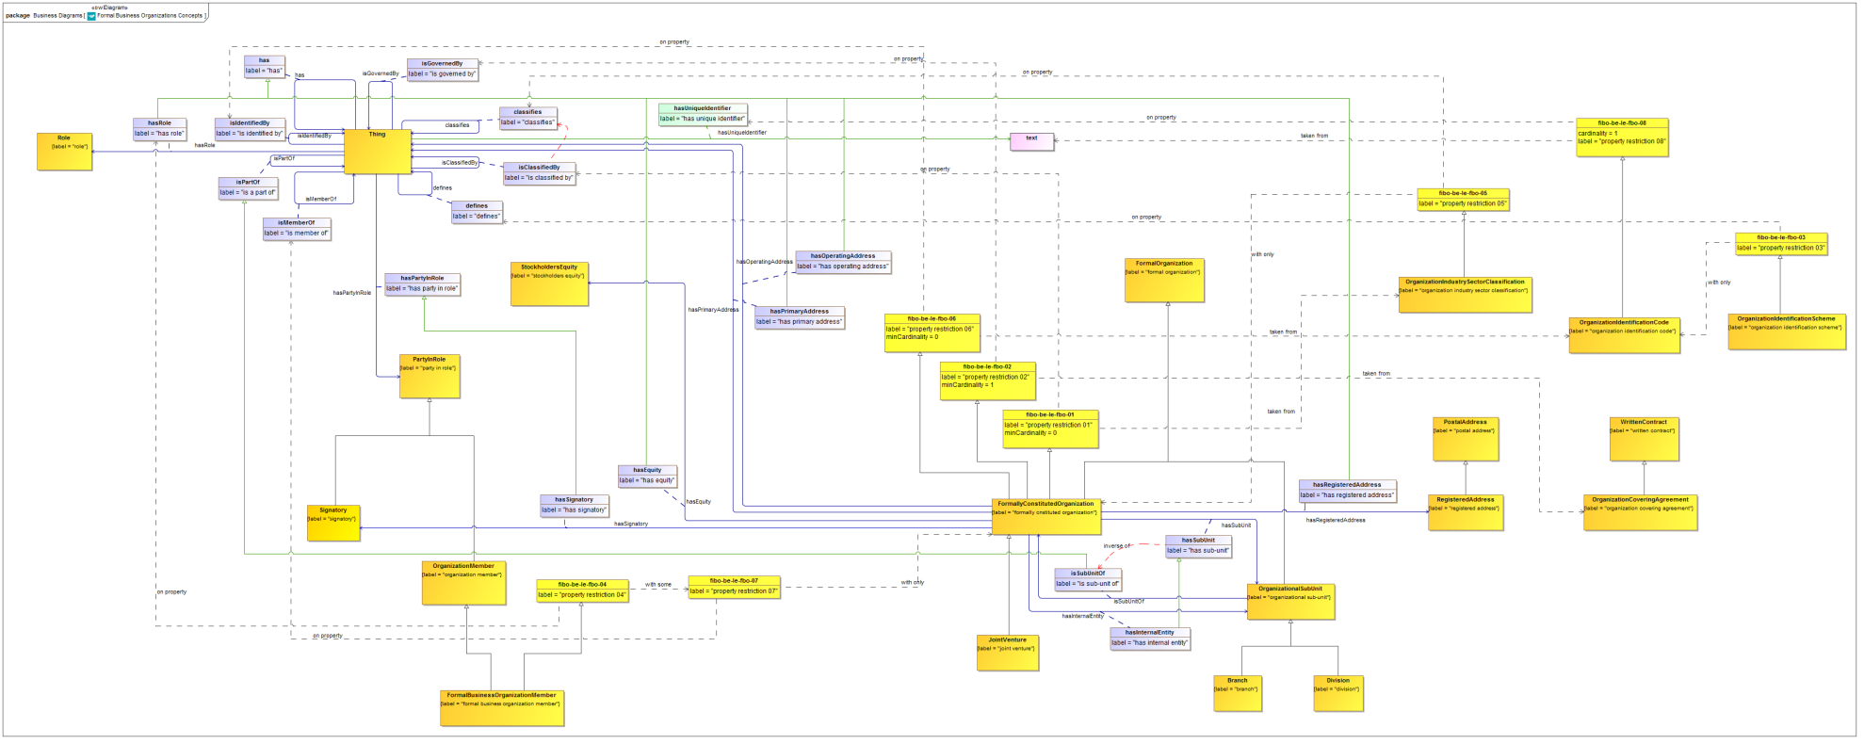

**Figure 9.2.2.3 Formal Business Organizations Ontology (full diagram)**

This shows the completed ontology for Formal Business Organizations. Properties defined in this ontology and elsewhere are refined or re-used to frame the properties essential to Formal Business Organizations and their related concepts.

Table 9-5. Formal Business Organizations Details

| **Concept Type** | **Name** | **Type Of Thing** | **Property** | **Definition** | **Parent** | **Mutually Exclusive With** | **Related Thing or Type** | **Inverse Of Property** | **Multiples** | **Editorial Note** | **Explanatory Note** | **Term Origin** | **Definition Source** |
| --- | --- | --- | --- | --- | --- | --- | --- | --- | --- | --- | --- | --- | --- |
| **Class** | **Branch** | **branch** |  | A part of a business organization or company, identified as a branch. | organizational sub-unit |  |  |  |  | This is not a separate legal entity in its own right, but a functional part of the entity. |  |  |  |
| **Class** | **Division** | **division** |  | a part of a company, such as a line of business, that may have separate accounting or reporting requirements | organizational sub-unit |  |  |  |  |  |  |  |  |
| **Class** | **FormalBusinessOrganizationMember** | **formal business organization member** |  | A member of some formal business organization. | organization member property restriction 04 |  |  |  |  | This party may hold some equity in the formal business organization and may or may not have some responsibilities or potential liabilitiy in resect of the activities of that organization. Terms setting out the position of the member in these and other matters are defined in the organization covering agreement, to which the member may be a signatory. |  |  |  |
| **Class** | **FormallyConstitutedOrganization** | **formally constituted organization** |  | Any organization with some formal contractual agreement among its principals | property restriction 01 property restriction 02 formal organization property restriction 06 |  |  |  |  |  |  |  |  |
| Relationship Property | hasEquity | formally constituted organization | has equity | the formal business organization has some form of stockholders equity | has |  | stockholders equity |  |  |  |  |  |  |
| Relationship Property | hasInternalEntity | formally constituted organization | has internal entity | the organization has some part which is formally defined as an Internal Entity, for example for reporting, management or accounting purposes | has sub-unit |  | organizational sub-unit |  |  |  |  |  |  |
| Relationship Property | hasOperatingAddress | formally constituted organization | has operating address | address at which the organization carries out its operations | has |  |  |  |  |  |  |  |  |
| Relationship Property | hasPrimaryAddress | formally constituted organization | has primary address | The main address at which communications to the organization may be addressed; its headquarters address. | has |  |  |  |  |  |  |  |  |
| Relationship Property | hasRegisteredAddress | formally constituted organization | has registered address | The organization has an address at which it is registered and at which legal papers may be served on it. | has |  | registered address |  |  |  |  |  |  |
| Relationship Property | hasSignatory | formally constituted organization | has signatory | has a party which is authorized to sign contracts on the party of the entity. | has party in role |  | signatory |  |  |  |  |  |  |
| Relationship Property | hasSubUnit | formally constituted organization | has sub-unit | The company has a branch, which is part of that company. This may be in another country or in the country in which that company is registered (incorporated). | has part |  | organizational sub-unit | is sub-unit of |  |  |  |  |  |
| **Class** | **JointVenture** | **joint venture** |  | A formal venture between two or more business entities | formally cnstituted organization |  |  |  |  | Detailed properties still to be modeled. This will be similar to Partnership in that it will have two or more venture partners (need to determine best label for these), and some formal standing. Also to research: whether JVs are only instituted via mutual share ownership and therefore may only be between limited companies (or may only be a limited company but may have other types of legal person and/or legal entity as venture partners). |  |  |  |
| **Class** | **OrganizationCoveringAgreement** | **organization covering agreement** |  | A formal agreement between the principals in a formal organization which covers the relationship between the principals, and between the principals and the entity. | written contract |  |  |  |  | Also covers the aims and purposes of the Entity. |  |  |  |
| **Class** | **OrganizationIdentificationCode** | **organization identification code** |  | A textual code which uniquely identifies a formal organization; Further Notes: Things which may identified by this kind of code Include but are not restricted to Legal Entity. At this most general level, this may be the identifier for a Fund, for a Legal Entity, for a Trust, or for the LEI scope of Artificial Person plus Trust. | property restriction 08 |  |  |  |  |  |  |  |  |
| **Class** | **OrganizationIdentificationScheme** | **organization identification scheme** |  | A formal scheme defining identification codes for a business entity. | property restriction 03 |  |  |  |  |  |  |  |  |
| **Class** | **OrganizationIndustrySectorClassification** | **organization industry sector classification** |  | The classification of an organization in terms of the industry sector in which it carries out business. | property restriction 05 |  |  |  |  |  |  |  |  |
| **Class** | **OrganizationalSubUnit** | **organizational sub-unit** |  | an organization that is part of a larger formal organization and only has full recognition within the context of that formal organization; In other words, it is not a legal entity in its own right. | formal organization |  |  |  |  |  |  |  |  |
| Relationship Property | isSubUnitOf | organizational sub-unit | is sub-unit of | The organization is a sub-unit of a formal business organization and has the role and function of being a formal part of that organization, such as a branch. | is a part of |  | formally cnstituted organization | has sub-unit |  |  |  |  |  |
| **Class** | **RegisteredAddress** | **registered address** |  | The address at which an entity is registered and at which legal papers may be served. | postal address |  |  |  |  | This usually has to not be a postal address (except in some jurisdictions). So there should be a common superclass. |  |  |  |
| Property Restriction | fibo-be-le-fbo-01 | property restriction 01 | is classified by | Set of things that may have the property shown, taken from the type of thing indicated. |  |  | organization industry sector classification |  | min 0 |  |  |  |  |
| Property Restriction | fibo-be-le-fbo-02 | property restriction 02 | is governed by | Set of things that have the property shown, in the multiples given, taken from the type of thing indicated. |  |  | organization covering agreement |  | min 1 |  |  |  |  |
| Property Restriction | fibo-be-le-fbo-03 | property restriction 03 | defines | Set of things which, if they have the property shown, all participants in that relationship must be taken from the type of thing indicated. |  |  | organization identification code |  | may only be |  |  |  |  |
| Property Restriction | fibo-be-le-fbo-04 | property restriction 04 | has role | Set of things with the property shown, where at least one participant in that relationship must be taken from the type of thing indicated. |  |  | property restriction 07 |  | must be some |  |  |  |  |
| Property Restriction | fibo-be-le-fbo-05 | property restriction 05 | classifies | Set of things which, if they have the property shown, all participants in that relationship must be taken from the type of thing indicated. |  |  | formally constituted organization |  | may only be |  |  |  |  |
| Property Restriction | fibo-be-le-fbo-06 | property restriction 06 | is identified by | Set of things that may have the property shown, taken from the type of thing indicated. |  |  | organization identification code |  | min 0 |  |  |  |  |
| Property Restriction | fibo-be-le-fbo-07 | property restriction 07 | is member of | Set of things which, if they have the property shown, all participants in that relationship must be taken from the type of thing indicated. |  |  | formally constituted organization |  | may only be |  |  |  |  |
| Property Restriction | fibo-be-le-fbo-08 | property restriction 08 | has unique identifier | Set of things that have the property shown, in the multiples given, taken from the type of thing indicated. |  |  | text |  | exactly 1 |  |  |  |  |

### 9.2.3 Ontology: Corporate Bodies

This ontology defines the basic mechanisms that establish legal personhood for judicial or artificial persons, specifically those that are corporate bodies, including bodies incorporated by equity, by guarantee, and by agreement.

Table 9-6. Corporate Bodies Ontology Metadata

|  |  |
| --- | --- |
| **Metadata Term** | **Value** |
| **sm:filename** | Corporate Bodies Ontology |
| **sm:fileAbbreviation** | fibo-be-le-cb |
| **OntologyIRI** | <http://www.omg.org/spec/EDMC-FIBO/BE/LegalEntities/CorporateBodies/> |
| **owl:versionIRI** | <http://www.omg.org/spec/EDMC-FIBO/BE/20131101/LegalEntities/CorporateBodies/> |
| **sm:dependsOn** | http://www.omg.org/spec/EDMC-FIBO/BE/LegalEntities/LegalPersons/  http://www.omg.org/spec/EDMC-FIBO/BE/LegalEntities/FormalBusinessOrganizations/ |

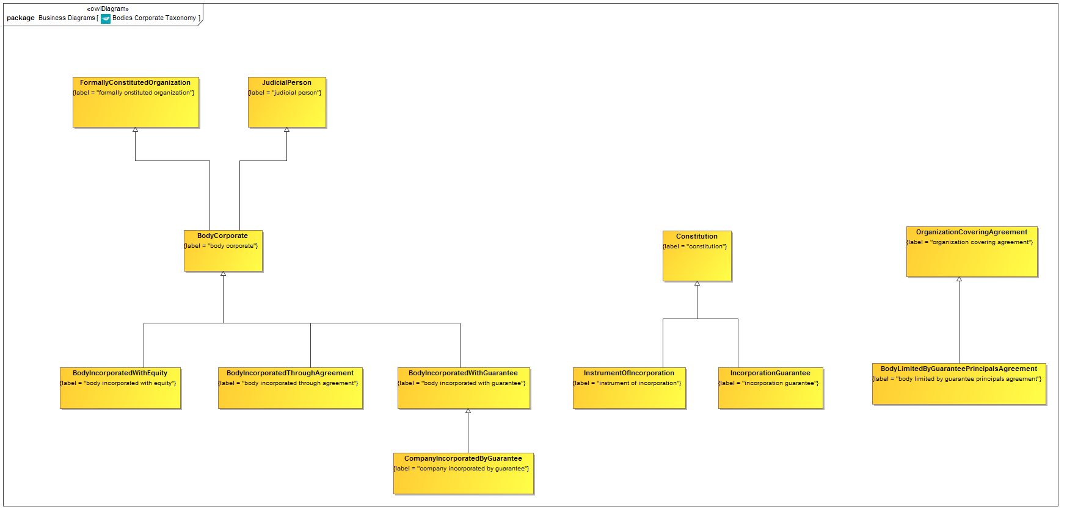

**Figure 9.2.3.1 Bodies Corporate Taxonomy**

This is the taxonomy of classes of “Thing” in the Corporations ontology along with the more general concepts of which they are a specialization.

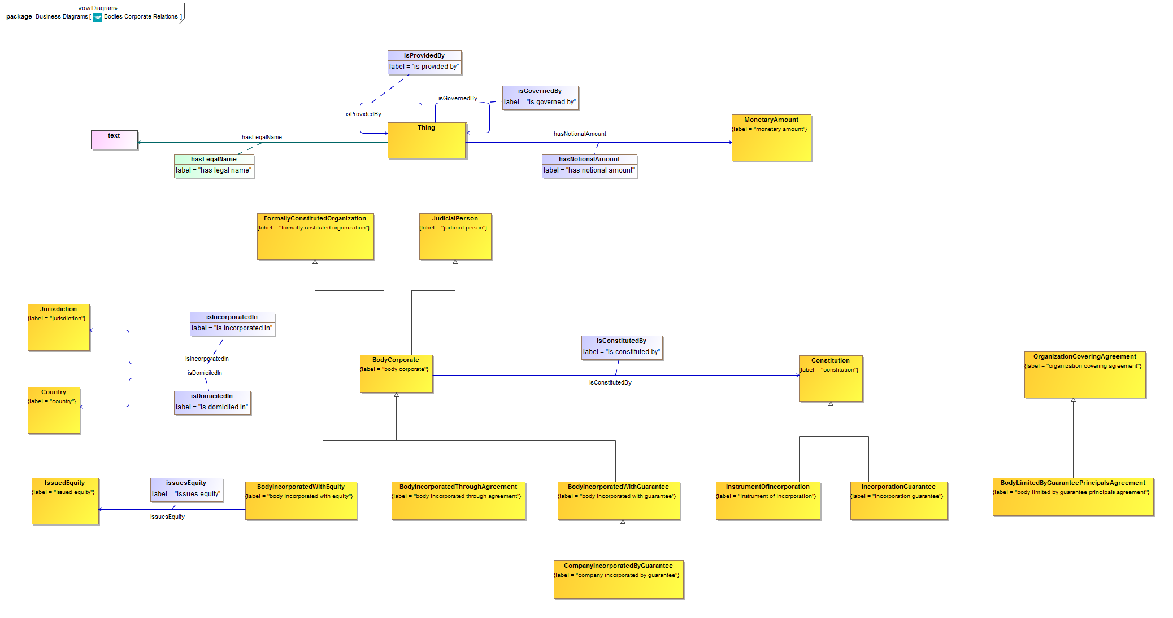

**Figure 9.2.3.2 Bodies Corporate Concepts and Relationship Properties**

This shows the taxonomy of concepts along with the relationships used in this ontology or adapted and refined by it.

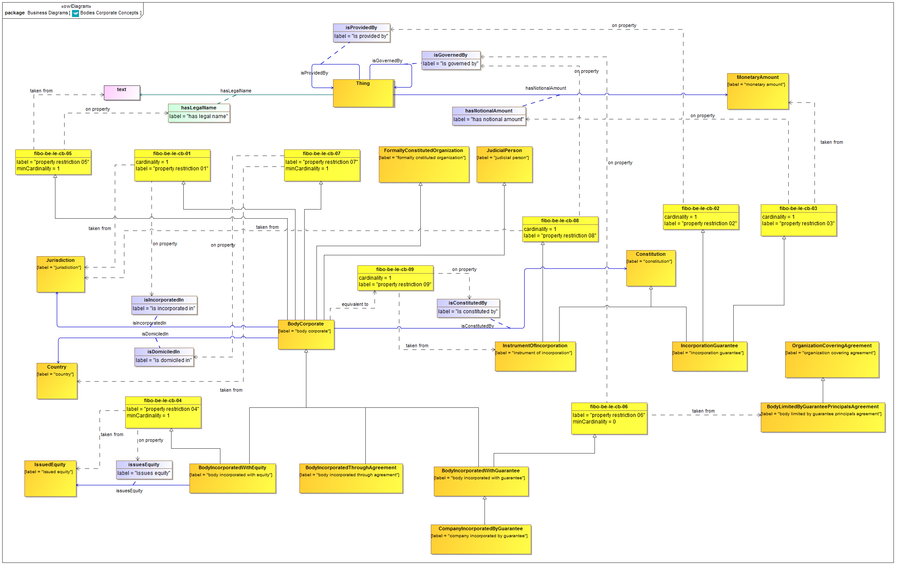

**Figure 9.2.3.3 Bodies Corporate Ontology (full diagram)**

This shows the completed ontology for Corporate Bodies. Properties defined in this ontology and elsewhere are refined or re-used to frame the properties essential to bodies corporate and their related concepts.

Table 9-7. Corporate Bodies Details

| **Concept Type** | **Name** | **Type Of Thing** | **Property** | **Definition** | **Parent** | **Mutually Exclusive With** | **Related Thing or Type** | **Inverse Of Property** | **Multiples** | **Editorial Note** | **Explanatory Note** | **Term Origin** | **Definition Source** |
| --- | --- | --- | --- | --- | --- | --- | --- | --- | --- | --- | --- | --- | --- |
| **Class** | **BodyCorporate** | **body corporate** |  | A body corporate has a legal name and has certain rights, protections, privileges, responsibilities, and liabilities under law, similar to those of a natural person. The concept is pertinent to the philosophy of law, as it is essential to laws affecting a corporation (corporations law) (the law of business associations). | property restriction 01 judicial person property restriction 05 property restriction 07 formally cnstituted organization |  |  |  |  | This is an artificial legal person, that is something with legal personhood but which has been created artificially. It is also a formal organization (unlike for example artificial legal persons created by statute or by royal charter). Bodies Corporate, and all non-natural legal persons, are generally created by some legal act and supported by some instrument such as the issuance of shares or guarantees. These are what give the entity a separate legal standing in the jurisdiction in which they are defined, and that jurisdiction will have created the laws which allow and cause this kind of entity to exist. |  |  |  |
| Relationship Property | isConstitutedBy | body corporate | is constituted by | the instrument by which an entity is incorporated |  |  | constitution |  |  |  |  |  |  |
| Relationship Property | isDomiciledIn | body corporate | is domiciled in | the country in which the body corporate is officially domiciled |  |  | country |  |  | This would normally be the country corresponding to the jurisdiction in which the body corporate is incorporated. For some primarily federal countries, the domicile is the country that makes up the federation while the jurisdiction under which the entity is registered would be that of some state in that federation. |  |  |  |
| Relationship Property | isIncorporatedIn | body corporate | is incorporated in | the legal jurisdiction under which the legal entity is incorporated |  |  | jurisdiction |  |  | It is the laws of this jurisdiction that cause and allow the legal entity to exist and to incur debt and be sued at law as a legal entity. |  |  |  |
| **Class** | **BodyIncorporatedThroughAgreement** | **body incorporated through agreement** |  | A body with legal personhood, incorporated through some agreement among the principals, and without equity or guarantee instruments which would isolate the principals from liability. | body corporate |  |  |  |  | An LLP (in the UK) is an example of this, and is also a partnership. There, the LLP Document is the legal document which effectively constitutes the Partnership. |  |  |  |
| **Class** | **BodyIncorporatedWithEquity** | **body incorporated with equity** |  | A body corporate which is incorporated by means of the issuance of equity. | body corporate property restriction 04 |  |  |  |  |  |  |  |  |
| Relationship Property | issuesEquity | body incorporated with equity | issues equity | A body incorporated by equity is incorporated through the issuance of some issued equity, which is a form of stockholders equity. |  |  | issued equity |  |  |  |  |  |  |
| **Class** | **BodyIncorporatedWithGuarantee** | **body incorporated with guarantee** |  | Incorporated entity without share capital, and in which the liability of its members is limited to the amount each one of them undertakes to contribute at the time the firm is wound up. | body corporate property restriction 06 |  |  |  |  | The profit motive is not the prime objective of the organization. |  |  |  |
| **Class** | **BodyLimitedByGuaranteePrincipalsAgreement** | **body limited by guarantee principals agreement** |  | The formal agreement between the principals of a body limited by guarantee. | organization covering agreement |  |  |  |  |  |  |  |  |
| **Class** | **CompanyIncorporatedByGuarantee** | **company incorporated by guarantee** |  |  | body incorporated with guarantee |  |  |  |  |  |  |  | www.investorwords.com |
| **Class** | **IncorporationGuarantee** | **incorporation guarantee** |  | A guarantee which is part of the means by which some incorporated entity is incorporated by guarantee. | property restriction 02 property restriction 03 constitution |  |  |  |  |  |  |  |  |
| **Class** | **InstrumentOfIncorporation** | **instrument of incorporation** |  | Some legal instrument by which some legal entity which is not a natural person is made to exist. | property restriction 08 constitution |  |  |  |  | This may be the issuance of shares, the existence of some agreement, guaranties and so on. |  |  |  |
| Property Restriction | fibo-be-le-cb-01 | property restriction 01 | is incorporated in | Set of things that have the property shown, in the multiples given, taken from the type of thing indicated. |  |  | jurisdiction |  | exactly 1 |  |  |  |  |
| Property Restriction | fibo-be-le-cb-02 | property restriction 02 | is provided by | Set of things that have the property shown, in the multiples given, taken from the type of thing indicated. |  |  | Anything |  | exactly 1 |  |  |  |  |
| Property Restriction | fibo-be-le-cb-03 | property restriction 03 | has notional amount | Set of things that have the property shown, in the multiples given, taken from the type of thing indicated. |  |  | monetary amount |  | exactly 1 |  |  |  |  |
| Property Restriction | fibo-be-le-cb-04 | property restriction 04 | issues equity | Set of things that have the property shown, in the multiples given, taken from the type of thing indicated. |  |  | issued equity |  | min 1 |  |  |  |  |
| Property Restriction | fibo-be-le-cb-05 | property restriction 05 | has legal name | Set of things that have the property shown, in the multiples given, taken from the type of thing indicated. |  |  | text |  | min 1 |  |  |  |  |
| Property Restriction | fibo-be-le-cb-06 | property restriction 06 | is governed by | Set of things that may have the property shown, taken from the type of thing indicated. |  |  | body limited by guarantee principals agreement |  | min 0 |  |  |  |  |
| Property Restriction | fibo-be-le-cb-07 | property restriction 07 | is domiciled in | Set of things that have the property shown, in the multiples given, taken from the type of thing indicated. |  |  | country |  | min 1 |  |  |  |  |
| Property Restriction | fibo-be-le-cb-08 | property restriction 08 | is governed by | Set of things that have the property shown, in the multiples given, taken from the type of thing indicated. |  |  | jurisdiction |  | exactly 1 |  |  |  |  |
| Property Restriction | fibo-be-le-cb-09 | property restriction 09 | is constituted by | Set of things that have the property shown, in the multiples given, taken from the type of thing indicated. |  |  | instrument of incorporation |  | exactly 1 |  |  |  |  |

### 9.2.4 Ontology: LEI Related Entities

This ontology defines concepts around contractually capable business entities. The terms defined here are those which are relevant to the Legal Entity Identifier (LEI) work. The term known as legal entity in that work is identified as a formal organization which is recognized in some jurisdiction as being capable of incurring some liability, whether or not is a legal person as understood by the legal community. This is labeled as contractually capable entity, to avoid confusion with the accepted legal term for Legal Entity. Such entities are recognized as requiring an LEI, but the identifier itself is allocated to the formal organization which is recognized as being contractually capable.

Table 9-8. LEI Related Entities Ontology Metadata

|  |  |
| --- | --- |
| **Metadata Term** | **Value** |
| **sm:filename** | LEI Entities Ontology |
| **sm:fileAbbreviation** | fibo-be-le-lei |
| **OntologyIRI** | [http://www.omg.org/spec/EDMC-FIBO/BE/LegalEntities/LEIEntities/](http://www.omg.org/spec/EDMC-FIBO/BE/20131101/LegalEntities/LEIEntities/) |
| **owl:versionIRI** | <http://www.omg.org/spec/EDMC-FIBO/BE/20131101/LegalEntities/LEIEntities/> |
| **sm:dependsOn** | http://www.omg.org/spec/EDMC-FIBO/BE/LegalEntities/LegalPersons/  http://www.omg.org/spec/EDMC-FIBO/BE/LegalEntities/FormalBusinessOrganizations/ |

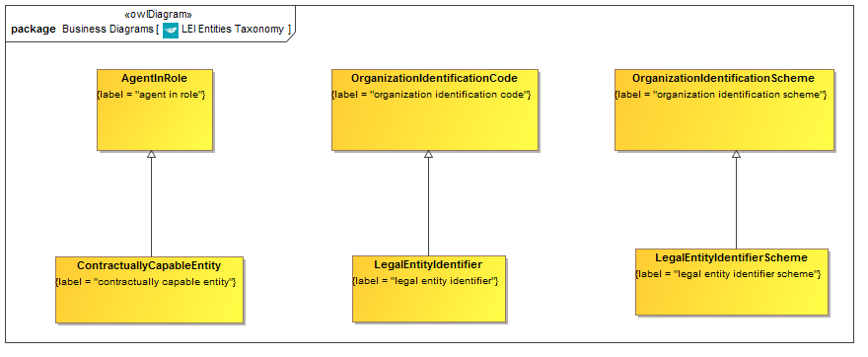

**Figure 9.2.4.1 Taxonomy of LEI Related Concepts**

This is the taxonomy of classes of “Thing” in the LEI Entities ontology along with the more general concepts of which they are a specialization.

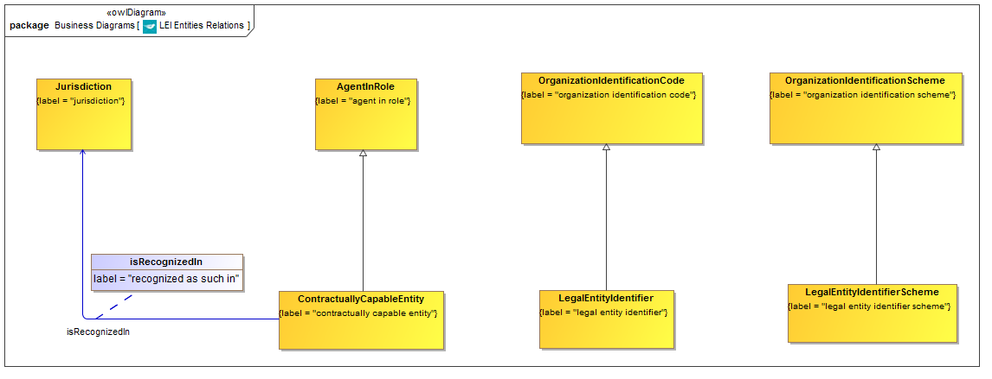

**Figure 9.2.4.2 LEI Entities Ontology with Relationship Properties**

Classes of Thing and the properties defined for them in this ontology. Note that other properties exist which are refined and reused by property restrictions, as shown in the complete diagram which follows. These are omitted here for clarity.

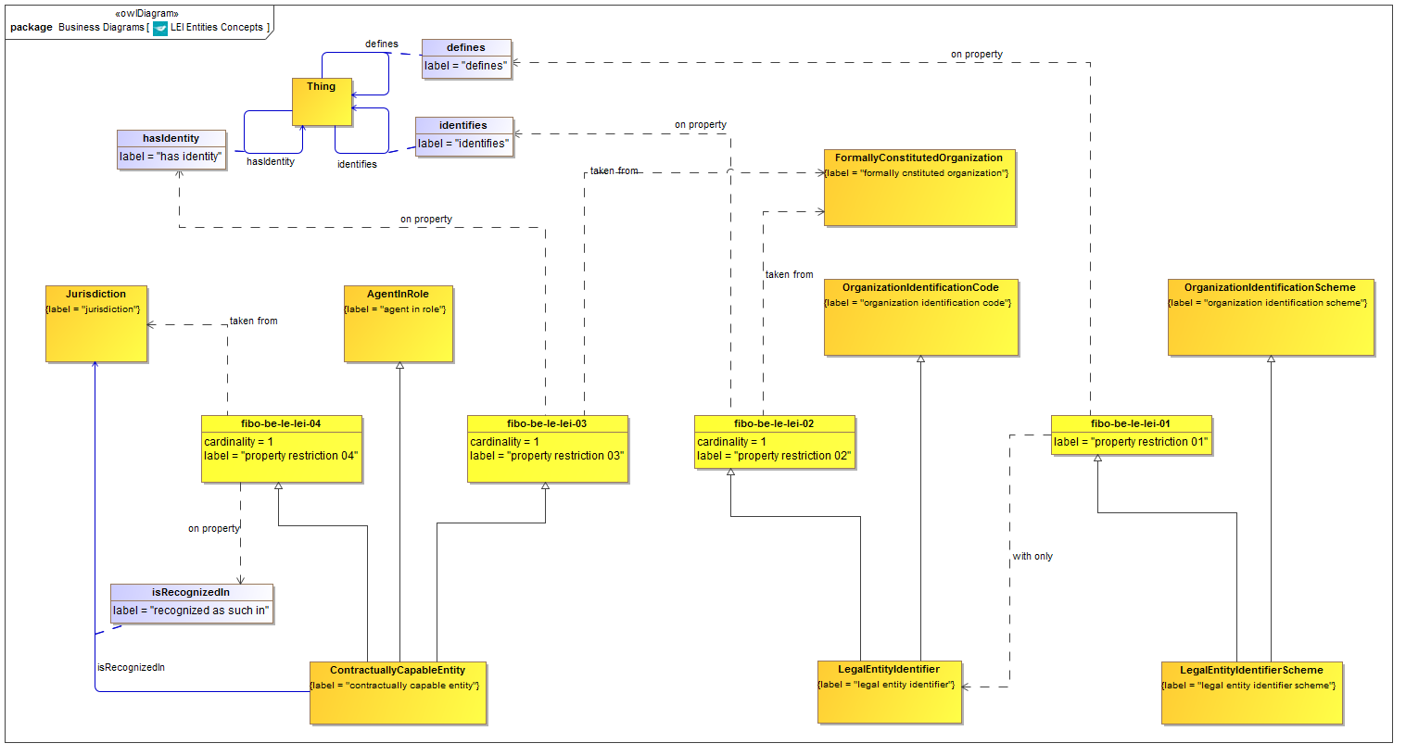

**Figure 9.2.4.3 LEI Entities Ontology (full diagram)**

This shows the completed ontology for LEI related concepts. Properties defined in this ontology and elsewhere are refined or re-used to frame the properties essential to LEI and related concepts.

Table 9-9. LEI Related Entities Details

| **Concept Type** | **Name** | **Type Of Thing** | **Property** | **Definition** | **Parent** | **Mutually Exclusive With** | **Related Thing or Type** | **Inverse Of Property** | **Multiples** | **Editorial Note** | **Explanatory Note** | **Term Origin** | **Definition Source** |
| --- | --- | --- | --- | --- | --- | --- | --- | --- | --- | --- | --- | --- | --- |
| **Class** | **ContractuallyCapableEntity** | **contractually capable entity** |  | A unique entity that is legally or financially responsible for the performance of financial transactions, or has the legal right in its jurisdiction to enter independently into legal contracts, regardless of whether it is incorporated or constituted in some other way (e.g. trust, partnership, contractual). This excludes natural persons, but includes governmental organizations and supranationals. | agent in role property restriction 03 property restriction 04 |  |  |  |  |  |  |  |  |
| Relationship Property | isRecognizedIn | contractually capable entity | recognized as such in | The concept of what is considered legal, with respect to a legal entity, is a function of the jurisdiction in which it is recognized. |  |  | jurisdiction |  |  |  |  |  |  |
| **Class** | **LegalEntityIdentifierScheme** | **legal entity identifier scheme** |  | The scheme under which the LEI code is defined. | organization identification scheme property restriction 01 |  |  |  |  |  |  |  |  |
| **Class** | **LegalEntityIdentifier** | **legal entity identifier** |  | A code which uniquely identifies a formal business organization and is allocated to it as a result of it being recognized as being a contractually capable entity (ISO 17442 Legal Entity). | property restriction 02 organization identification code |  |  |  |  | This is at variance with the name of this identifier type, but is in line with the stated aim of the LEI initiative to which this identification code refers. |  |  |  |
| Property Restriction | fibo-be-le-lei-01 | property restriction 01 | defines | Set of things which, if they have the property shown, all participants in that relationship must be taken from the type of thing indicated. |  |  | legal entity identifier |  | may only be |  |  |  |  |
| Property Restriction | fibo-be-le-lei-02 | property restriction 02 | identifies | Set of things that have the property shown, in the multiples given, taken from the type of thing indicated. |  |  | formally constituted organization |  | exactly 1 |  |  |  |  |
| Property Restriction | fibo-be-le-lei-03 | property restriction 03 | has identity | Set of things that have the property shown, in the multiples given, taken from the type of thing indicated. |  |  | formally constituted organization |  | exactly 1 |  |  |  |  |
| Property Restriction | fibo-be-le-lei-04 | property restriction 04 | recognized as such in | Set of things that have the property shown, in the multiples given, taken from the type of thing indicated. |  |  | jurisdiction |  | exactly 1 |  |  |  |  |

## 9.3. Module: Corporations

Table 9-10. Corporations Module Metadata

|  |  |
| --- | --- |
| **Metadata Term** | **Value** |
| **sm:moduleName** | Corporations |
| **sm:moduleAbbreviation** | FIBO-BE-CORP |
| **sm:moduleVersion** | 1.0 |
| **sm:moduleAbstract** | This module includes ontologies describing the essential features of companies incorporated by the issuance of shares. The terms in these ontologies build on terms about incorporated bodies more generally, and include terms about shareholding, which form the basis of relationships of ownership and control of or among these kinds of entities. |

### 9.3.1 Ontology: Corporations

This ontology defines the fundamental concepts for companies incorporated by the issuance of shares. Terms defined in this ontology are those which are applicable to all such entities. Many of these concepts form the basis of the relationships of ownership and control which obtain between entities of this type.

Table 9-11. Corporations Ontology Metadata

|  |  |
| --- | --- |
| **Metadata Term** | **Value** |
| **sm:filename** | Corporations Ontology |
| **sm:fileAbbreviation** | fibo-be-corp-corp |
| **OntologyIRI** | [http://www.omg.org/spec/EDMC-FIBO/BE/Corporations/Corporations/](http://www.omg.org/spec/EDMC-FIBO/BE/20131101/Corporations/Corporations/) |
| **owl:versionIRI** | <http://www.omg.org/spec/EDMC-FIBO/BE/20131101/Corporations/Corporations/> |
| **sm:dependsOn** | http://www.omg.org/spec/EDMC-FIBO/BE/LegalEntities/LegalPersons/  http://www.omg.org/spec/EDMC-FIBO/BE/LegalEntities/FormalBusinessOrganizations/  http://www.omg.org/spec/EDMC-FIBO/BE/LegalEntities/CorporateBodies/ |

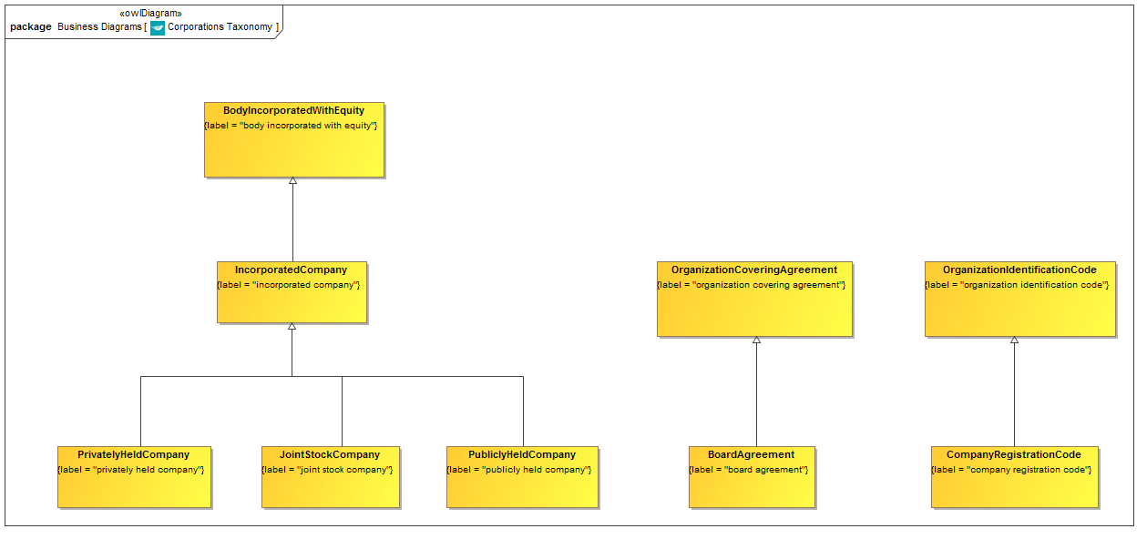

**Figure 9.3.1.1 Corporations Taxonomy**

This is the taxonomy of classes of “Thing” in the Corporations ontology along with the more general concepts of which they are a specialization.

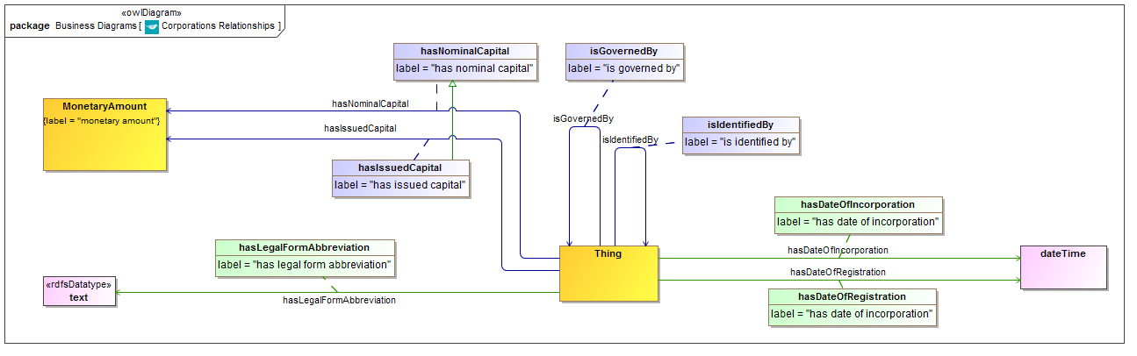

**Figure 9.3.1.2 Corporations Relationship Properties**

These properties are refined and reused by property restrictions, as shown in the complete diagram which follows.

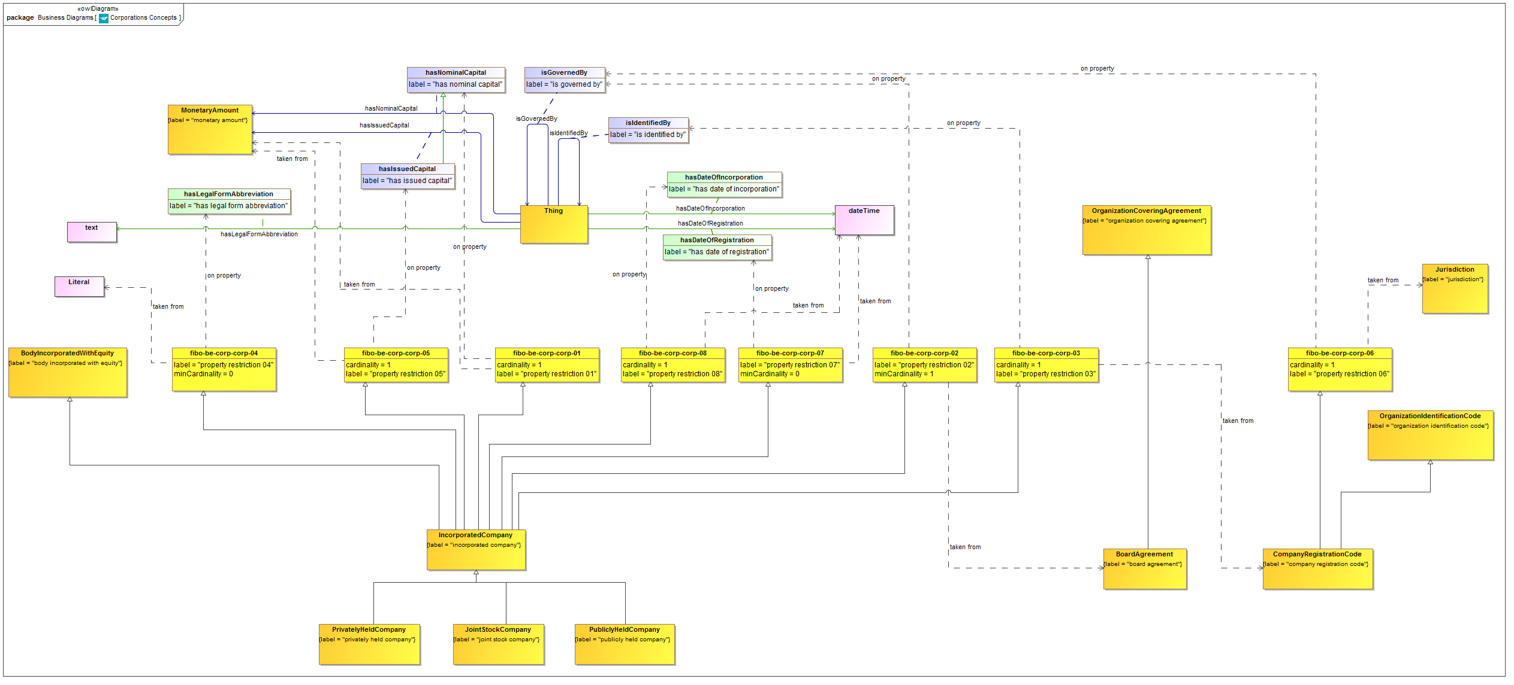

**Figure 9.3.1.3 Corporations Concepts (full diagram)**

This shows the completed ontology for Corporations. Properties defined in this ontology and elsewhere are refined or re-used to frame the properties essential to corporations and their related concepts.

Table 9-12. Corporations Details

| **Concept Type** | **Name** | **Type Of Thing** | **Property** | **Definition** | **Parent** | **Mutually Exclusive With** | **Related Thing or Type** | **Inverse Of Property** | **Multiples** | **Editorial Note** | **Explanatory Note** | **Term Origin** | **Definition Source** |
| --- | --- | --- | --- | --- | --- | --- | --- | --- | --- | --- | --- | --- | --- |
| Simple Property | hasDateOfRegistration | Anything | has date of incorporation | Date at which the corporation is registered in some jurisdiction for regulatory and / or for tax purposes. Further Notes: This is analogous to a person registering for paying taxes somewhere, regardless of their birth, citizenship and so on. |  |  | xsd:dateTime |  |  |  |  |  |  |
| Simple Property | hasDateOfIncorporation | Anything | has date of incorporation | The date of formation of the company. This is identified as the formal date of registration in company registration documents. Further Notes: Generally known as Date of Incorporation. |  |  | xsd:dateTime |  |  |  |  |  |  |
| Relationship Property | hasIssuedCapital | Anything | has issued capital | The total of a companys shares that are held by shareholders. A company can, at any time, issue new shares up to the full amount of authorized share capital. | has nominal capital |  | monetary amount |  |  |  |  |  |  |
| Simple Property | hasLegalFormAbbreviation | Anything | has legal form abbreviation | The precise form of the incorporated company abbreviation as defined in the jurisdiction in which it is registered, for example LLC, LLP, Ltd, PLC, Corp. |  |  | text |  |  |  |  |  |  |
| Relationship Property | hasNominalCapital | Anything | has nominal capital | Nominal capital is an alternate term for authorized share capital. The maximum value of securities that a company can legally issue. This number is specified in the memorandum of association (or articles of incorporation in the US) when a company is incorporated, but can be changed later with shareholders approval. Authorized share capital may be divided into (1) Issued capital - par value of the shares actually issued, (2) Paid up capital - money received from the shareholders in exchange for shares, and (3) Uncalled capital - money remaining unpaid by the shareholders for the shares they have bought. | has |  | monetary amount |  |  |  |  |  |  |
| **Class** | **BoardAgreement** | **board agreement** |  | The agreement between members of the Board of the Company. | organization covering agreement |  |  |  |  |  |  |  |  |
| **Class** | **CompanyRegistrationCode** | **company registration code** |  | A code which is officially allocated under a jurisdiction in which a company is incorporated, and which is used within that jurisdiction to identify the company. This usually has to be included in official stationary and must always be publicly available. | organization identification code property restriction 06 |  |  |  |  |  |  |  |  |
| **Class** | **IncorporatedCompany** | **incorporated company** |  | a company incorporated by the issuance of shares | body incorporated with equity property restriction 01 property restriction 02 property restriction 03 property restriction 04 property restriction 05 property restriction 07 property restriction 08 |  |  |  |  |  |  |  |  |
| **Class** | **JointStockCompany** | **joint stock company** |  | 1. In the UK, the original (17th century) name for a corporation in which the liability of the owners is limited to the nominal value of the stock (shares) held by them. 2. In the US, a corporation with unlimited liability for the shareholders. Investors in a US joint stock company receive stock (shares) which can be transferred, and can elect a board of directors, but are jointly-and-severally liable for companys debts and obligations. A US joint stock company cannot hold title to a real property. | incorporated company |  |  |  |  | There are two kinds of joint stock company. The private company kind and the open market. The shares are usually only held by the directors and Company Secretary. |  |  | http://www.businessdictionary.com/definition/joint-stock-company.html |
| **Class** | **PrivatelyHeldCompany** | **privately held company** |  | A firm whose issued shares are all held by a family or a small group of investors and, therefore, cannot be bought by the public. | incorporated company |  |  |  |  | Wikipedia: definition for British or Commonwealth version: A private company limited by shares is a type of company incorporated under the laws of England and Wales, Scotland, that of certain Commonwealth countries and the Republic of Ireland. It has shareholders with limited liability and its shares may not be offered to the general public, unlike those of public limited companies. Additional notes from Wikipedia: Limited by shares means that the company has shareholders, and that the liability of the shareholders to creditors of the company is limited to the capital originally invested, i.e. the nominal value of the shares and any premium paid in return for the issue of the shares by the company. A shareholders personal assets are thereby protected in the event of the companys insolvency, but money invested in the company will be lost. A limited company may be private or public. A private limited companys disclosure requirements are lighter, but for this reason its shares may not be offered to the general public (and therefore cannot be traded on a public stock exchange). This is the major distinguishing feature between a private limited company and a public limited company. Most companies, particularly small companies, are private. Private companies limited by shares are required to have the suffix Limited (often written Ltd or Ltd.) or Incorporated (Inc.) as part of their name, though the latter cannot be used in the UK or the Republic of Ireland. In the Republic of Ireland, Teoranta (Teo.) may be used instead, largely by Gaeltacht companies. Cyfyngedig (Cyf.) may be used by Welsh companies in a similar fashion. |  |  | http://www.businessdictionary.com/definition/closed-corporation.html |
| **Class** | **PubliclyHeldCompany** | **publicly held company** |  | a company whose shares are traded and held publicly. | incorporated company |  |  |  |  |  |  |  |  |
| Property Restriction | fibo-be-corp-corp-01 | property restriction 01 | has nominal capital | Set of things that have the property shown, in the multiples given, taken from the type of thing indicated. |  |  | monetary amount |  | exactly 1 |  |  |  |  |
| Property Restriction | fibo-be-corp-corp-02 | property restriction 02 | is governed by | Set of things that have the property shown, in the multiples given, taken from the type of thing indicated. |  |  | board agreement |  | min 1 |  |  |  |  |
| Property Restriction | fibo-be-corp-corp-03 | property restriction 03 | is identified by | Set of things that have the property shown, in the multiples given, taken from the type of thing indicated. |  |  | company registration code |  | exactly 1 |  |  |  |  |
| Property Restriction | fibo-be-corp-corp-04 | property restriction 04 | has legal form abbreviation | Set of things that may have the property shown, taken from the type of thing indicated. |  |  | literal |  | min 0 |  |  |  |  |
| Property Restriction | fibo-be-corp-corp-05 | property restriction 05 | has issued capital | Set of things that have the property shown, in the multiples given, taken from the type of thing indicated. |  |  | monetary amount |  | exactly 1 |  |  |  |  |
| Property Restriction | fibo-be-corp-corp-06 | property restriction 06 | is governed by | Set of things that have the property shown, in the multiples given, taken from the type of thing indicated. |  |  | jurisdiction |  | exactly 1 |  |  |  |  |
| Property Restriction | fibo-be-corp-corp-07 | property restriction 07 | hasDateOfRegistration | Set of things that may have the property shown, taken from the type of thing indicated. |  |  | dateTime |  | min 0 |  |  |  |  |
| Property Restriction | fibo-be-corp-corp-08 | property restriction 08 | has date of incorporation | Set of things that have the property shown, in the multiples given, taken from the type of thing indicated. |  |  | dateTime |  | exactly 1 |  |  |  |  |

## 9.4. Module: Partnerships

Table 9-13. Partnerships Module Metadata

|  |  |
| --- | --- |
| **Metadata Term** | **Value** |
| **sm:moduleName** | Partnerships |
| **sm:moduleAbbreviation** | FIBO-BE-PTR |
| **sm:moduleVersion** | 1.0 |
| **sm:moduleAbstract** | This module contains ontologies that define concepts relating to types of partnerships, including incorporated and non-incorporated organizations. Partnerships are defined without reference to jurisdiction-specific legal forms. The abstractions distinguish between types of partnerships and related formation characteristics, as well as kinds of partners and types of partnership equity. |

### 9.4.1 Ontology: Partnerships

This ontology defines partnerships and related concepts. The concepts distinguish general from limited partners, as well as the types of equity that they hold. Included are abstract definitions of partnership types based on whether they have general, limited or both kinds of partners. Both legally incorporated and non incorporated forms of partnerships are covered.

Table 9-14. Partnerships Ontology Metadata

|  |  |
| --- | --- |
| **Metadata Term** | **Value** |
| **sm:filename** | Partnerships Ontology |
| **sm:fileAbbreviation** | fibo-be-ptr-ptr |
| **OntologyIRI** | [http://www.omg.org/spec/EDMC-FIBO/BE/Partnerhips/Partnerships/](http://www.omg.org/spec/EDMC-FIBO/BE/20131101/Partnerhips/Partnerships/) |
| **owl:versionIRI** | <http://www.omg.org/spec/EDMC-FIBO/BE/20131101/Partnerhips/Partnerships/> |
| **sm:dependsOn** | http://www.omg.org/spec/EDMC-FIBO/BE/LegalEntities/LegalPersons/  http://www.omg.org/spec/EDMC-FIBO/BE/LegalEntities/FormalBusinessOrganizations/  http://www.omg.org/spec/EDMC-FIBO/BE/LegalEntities/CorporateBodies/  http://www.omg.org/spec/EDMC-FIBO/BE/LegalEntities/LEIEntities/  http://www.omg.org/spec/EDMC-FIBO/BE/OwnershipAndControl/OwnershipParties/  http://www.omg.org/spec/EDMC-FIBO/BE/OwnershipAndControl/ControlParties/ |

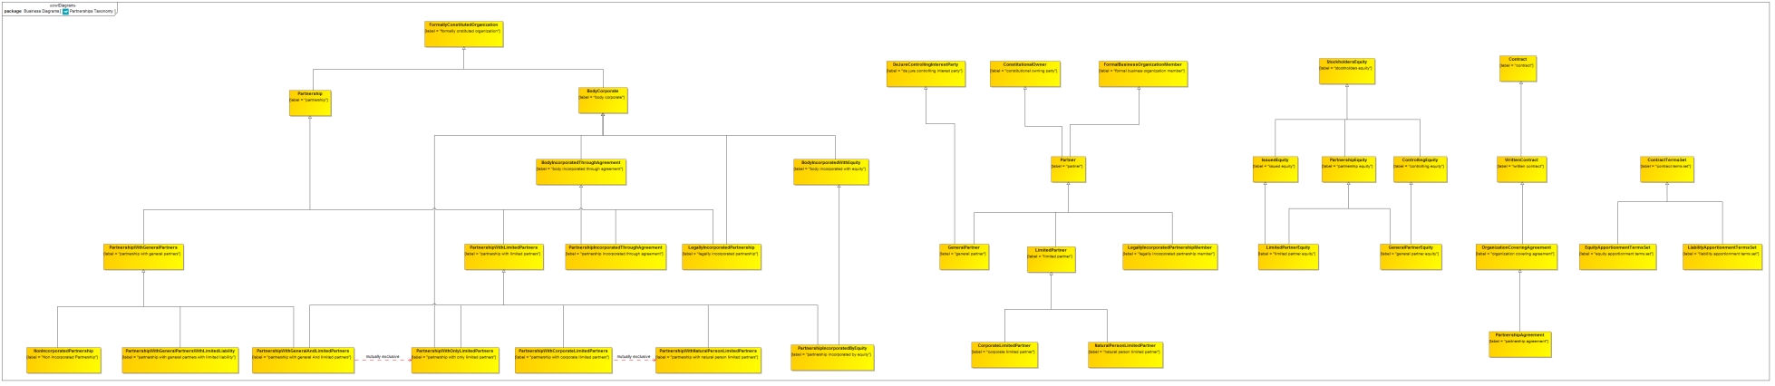

**Figure 9.4.1.1 Partnerships Taxonomy**

This is the taxonomy of classes of “Thing” in the Partnerships ontology along with the more general concepts of which they are a specialization.

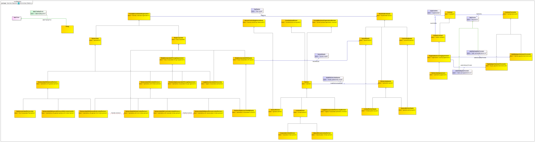

**Figure 9.4.1.2 Partnerships Relationship Properties**

These properties are refined and reused by property restrictions, as shown in the complete diagram which follows.

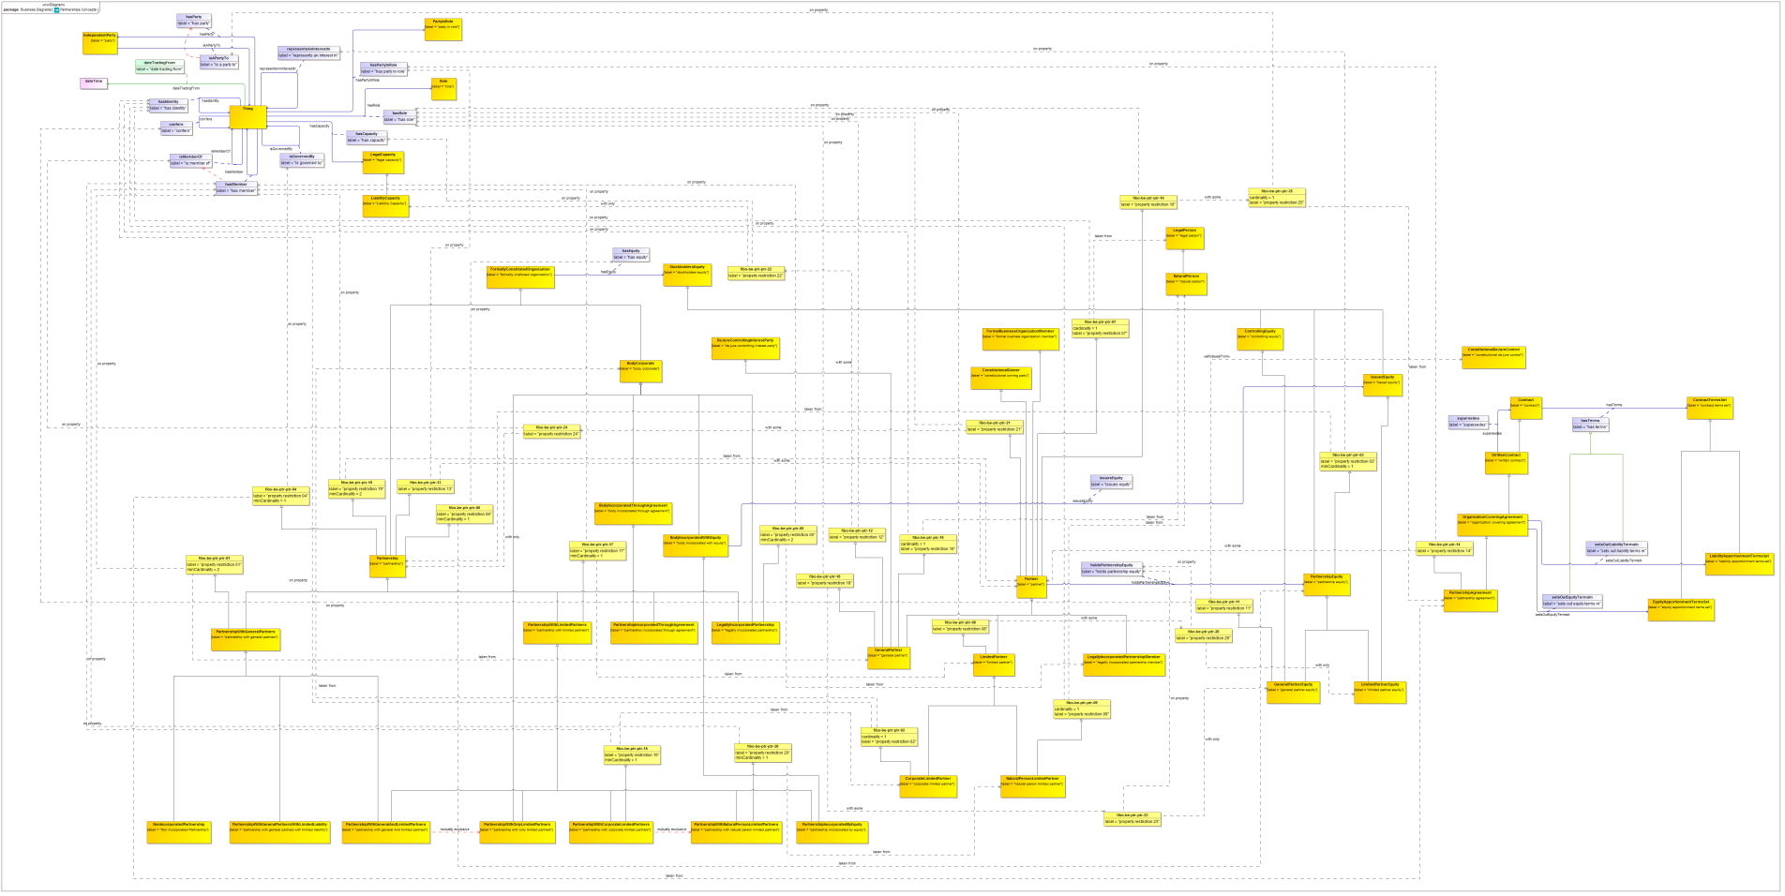

**Figure 9.4.1.3 Partnerships Ontology (full diagram)**

This shows the completed ontology for Partnerships. Properties defined in this ontology and elsewhere are refined or re-used to frame the properties essential to Partnerships and their related concepts.

Table 9-15. Partnerships Details

| **Concept Type** | **Name** | **Type Of Thing** | **Property** | **Definition** | **Parent** | **Mutually Exclusive With** | **Related Thing or Type** | **Inverse Of Property** | **Multiples** | **Editorial Note** | **Explanatory Note** | **Term Origin** | **Definition Source** |
| --- | --- | --- | --- | --- | --- | --- | --- | --- | --- | --- | --- | --- | --- |
| Simple Property | dateTradingFrom | Anything | date trading from | date on which the partnership started trading |  |  | xsd:dateTime |  |  |  |  |  |  |
| Relationship Property | setsOutEquityTermsIn | organization covering agreement | sets out equity terms in | has terms setting out the apportionment of equity in some formal business organization | has terms |  | equity apportionment terms set |  |  |  |  |  |  |
| Relationship Property | setsOutLiabilityTermsIn | organization covering agreement | sets out liability terms in | has terms setting out the apportionment of liabilities for debts or other liabilities accrued by some formal business organization | has terms |  | liability apportionment terms set |  |  |  |  |  |  |
| **Class** | **CorporateLimitedPartner** | **corporate limited partner** |  | A limited partner in a partnership, who is and may only be a Corporate Legal Person (i.e., not a natural person) | property restriction 02 limited partner |  |  |  |  |  |  |  |  |
| **Class** | **EquityApportionmentTermsSet** | **equity apportionment terms set** |  | Terms setting out the apportionment of equity in some formal business organization. | contract terms set |  |  |  |  |  |  |  |  |
| **Class** | **GeneralPartnerEquity** | **general partner equity** |  | Equity in a partnership held by general partners; this is typically accompanied by full liability capability on the part of the holders of the equity. | controlling equity property restriction 11 partnership equity |  |  |  |  | For a typical, non incorporated partnership, this is the only equity in the entity. Other typically incorporated partnerships may have additional limited equity in addition to or instead of this. |  |  |  |
| **Class** | **GeneralPartner** | **general partner** |  | a partner in a partnership, who holds some part of the general partner equity and typically is jointly and severally liable with the other partners for the liabilities incurred by that partnership | property restriction 10 property restriction 12 partner de jure controlling interest party property restriction 18 |  |  |  |  |  |  |  |  |
| **Class** | **LegallyIncorporatedPartnershipMember** | **legally incorporated partnership member** |  | A party which is a member or partner in a Legally Incorporated Partnership such as an LLC or LLP. | partner |  |  |  |  |  |  |  |  |
| **Class** | **LegallyIncorporatedPartnership** | **legally incorporated partnership** |  | Any partnership which is defined as a legal person within a given jurisdiction, for example a limited liability partnership (if that is a legal person). | property restriction 05 body corporate partnership |  |  |  |  | The precise details and definition of these may vary from one jurisdiction to another. This type of entity is defined by being a legal person in its own right, as distinct from the usual type of partnership where the partners remain jointly and severally liable for debts. |  |  |  |
| **Class** | **LiabilityApportionmentTermsSet** | **liability apportionment terms set** |  | Terms setting out the apportionment of liabilities for debts or other liabilities accrued by some formal business organization. | contract terms set |  |  |  |  |  |  |  |  |
| **Class** | **LimitedPartnerEquity** | **limited partner equity** |  | equity in a partnership held by limited partners; this is not accompanied by any liability capability on the part of the holders of this equity. | partnership equity issued equity |  |  |  |  |  |  |  |  |
| **Class** | **LimitedPartner** | **limited partner** |  | A partner in a partnership whose liabilities are limited to the extent of their equity holding or guarantees | property restriction 08 partner |  |  |  |  |  |  |  |  |
| **Class** | **NaturalPersonLimitedPartner** | **natural person limited partner** |  | A limited partner in a partnership, who is and may only be a Natural Person i.e. a human being. | property restriction 09 limited partner |  |  |  |  |  |  |  |  |
| **Class** | **NonIncorporatedPartnership** | **Non Incorporated Partnership** |  | A partnership in the usual sense of the term, that is a partnership in which the partners are jointly and severally liable for liabilities incurred by the entity. | partnership with general partners |  |  |  |  |  |  |  |  |
| **Class** | **Partner** | **partner** |  | Individual who is a member of a partnership. | property restriction 07 formal business organization member property restriction 16 constitutional owning party property restriction 21 |  |  |  |  |  |  |  | http://www.investorwords.com/3608/partner.html |
| Relationship Property | holdsPartnershipEquity | partner | holds partnership equity | the equity held by the partner in the partnership | owns |  | partnership equity |  |  |  |  |  |  |
| **Class** | **PartnershipAgreement** | **partnership agreement** |  | a document setting up a partnership, giving the details of the business and the amount each partner is contributing to it. | property restriction 14 organization covering agreement |  |  |  |  |  |  |  | http://www.investorguide.com/definition/partnership-agreement.html |
| **Class** | **PartnershipEquity** | **partnership equity** |  | Equity in some Partnership. | property restriction 03 stockholders equity |  |  |  |  |  |  |  |  |
| **Class** | **PartnershipIncorporatedByEquity** | **partnership incorporated by equity** |  | partnership which is incorporated by the issuance of equity | body incorporated with equity partnership with limited partners |  |  |  |  |  |  |  |  |
| **Class** | **PartnershipIncorporatedThroughAgreement** | **partnership incorporated through agreement** |  | a partnership which has legal personhood, but for which there is not some issuance of limited partner equity | partnership body incorporated through agreement |  |  |  |  | An LLP (in the UK) is an example of this - in this case, the LLP document is the legal document which effectively constitutes the partnership |  |  |  |
| **Class** | **PartnershipWithCorporateLimitedPartners** | **partnership with corporate limited partners** |  | A partnership with limited partners (partners whose liability is limited) and where those partners are necessarily non natural persons (i.e. cannot be individuals). | partnership with limited partners property restriction 15 | partnership with natural person limited partners |  |  |  |  |  |  |  |
| **Class** | **PartnershipWithGeneralAndLimitedPartners** | **partnership with general And limited partners** |  | A partnership having both limited partners and general partners. | partnership with limited partners partnership with general partners | partnership with only limited partners |  |  |  |  |  |  |  |
| **Class** | **PartnershipWithGeneralPartnersWithLimitedLiability** | **partnership with general partners with limited liability** |  | A partnership that has general partners, but where those general partners have limited liability. | partnership with general partners |  |  |  |  |  |  |  |  |
| **Class** | **PartnershipWithGeneralPartners** | **partnership with general partners** |  | A partnership which has two or more General Partners. | property restriction 01 partnership |  |  |  |  | The partnership may or may not also have Limited Partners. In a typical non incorporated partnership, it does not. General Partners of a partnership must be natural persons. |  |  |  |
| **Class** | **PartnershipWithLimitedPartners** | **partnership with limited partners** |  | A partnership having Limited Partners, that is partners whose liabilities are limited to the extent of their equity or guarantees. | partnership property restriction 17 |  |  |  |  | Possibly but not necessarily a Legal Person. If there are only Limited Partners then this is of necessity a Legal Person (no-one else has liability in this structure). |  |  |  |
| **Class** | **PartnershipWithNaturalPersonLimitedPartners** | **partnership with natural person limited partners** |  | A partnership with limited partners (partners whose liability is limited) and where those partners are necessarily natural persons (i.e. cannot be corporates). | partnership with limited partners property restriction 20 | partnership with corporate limited partners |  |  |  |  |  |  |  |
| **Class** | **PartnershipWithOnlyLimitedPartners** | **partnership with only limited partners** |  | A Partnership having limited partners but no general partners. | partnership with limited partners body corporate | partnership with general And limited partners |  |  |  |  |  |  |  |
| **Class** | **Partnership** | **partnership** |  | Venture in which two or more legal entities carry out some business activities under a common identity. | property restriction 04 property restriction 06 property restriction 13 formally cnstituted organization property restriction 19 |  |  |  |  | If the partnership doesn't limit the liability of the partners then the party to the contract is a natural person. If it does, then it's an artificial legal person (Body Corporate) - see Legally Incorporated Partnerships. Scope Note: This term of Partnership in the most general sense is ancestral to both of those. |  |  |  |
| Property Restriction | fibo-be-ptr-ptr-01 | property restriction 01 | has member | Set of things that have the property shown, in the multiples given, taken from the type of thing indicated. |  |  | general partner |  | min 2 |  |  |  |  |
| Property Restriction | fibo-be-ptr-ptr-02 | property restriction 02 | has identity | Set of things that have the property shown, in the multiples given, taken from the type of thing indicated. |  |  | body corporate |  | exactly 1 |  |  |  |  |
| Property Restriction | fibo-be-ptr-ptr-03 | property restriction 03 | represents an interest in | Set of things that have the property shown, in the multiples given, taken from the type of thing indicated. |  |  | partnership |  | min 1 |  |  |  |  |
| Property Restriction | fibo-be-ptr-ptr-04 | property restriction 04 | is governed by | Set of things that have the property shown, in the multiples given, taken from the type of thing indicated. |  |  | partnership agreement |  | min 1 |  |  |  |  |
| Property Restriction | fibo-be-ptr-ptr-05 | property restriction 05 | has member | Set of things that have the property shown, in the multiples given, taken from the type of thing indicated. |  |  | legally incorporated partnership member |  | min 2 |  |  |  |  |
| Property Restriction | fibo-be-ptr-ptr-06 | property restriction 06 | has equity | Set of things that have the property shown, in the multiples given, taken from the type of thing indicated. |  |  | partnership equity |  | min 1 |  |  |  |  |
| Property Restriction | fibo-be-ptr-ptr-07 | property restriction 07 | has identity | Set of things that have the property shown, in the multiples given, taken from the type of thing indicated. |  |  | legal person |  | exactly 1 |  |  |  |  |
| Property Restriction | fibo-be-ptr-ptr-08 | property restriction 08 | has role | Set of things with the property shown, where at least one participant in that relationship must be taken from the type of thing indicated. |  |  | property restriction 26 |  | must be some |  |  |  |  |
| Property Restriction | fibo-be-ptr-ptr-09 | property restriction 09 | has identity | Set of things that have the property shown, in the multiples given, taken from the type of thing indicated. |  |  | natural person |  | exactly 1 |  |  |  |  |
| Property Restriction | fibo-be-ptr-ptr-10 | property restriction 10 | has identity | Set of things that have the property shown, in the multiples given, taken from the type of thing indicated. |  |  | natural person |  | exactly 1 |  |  |  |  |
| Property Restriction | fibo-be-ptr-ptr-11 | property restriction 11 | confers | Set of things which, if they have the property shown, all participants in that relationship must be taken from the type of thing indicated. |  |  | constitutional de jure control |  | may only be |  |  |  |  |
| Property Restriction | fibo-be-ptr-ptr-12 | property restriction 12 | has role | Set of things with the property shown, where at least one participant in that relationship must be taken from the type of thing indicated. |  |  | property restriction 22 |  | must be some |  |  |  |  |
| Property Restriction | fibo-be-ptr-ptr-13 | property restriction 13 | has party in role | Set of things with the property shown, where at least one participant in that relationship must be taken from the type of thing indicated. |  |  | partner |  | must be some |  |  |  |  |
| Property Restriction | fibo-be-ptr-ptr-14 | property restriction 14 | has party in role | Set of things with the property shown, where at least one participant in that relationship must be taken from the type of thing indicated. |  |  | partner |  | must be some |  |  |  |  |
| Property Restriction | fibo-be-ptr-ptr-15 | property restriction 15 | has member | Set of things that have the property shown, in the multiples given, taken from the type of thing indicated. |  |  | corporate limited partner |  | min 1 |  |  |  |  |
| Property Restriction | fibo-be-ptr-ptr-16 | property restriction 16 | has role | Set of things with the property shown, where at least one participant in that relationship must be taken from the type of thing indicated. |  |  | property restriction 25 |  | must be some |  |  |  |  |
| Property Restriction | fibo-be-ptr-ptr-17 | property restriction 17 | has member | Set of things that have the property shown, in the multiples given, taken from the type of thing indicated. |  |  | limited partner |  | min 1 |  |  |  |  |
| Property Restriction | fibo-be-ptr-ptr-18 | property restriction 18 | has role | Set of things with the property shown, where at least one participant in that relationship must be taken from the type of thing indicated. |  |  | property restriction 23 |  | must be some |  |  |  |  |
| Property Restriction | fibo-be-ptr-ptr-19 | property restriction 19 | has member | Set of things that have the property shown, in the multiples given, taken from the type of thing indicated. |  |  | partner |  | min 2 |  |  |  |  |
| Property Restriction | fibo-be-ptr-ptr-20 | property restriction 20 | has member | Set of things that have the property shown, in the multiples given, taken from the type of thing indicated. |  |  | natural person limited partner |  | min 1 |  |  |  |  |
| Property Restriction | fibo-be-ptr-ptr-21 | property restriction 21 | has role | Set of things with the property shown, where at least one participant in that relationship must be taken from the type of thing indicated. |  |  | property restriction 24 |  | must be some |  |  |  |  |
| Property Restriction | fibo-be-ptr-ptr-22 | property restriction 22 | has capacity | Set of things which, if they have the property shown, all participants in that relationship must be taken from the type of thing indicated. |  |  | Liability Capacity |  | may only be |  |  |  |  |
| Property Restriction | fibo-be-ptr-ptr-23 | property restriction 23 | holds partnership equity | Set of things which, if they have the property shown, all participants in that relationship must be taken from the type of thing indicated. |  |  | general partner equity |  | may only be |  |  |  |  |
| Property Restriction | fibo-be-ptr-ptr-24 | property restriction 24 | is member of | Set of things which, if they have the property shown, all participants in that relationship must be taken from the type of thing indicated. |  |  | partnership |  | may only be |  |  |  |  |
| Property Restriction | fibo-be-ptr-ptr-25 | property restriction 25 | is a party to | Set of things that have the property shown, in the multiples given, taken from the type of thing indicated. |  |  | partnership agreement |  | exactly 1 |  |  |  |  |
| Property Restriction | fibo-be-ptr-ptr-26 | property restriction 26 | holds partnership equity | Set of things which, if they have the property shown, all participants in that relationship must be taken from the type of thing indicated. |  |  | limited partner equity |  | may only be |  |  |  |  |

## 9.5 Module: Trusts

Table 9-16. Trusts Module Metadata

|  |  |
| --- | --- |
| **Metadata Term** | **Value** |
| **sm:moduleName** | Trusts |
| **sm:moduleAbbreviation** | FIBO-BE-TR |
| **sm:moduleVersion** | 1.0 |
| **sm:moduleAbstract** | This module contains ontologies which define types of trust and the facts about them. Trusts are defined as a kind of formally constituted organization with specific parties as set down in law for trusts (trustor, trustee and beneficiary), each of these being signatories to a trust agreement. Types of trusts include trusts as used for trust funds, which when modeled, will belong in this module.  It depends on and extends a number of the FIBO Foundations modules, particularly those describing formal organizations, ownership, and control relationships, and therefore on the ontologies that they depend on, either directly or indirectly. |

### 9.5.1 Ontology: Trusts

This ontology defines the fundamental common terms for trusts. Trusts are entities set up in terms of the applicable local statutes governing trusts, and have as a minimum three specific, defined parties, known in many jurisdictions as trustor (sometimes sponsor), trustee and beneficiary. The terms in this ontology may be extended as necessary to represent specific types of trust, for example in the funds arena.

Table 9-17. Trusts Ontology Metadata

|  |  |
| --- | --- |
| **Metadata Term** | **Value** |
| **sm:filename** | Trusts Ontology |
| **sm:fileAbbreviation** | fibo-be-tr-tr |
| **OntologyIRI** | [http://www.omg.org/spec/EDMC-FIBO/BE/Trusts/Trusts/](http://www.omg.org/spec/EDMC-FIBO/BE/20131101/Trusts/Trusts/) |
| **owl:versionIRI** | <http://www.omg.org/spec/EDMC-FIBO/BE/20131101/Trusts/Trusts/> |
| **sm:dependsOn** | http://www.omg.org/spec/EDMC-FIBO/BE/LegalEntities/LegalPersons/  http://www.omg.org/spec/EDMC-FIBO/BE/LegalEntities/FormalBusinessOrganizations/  http://www.omg.org/spec/EDMC-FIBO/BE/LegalEntities/CorporateBodies/  http://www.omg.org/spec/EDMC-FIBO/BE/LegalEntities/LEIEntities/  http://www.omg.org/spec/EDMC-FIBO/BE/OwnershipAndControl/OwnershipParties/ |

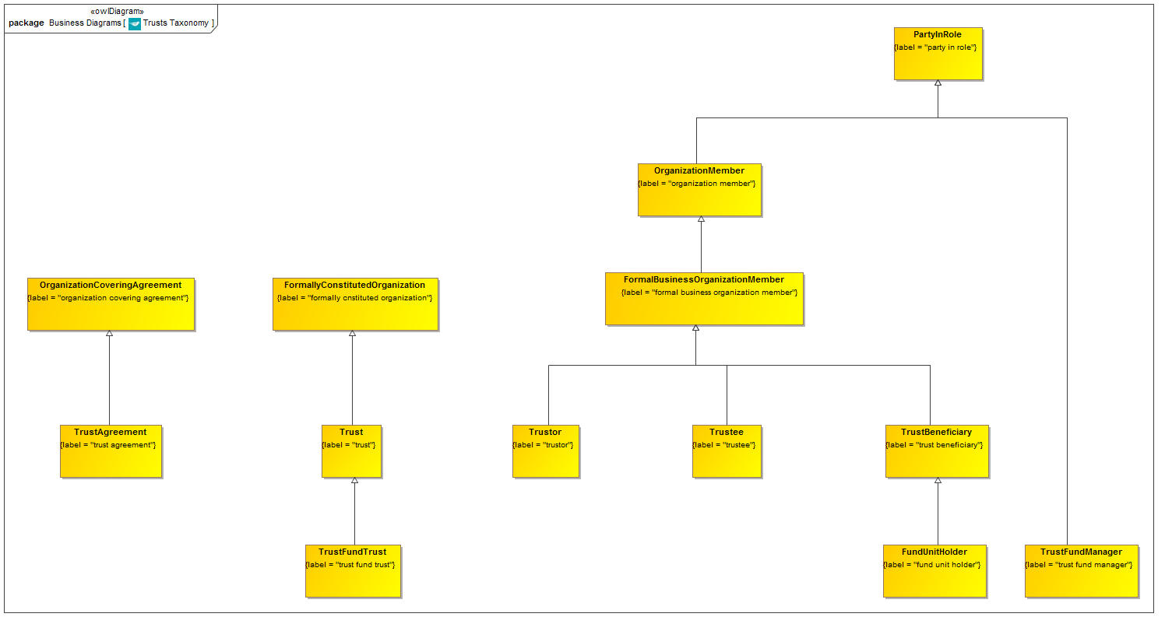

**Figure 9.5.1.1 Trusts Taxonomy**

This is the taxonomy of classes of “Thing” in the Trusts ontology along with the more general concepts of which they are a specialization.

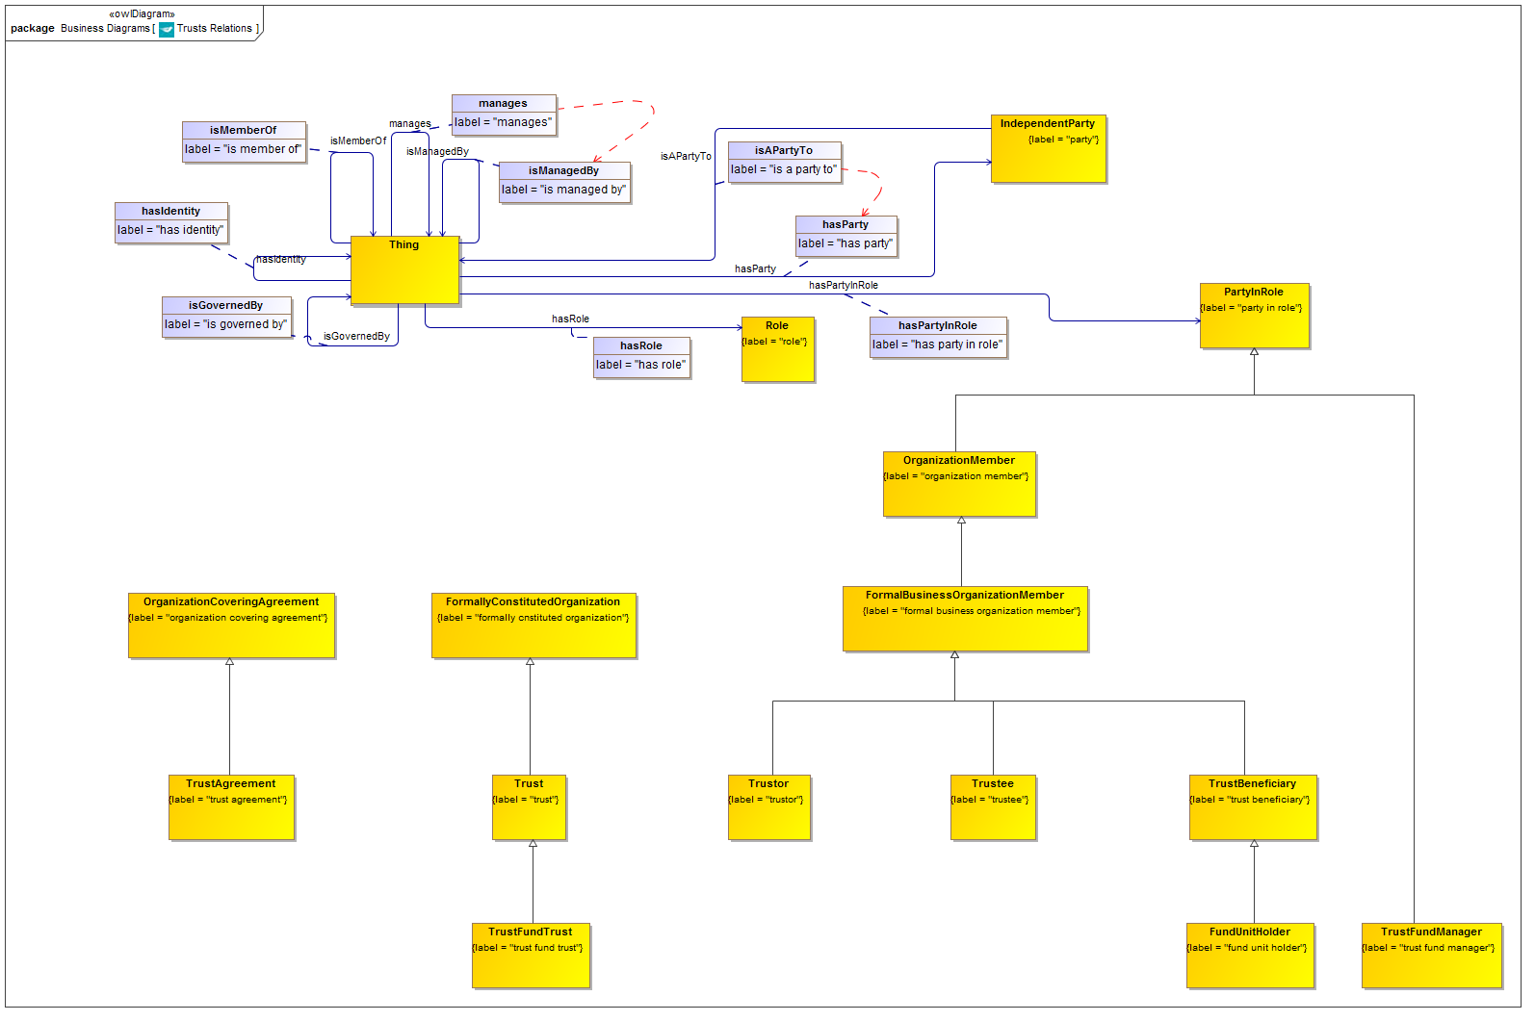

**Figure 9.5.1.2 Trusts with Relationship Properties**

Properties in from elsewhere in these ontologies, which are refined and reused by property restrictions, as shown in the complete diagram which follows. There are no new relationships introduced in this ontology.

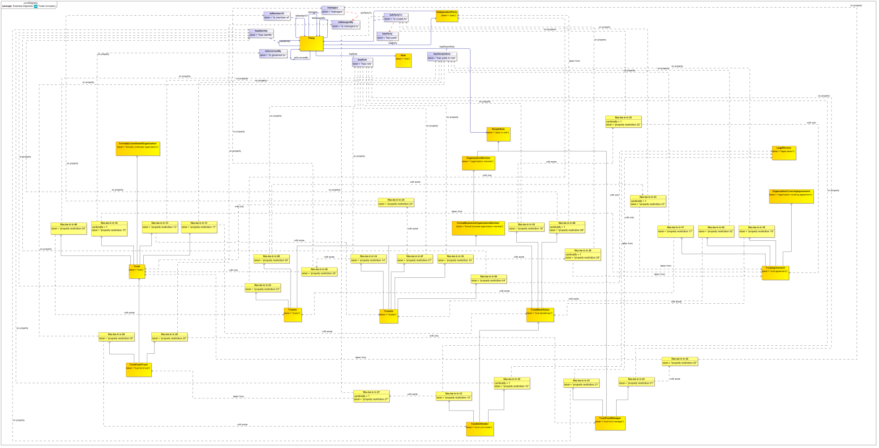

**Figure 9.5.1.3 Trusts Ontology (full diagram)**

This shows the completed ontology for Trusts. Properties defined in this ontology and elsewhere are refined or re-used to frame the properties essential to Trusts and their related concepts.

Table 9-18. Trusts Details

| **Concept Type** | **Name** | **Type Of Thing** | **Property** | **Definition** | **Parent** | **Mutually Exclusive With** | **Related Thing or Type** | **Inverse Of Property** | **Multiples** | **Editorial Note** | **Explanatory Note** | **Term Origin** | **Definition Source** |
| --- | --- | --- | --- | --- | --- | --- | --- | --- | --- | --- | --- | --- | --- |
| **Class** | **FundUnitHolder** | **fund unit holder** |  | A party which holds some unit in a fund | property restriction 10 trust beneficiary property restriction 12 |  |  |  |  |  |  |  |  |
| **Class** | **TrustAgreement** | **trust agreement** |  | Formal agreement through which a trustor vests the ownership rights (title) to one or more assets to one or more trustees for conservation and protection on behalf of one or more beneficiaries of the trust. It normally states the (1) purpose for which the trust was established and fulfillment of which will terminate the trust, (2) details of the assets placed in the trust, (3) powers and limitations of the trustees, their reporting requirements, and other associated provisions, and (4) may also specify the trustees' compensation, if any. A trust agreement involving real estate requires its exact description and the trustor's express, written consent to create the trust to be valid. A will admitted to probate may also act like a trust agreement. | property restriction 02 organization covering agreement property restriction 17 property restriction 19 |  |  |  |  | See also Deed. These are distinct from Contracts in that they impose obligations but without necessarily reciprocating rights. |  |  | http://www.businessdictionary.com/definition/trust-agreement.html |
| **Class** | **TrustBeneficiary** | **trust beneficiary** |  | Person or organization for whose present or future interest (benefit) an annuity, assignment (such as a letter of credit), contract, insurance policy, judgment, promise, trust, will, etc., is made | property restriction 08 property restriction 18 formal business organization member |  |  |  |  |  |  |  | http://www.businessdictionary.com/definition/beneficiary.html |
| **Class** | **TrustFundManager** | **trust fund manager** |  | A trust fund manager acts on behalf of the Trustee to manage the assets of the Trust. | property restriction 01 party in role property restriction 21 |  |  |  |  |  |  |  |  |
| **Class** | **TrustFundTrust** | **trust fund trust** |  | A trust which forms the basis for a fund. | property restriction 05 trust property restriction 20 |  |  |  |  | The fund is identified as being a kind of Trust Fund. |  |  |  |
| **Class** | **Trust** | **trust** |  | A fiduciary relationship in which one party, known as a trustor, gives another party, the trustee, the right to hold title to property or assets for the benefit of a third party, the beneficiary. | property restriction 06 property restriction 11 property restriction 13 property restriction 15 formally cnstituted organization |  |  |  |  | This is a legal agreement between parties that someone owns, and is thereby an asset that they own. They can be taxed on this as any other asset. There are generally accepted things such as the source of funds that will determine who the revenue agency will go after. Definition reference URL: http://www.investopedia.com/terms/t/trust.asp |  |  |  |
| **Class** | **Trustee** | **trustee** |  | An individual or organization which holds or manages and invests assets for the benefit of another. The trustee is legally obliged to make all trust-related decisions with the beneficiary's interests in mind, and may be liable for damages in the event of not doing so. Trustees may be entitled to a payment for their services, if specified in the trust deed. In the specific case of the bond market, a trustee administers a bond issue for a borrower, and ensures that the issuer meets all the terms and conditions associated with the borrowing. | property restriction 04 property restriction 07 property restriction 14 property restriction 16 formal business organization member |  |  |  |  |  |  |  | http://www.investorwords.com/5086/trustee.html |
| **Class** | **Trustor** | **trustor** |  | Entity that establishes a trust and place property under the protection and management of one or more trustees for the immediate or eventual benefit of ascertainable one or more beneficiaries. It is not always necessary to identify the trustor who may be also be a trustee and/or one of the beneficiaries. In legal parlance, a trustor is called a settlor in the UK and a grantor in the US, whereas in common usage he or she may also be called a creator, donor, initiator, owner, or Trust maker. | property restriction 03 formal business organization member property restriction 09 |  |  |  |  |  |  |  | http://www.businessdictionary.com/definition/trustor.html |
| Property Restriction | fibo-be-tr-tr-01 | property restriction 01 | has role | Set of things with the property shown, where at least one participant in that relationship must be taken from the type of thing indicated. |  |  | property restriction 25 |  | must be some |  |  |  |  |
| Property Restriction | fibo-be-tr-tr-02 | property restriction 02 | has party in role | Set of things with the property shown, where at least one participant in that relationship must be taken from the type of thing indicated. |  |  | trustee |  | must be some |  |  |  |  |
| Property Restriction | fibo-be-tr-tr-03 | property restriction 03 | has identity | Set of things which, if they have the property shown, all participants in that relationship must be taken from the type of thing indicated. |  |  | party |  | may only be |  |  |  |  |
| Property Restriction | fibo-be-tr-tr-04 | property restriction 04 | has identity | Set of things which, if they have the property shown, all participants in that relationship must be taken from the type of thing indicated. |  |  | legal person |  | may only be |  |  |  |  |
| Property Restriction | fibo-be-tr-tr-05 | property restriction 05 | has party in role | Set of things with the property shown, where at least one participant in that relationship must be taken from the type of thing indicated. |  |  | fund unit holder |  | must be some |  |  |  |  |
| Property Restriction | fibo-be-tr-tr-06 | property restriction 06 | has party in role | Set of things with the property shown, where at least one participant in that relationship must be taken from the type of thing indicated. |  |  | trustor |  | must be some |  |  |  |  |
| Property Restriction | fibo-be-tr-tr-07 | property restriction 07 | has role | Set of things with the property shown, where at least one participant in that relationship must be taken from the type of thing indicated. |  |  | property restriction 24 |  | must be some |  |  |  |  |
| Property Restriction | fibo-be-tr-tr-08 | property restriction 08 | has identity | Set of things that have the property shown, in the multiples given, taken from the type of thing indicated. |  |  | party |  | exactly 1 |  |  |  |  |
| Property Restriction | fibo-be-tr-tr-09 | property restriction 09 | has role | Set of things with the property shown, where at least one participant in that relationship must be taken from the type of thing indicated. |  |  | property restriction 23 |  | must be some |  |  |  |  |
| Property Restriction | fibo-be-tr-tr-10 | property restriction 10 | has identity | Set of things that have the property shown, in the multiples given, taken from the type of thing indicated. |  |  | legal person |  | exactly 1 |  |  |  |  |
| Property Restriction | fibo-be-tr-tr-11 | property restriction 11 | has party in role | Set of things with the property shown, where at least one participant in that relationship must be taken from the type of thing indicated. |  |  | trust beneficiary |  | must be some |  |  |  |  |
| Property Restriction | fibo-be-tr-tr-12 | property restriction 12 | has role | Set of things with the property shown, where at least one participant in that relationship must be taken from the type of thing indicated. |  |  | property restriction 27 |  | must be some |  |  |  |  |
| Property Restriction | fibo-be-tr-tr-13 | property restriction 13 | has party in role | Set of things with the property shown, where at least one participant in that relationship must be taken from the type of thing indicated. |  |  | trustee |  | must be some |  |  |  |  |
| Property Restriction | fibo-be-tr-tr-14 | property restriction 14 | has role | Set of things with the property shown, where at least one participant in that relationship must be taken from the type of thing indicated. |  |  | property restriction 26 |  | must be some |  |  |  |  |
| Property Restriction | fibo-be-tr-tr-15 | property restriction 15 | is governed by | Set of things that have the property shown, in the multiples given, taken from the type of thing indicated. |  |  | trust agreement |  | exactly 1 |  |  |  |  |
| Property Restriction | fibo-be-tr-tr-16 | property restriction 16 | has role | Set of things with the property shown, where at least one participant in that relationship must be taken from the type of thing indicated. |  |  | property restriction 28 |  | must be some |  |  |  |  |
| Property Restriction | fibo-be-tr-tr-17 | property restriction 17 | has party in role | Set of things with the property shown, where at least one participant in that relationship must be taken from the type of thing indicated. |  |  | trustor |  | must be some |  |  |  |  |
| Property Restriction | fibo-be-tr-tr-18 | property restriction 18 | has role | Set of things with the property shown, where at least one participant in that relationship must be taken from the type of thing indicated. |  |  | property restriction 22 |  | must be some |  |  |  |  |
| Property Restriction | fibo-be-tr-tr-19 | property restriction 19 | has party in role | Set of things with the property shown, where at least one participant in that relationship must be taken from the type of thing indicated. |  |  | trust beneficiary |  | must be some |  |  |  |  |
| Property Restriction | fibo-be-tr-tr-20 | property restriction 20 | is managed by | Set of things which, if they have the property shown, all participants in that relationship must be taken from the type of thing indicated. |  |  | trust fund manager |  | may only be |  |  |  |  |
| Property Restriction | fibo-be-tr-tr-21 | property restriction 21 | has identity | Set of things which, if they have the property shown, all participants in that relationship must be taken from the type of thing indicated. |  |  | legal person |  | may only be |  |  |  |  |
| Property Restriction | fibo-be-tr-tr-22 | property restriction 22 | is a party to | Set of things that have the property shown, in the multiples given, taken from the type of thing indicated. |  |  | trust agreement |  | exactly 1 |  |  |  |  |
| Property Restriction | fibo-be-tr-tr-23 | property restriction 23 | is a party to | Set of things that have the property shown, in the multiples given, taken from the type of thing indicated. |  |  | trust agreement |  | exactly 1 |  |  |  |  |
| Property Restriction | fibo-be-tr-tr-24 | property restriction 24 | is member of | Set of things which, if they have the property shown, all participants in that relationship must be taken from the type of thing indicated. |  |  | trust |  | may only be |  |  |  |  |
| Property Restriction | fibo-be-tr-tr-25 | property restriction 25 | manages |  |  |  | trust |  | undefined |  |  |  |  |
| Property Restriction | fibo-be-tr-tr-26 | property restriction 26 | manages | Set of things which, if they have the property shown, all participants in that relationship must be taken from the type of thing indicated. |  |  | trust |  | may only be |  |  |  |  |
| Property Restriction | fibo-be-tr-tr-27 | property restriction 27 | is a party to | Set of things that have the property shown, in the multiples given, taken from the type of thing indicated. |  |  | trust fund trust |  | exactly 1 |  |  |  |  |
| Property Restriction | fibo-be-tr-tr-28 | property restriction 28 | is a party to | Set of things that have the property shown, in the multiples given, taken from the type of thing indicated. |  |  | trust agreement |  | exactly 1 |  |  |  |  |

## 9.6. Module: Ownership and Control

Table 9-19. Ownership and Control Module Metadata

|  |  |
| --- | --- |
| **Metadata Term** | **Value** |
| **sm:moduleName** | Ownership and Control |
| **sm:moduleAbbreviation** | FIBO-BE-OAC |
| **sm:moduleVersion** | 1.0 |
| **sm:moduleAbstract** | This module contains ontologies that define various types and aspects of ownership and control as they apply among and between business entities. The ontologies in this module include the definition of types of party as defined in the roles of ownership and control along with the capacities which define those parties, and separately the relationships of ownership and control directly between organizations, which arise from the existence of those roles. Specific types of ownership and control relationships that are unique to incorporated companies are defined in addition to the more general terms to which these relate. Also included is an ontology of the types of control relationships that exist by virtue of the powers conferred upon corporate officers, board members and other executive roles. |

### 9.6.1 Ontology: Ownership Parties

This ontology defines concepts relating to types of organization owning parties. The concepts defined here are party in role concepts, which define the nature of some entity such as an organization or a legal person, in some role such as that of owning equity in the entity. These roles are defined in terms of the ownership enjoyed by the party, with distinctions between constitutional ownership i.e. ownership defined in terms of stockholder equity, and investment ownership more generally.

Table 9-20. Ownership Parties Ontology Metadata

|  |  |
| --- | --- |
| **Metadata Term** | **Value** |
| **sm:filename** | Ownership Parties Ontology |
| **sm:fileAbbreviation** | fibo-be-oac-opty |
| **OntologyIRI** | [http://www.omg.org/spec/EDMC-FIBO/BE/OwnershipAndControl/OwnershipParties/](http://www.omg.org/spec/EDMC-FIBO/BE/20131101/OwnershipAndControl/OwnershipParties/) |
| **owl:versionIRI** | <http://www.omg.org/spec/EDMC-FIBO/BE/20131101/OwnershipAndControl/OwnershipParties/> |
| **sm:dependsOn** | http://www.omg.org/spec/EDMC-FIBO/BE/LegalEntities/LegalPersons/  http://www.omg.org/spec/EDMC-FIBO/BE/LegalEntities/FormalBusinessOrganizations/  http://www.omg.org/spec/EDMC-FIBO/BE/LegalEntities/CorporateBodies/  http://www.omg.org/spec/EDMC-FIBO/BE/LegalEntities/LEIEntities/ |

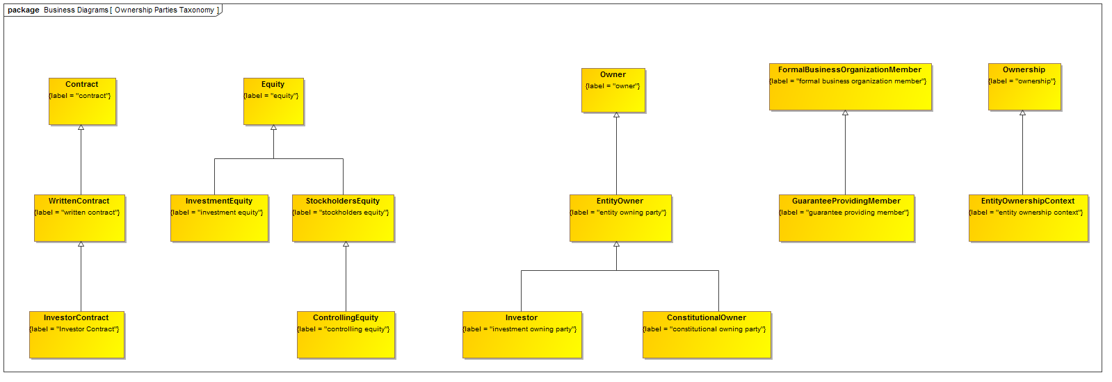

**Figure 9.6.1.1 Ownership Parties Taxonomy**

This is the taxonomy of classes of “Thing” in the Ownership Parties ontology along with the more general concepts of which they are a specialization.

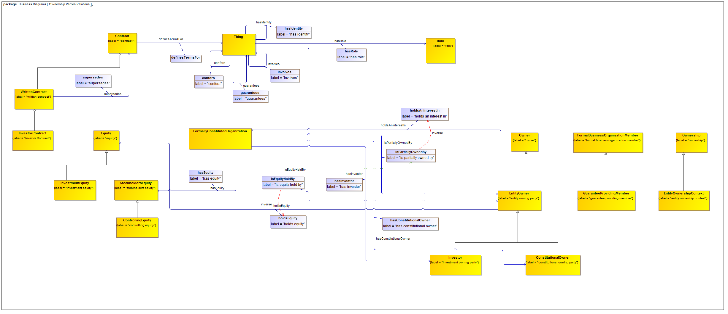

**Figure 9.6.1.2 Ownership Parties with Relationship Properties**

Properties in this ontology and elsewhere which are refined and reused by property restrictions, as shown in the complete diagram which follows.

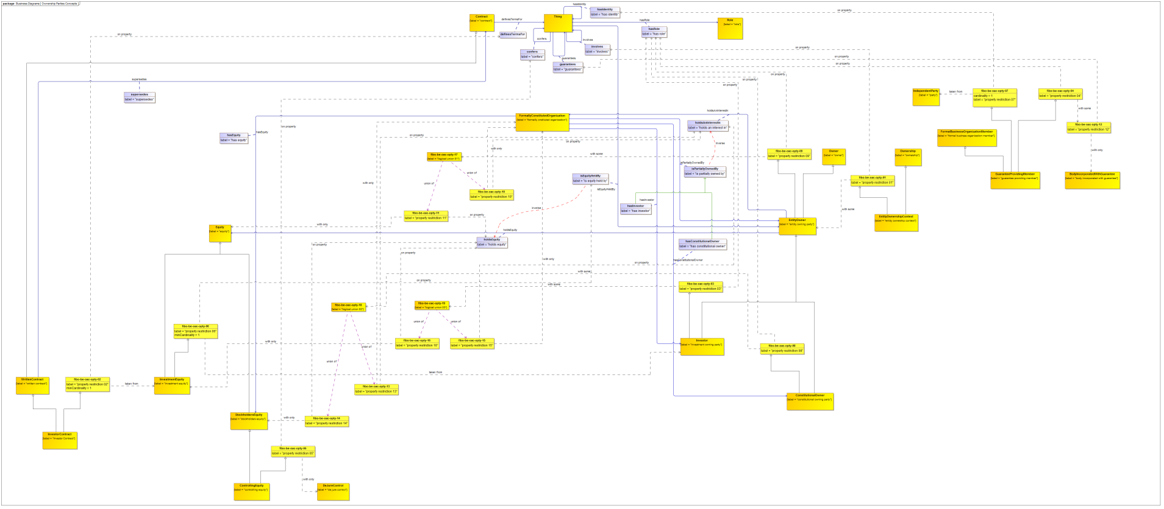

**Figure 9.6.1.3 Ownership Parties Ontology (full diagram)**

This shows the completed ontology for Ownership Parties. Properties defined in this ontology and elsewhere are refined or re-used to frame the properties essential to Ownership Parties and their related concepts.

Table 9-21. Ownership Parties Details

| **Concept Type** | **Name** | **Type Of Thing** | **Property** | **Definition** | **Parent** | **Mutually Exclusive With** | **Related Thing or Type** | **Inverse Of Property** | **Multiples** | **Editorial Note** | **Explanatory Note** | **Term Origin** | **Definition Source** |
| --- | --- | --- | --- | --- | --- | --- | --- | --- | --- | --- | --- | --- | --- |
| Relationship Property | guarantees | Anything | guarantees | provide a formal assurance or promise, esp. that certain conditions shall be fulfilled relating to a product, service, or transaction |  |  |  |  |  |  |  |  |  |
| Relationship Property | hasConstitutionalOwner | Anything | has constitutional owner | links a constitutional interest/position in something (e.g., a formal business organization) to the party that holds or owns it, in whole or in part | is partially owned by |  | constitutional owning party |  |  |  |  |  |  |
| Relationship Property | hasInvestor | Anything | has investor | links an investment interest in something (e.g., a formal business organization) to the party that holds or owns it, in whole or in part | is partially owned by |  | investment owning party |  |  |  |  |  |  |
| Relationship Property | isEquityHeldBy | Anything | is equity held by | links some equity to the party that holds it | is owned by |  | entity owning party | holds equity |  |  |  |  |  |
| Relationship Property | isPartiallyOwnedBy | Anything | is partially owned by | links an interest/position in something (e.g, a formal business organization) to the party that holds or owns it, in whole or in part | is owned by |  | entity owning party | holds an interest in |  |  |  |  |  |
| **Class** | **ConstitutionalOwner** | **constitutional owning party** |  | A party which owns some equity stake in some entity, which is some part of the formal equity make-up of that entity, such as shares or general partner equity. Some party which has some degree of ownership in the organization, that ownership being reflected in some formal part of the constitutive documentation of the organization. | entity owning party property restriction 08 |  |  |  |  | Typically this would be share ownership or the holding of partnership equity. Ownership in this "constitutional" sense means that the owner is in some way a member of the organization, as distinct from some outside investor. |  |  |  |
| **Class** | **ControllingEquity** | **controlling equity** |  | Equity which brings with it some form of de jure control over the entity in which it represents an interest. | stockholders equity property restriction 05 |  |  |  |  |  |  |  |  |
| **Class** | **EntityOwnershipContext** | **entity ownership context** |  | the context of ownership by some party of an interest in some formal organization. | property restriction 01 ownership |  |  |  |  |  |  |  |  |
| **Class** | **EntityOwner** | **entity owning party** |  | A party having some ownership in some entity. | owner property restriction 09 |  |  |  |  | This is not the same meaning as being some owner of some asset. Rather, this is some party which partakes in the ownership of some kind of entity (a business entity or a legal entity for example) via some mechanism such as the ownership of equity in that entity. |  |  |  |
| Relationship Property | holdsAnInterestIn | entity owning party | holds an interest in | links a party to some organization it holds an interest in | owns |  | formally cnstituted organization | is partially owned by |  |  |  |  |  |
| Relationship Property | holdsEquity | entity owning party | holds equity | links a party to some equity it holds | owns |  | equity | is equity held by |  |  |  |  |  |
| **Class** | **GuaranteeProvidingMember** | **guarantee providing member** |  | An entity which has issued some Guarantee for a body incorporated by the issuance of Guarantees. | property restriction 04 property restriction 07 formal business organization member |  |  |  |  | This can be any contractually capable entity. |  |  |  |
| **Class** | **InvestmentEquity** | **investment equity** |  | Equity which represents investment in some entity, but may or may not take the form of stockholders equity. | equity property restriction 06 |  |  |  |  | Typically an investment in some entity may take the form of shares (issued or privately held), stockholders equity (e.g., partnership equity), or it may take the form of some capital amount which is not reflected in stockholders equity. In each case, there would typically be a contractual basis for the investment setting out what controls or other benefits accrue to the investor. |  |  |  |
| **Class** | **Investor** | **investment owning party** |  | A party which owns some stake in some organization by way of investment. | entity owning party property restriction 03 |  |  |  |  | This is regardless of whether or not the investor is also a constitutional owner (e.g. shareholder) in the entity. |  |  |  |
| **Class** | **InvestorContract** | **Investor Contract** |  | Contract setting out the terms under which some investor invests in the entity and setting out the rights which are conferred on that investor. | written contract property restriction 02 |  |  |  |  |  |  |  |  |
| Logical Union | fibo-be-oac-opty-17 | logical union 01 | union of | Logical union of the types of thing identified in the column "Related Thing or Type". |  |  | property restriction 10 property restriction 11 |  |  |  |  |  |  |
| Logical Union | fibo-be-oac-opty-18 | logical union 02 | union of | Logical union of the types of thing identified in the column "Related Thing or Type". |  |  | property restriction 13 property restriction 14 |  |  |  |  |  |  |
| Logical Union | fibo-be-oac-opty-19 | logical union 03 | union of | Logical union of the types of thing identified in the column "Related Thing or Type". |  |  | property restriction 15 property restriction 16 |  |  |  |  |  |  |
| Property Restriction | fibo-be-oac-opty-01 | property restriction 01 | involves | Set of things with the property shown, where at least one participant in that relationship must be taken from the type of thing indicated. |  |  | entity owning party |  | must be some |  |  |  |  |
| Property Restriction | fibo-be-oac-opty-02 | property restriction 02 | definesTermsFor | Set of things that have the property shown, in the multiples given, taken from the type of thing indicated. |  |  | investment equity |  | min 1 |  |  |  |  |
| Property Restriction | fibo-be-oac-opty-03 | property restriction 03 | has role | Set of things with the property shown, where at least one participant in that relationship must be taken from the type of thing indicated. |  |  | logical union 03 |  | must be some |  |  |  |  |
| Property Restriction | fibo-be-oac-opty-04 | property restriction 04 | has role | Set of things with the property shown, where at least one participant in that relationship must be taken from the type of thing indicated. |  |  | property restriction 12 |  | must be some |  |  |  |  |
| Property Restriction | fibo-be-oac-opty-05 | property restriction 05 | confers | Set of things which, if they have the property shown, all participants in that relationship must be taken from the type of thing indicated. |  |  | de jure control |  | may only be |  |  |  |  |
| Property Restriction | fibo-be-oac-opty-06 | property restriction 06 | is equity held by | Set of things that have the property shown, in the multiples given, taken from the type of thing indicated. |  |  | investment owning party |  | min 1 |  |  |  |  |
| Property Restriction | fibo-be-oac-opty-07 | property restriction 07 | has identity | Set of things that have the property shown, in the multiples given, taken from the type of thing indicated. |  |  | party |  | exactly 1 |  |  |  |  |
| Property Restriction | fibo-be-oac-opty-08 | property restriction 08 | has role | Set of things with the property shown, where at least one participant in that relationship must be taken from the type of thing indicated. |  |  | logical union 02 |  | must be some |  |  |  |  |
| Property Restriction | fibo-be-oac-opty-09 | property restriction 09 | has role | Set of things with the property shown, where at least one participant in that relationship must be taken from the type of thing indicated. |  |  | logical union 01 |  | must be some |  |  |  |  |
| Property Restriction | fibo-be-oac-opty-10 | property restriction 10 | holds an interest in | Set of things which, if they have the property shown, all participants in that relationship must be taken from the type of thing indicated. |  |  | formally constituted organization |  | may only be |  |  |  |  |
| Property Restriction | fibo-be-oac-opty-11 | property restriction 11 | holds equity | Set of things which, if they have the property shown, all participants in that relationship must be taken from the type of thing indicated. |  |  | equity |  | may only be |  |  |  |  |
| Property Restriction | fibo-be-oac-opty-12 | property restriction 12 | guarantees | Set of things which, if they have the property shown, all participants in that relationship must be taken from the type of thing indicated. |  |  | body incorporated with guarantee |  | may only be |  |  |  |  |
| Property Restriction | fibo-be-oac-opty-13 | property restriction 13 | holds an interest in | Set of things which, if they have the property shown, all participants in that relationship must be taken from the type of thing indicated. |  |  | formally constituted organization |  | may only be |  |  |  |  |
| Property Restriction | fibo-be-oac-opty-14 | property restriction 14 | holds equity | Set of things which, if they have the property shown, all participants in that relationship must be taken from the type of thing indicated. |  |  | stockholders equity |  | may only be |  |  |  |  |
| Property Restriction | fibo-be-oac-opty-15 | property restriction 15 | holds an interest in | Set of things with the property shown, where at least one participant in that relationship must be taken from the type of thing indicated. |  |  | logical union 03 |  | must be some |  |  |  |  |
| Property Restriction | fibo-be-oac-opty-16 | property restriction 16 | holds equity | Set of things which, if they have the property shown, all participants in that relationship must be taken from the type of thing indicated. |  |  | investment equity |  | may only be |  |  |  |  |

### 9.6.2 Ontology: Control Parties

This ontology defines concepts relating to types of controlling parties. The concepts defined here are party in role concepts, which define the nature of some entity such as an organization or a legal person, in some role such as that of owning a controlling interest in the entity or of controlling that entity. These roles are defined in terms of the types of control enjoyed by the party, for example de facto or de jure control. An important feature of this ontology is the distinction between the holding of a controlling interest (such as voting shares), and the de facto existence of control of one body by another as asserted in company filings or as a conclusion drawn from computational analysis of controlling interests.

Table 9-22. Control Parties Ontology Metadata

|  |  |
| --- | --- |
| **Metadata Term** | **Value** |
| **sm:filename** | Control Parties Ontology |
| **sm:fileAbbreviation** | fibo-be-oac-cpty |
| **OntologyIRI** | [http://www.omg.org/spec/EDMC-FIBO/BE/OwnershipAndControl/ControlParties/](http://www.omg.org/spec/EDMC-FIBO/BE/20131101/OwnershipAndControl/ControlParties/) |
| **owl:versionIRI** | <http://www.omg.org/spec/EDMC-FIBO/BE/20131101/OwnershipAndControl/ControlParties/> |
| **sm:dependsOn** | http://www.omg.org/spec/EDMC-FIBO/BE/LegalEntities/LegalPersons/  http://www.omg.org/spec/EDMC-FIBO/BE/LegalEntities/FormalBusinessOrganizations/  http://www.omg.org/spec/EDMC-FIBO/BE/LegalEntities/CorporateBodies/  http://www.omg.org/spec/EDMC-FIBO/BE/LegalEntities/LEIEntities/  http://www.omg.org/spec/EDMC-FIBO/BE/OwnershipAndControl/OwnershipParties/ |

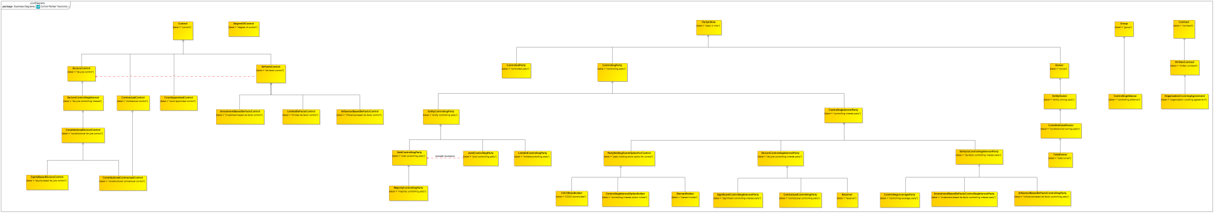

**Figure 9.6.2.1 Control Parties Taxonomy**

This is the taxonomy of classes of “Thing” in the Control Parties ontology along with the more general concepts of which they are a specialization.

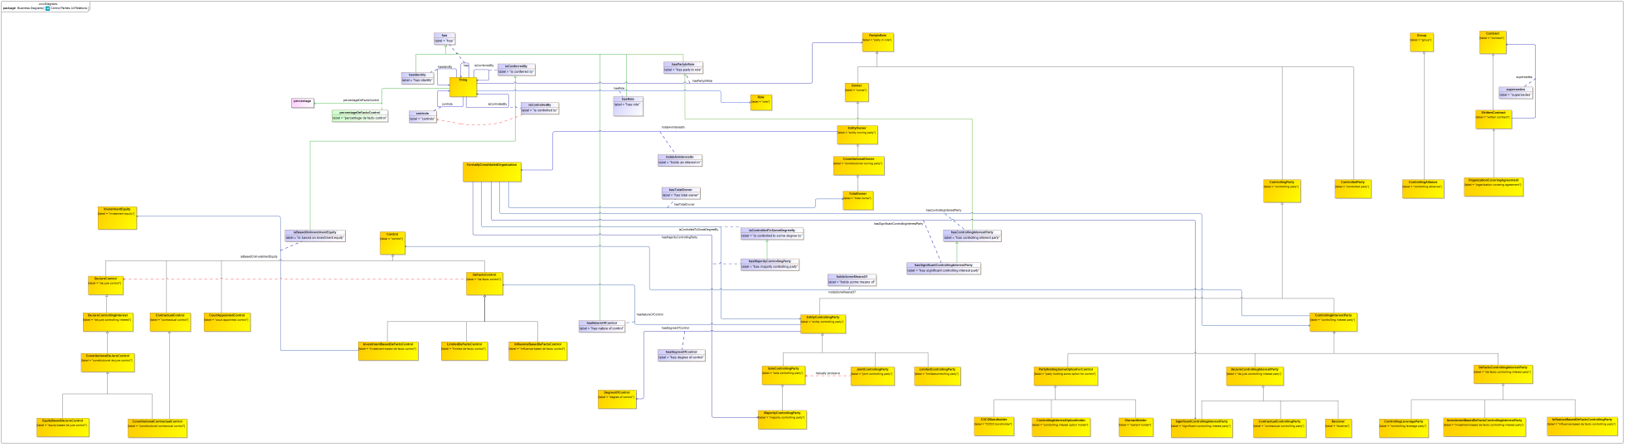

**Figure 9.6.2.2 Control Parties Relationship Properties – All Classes and Relations**

These properties are refined and reused by property restrictions, as shown in the complete diagram which follows.

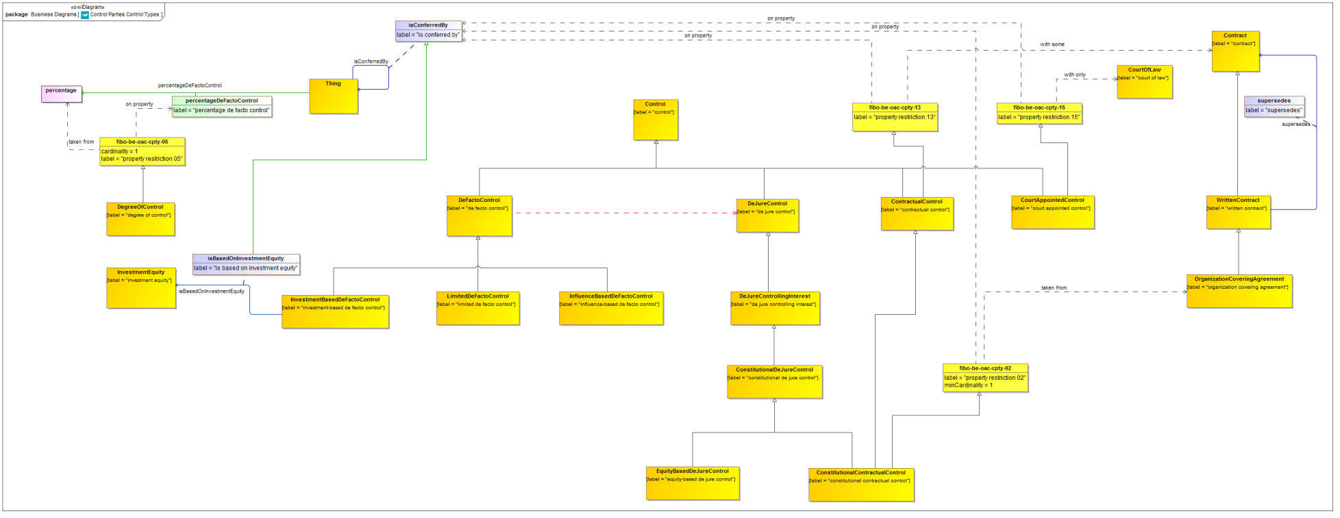

**Figure 9.6.2.3 Control Parties: Types of Control**

Partial view of the concepts in the Control Parties ontology, showing different types of control.

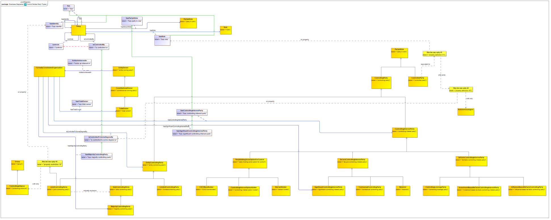

**Figure 9.6.2.4: Control Parties: Types of Party with Control**

Partial view of the concepts in the Control Parties ontology, showing types of party which are defined in terms of the types of control which they hold or are able to exercise.

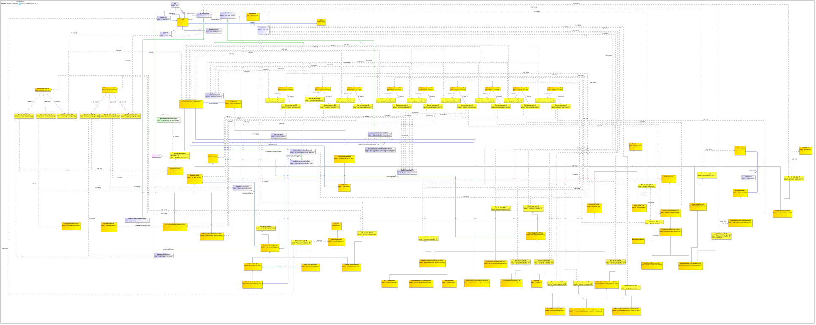

**Figure 9.6.2.5 Control Parties Ontology (full diagram)**

This shows the completed ontology for Control Parties. Properties defined in this ontology and elsewhere are refined or re-used to frame the properties essential to control parties and their related concepts.

Table 9-23. Control Parties Details

| **Concept Type** | **Name** | **Type Of Thing** | **Property** | **Definition** | **Parent** | **Mutually Exclusive With** | **Related Thing or Type** | **Inverse Of Property** | **Multiples** | **Editorial Note** | **Explanatory Note** | **Term Origin** | **Definition Source** |
| --- | --- | --- | --- | --- | --- | --- | --- | --- | --- | --- | --- | --- | --- |
| Simple Property | percentageDeFactoControl | Anything | percentage de facto control |  |  |  | percentage |  |  |  |  |  |  |
| **proxy** | **FormallyConstitutedOrganization** | **Formally Constituted Organization** |  | Proxy for the class, in order that properties or restrictions may be added locally. |  |  |  |  |  |  |  |  |  |
| Relationship Property | hasControllingInterestParty | Formally Constituted Organization | has controlling interest party | indicates an entity that has the ability to exercise some control over a formal business organization | has party in role |  | controlling interest party |  |  |  |  |  |  |
| Relationship Property | hasMajorityControllingParty | Formally Constituted Organization | has majority controlling party | The parent of the company, if there is one. | is controlled to some degree by |  | majority controlling party |  |  | This is usually (but not necessarily) any entity which owns a controlling stake (50 percent plus one voting share or above, or equivalent) in this company, if it is a limited company. |  |  |  |
| Relationship Property | hasSignificantControllingInterestParty | Formally Constituted Organization | has significant controlling interest party | identifies an entity that owns a significant percentage of the equity in this company, but less than 50 percent | has controlling interest party |  | significant controlling interest party |  |  | This is a relationship for any ownership between a lower threshold (defined in AML regulations locally) and 50 percent. It is the inverse of the Affiliate (AKA Associate) relationship. |  |  |  |
| Relationship Property | hasTotalOwner | Formally Constituted Organization | has total owner | indicates the party that wholly controls the organization, i.e., one that owns 100 percent interest | has constitutional owner |  | total owner |  |  | This may be any entity which is capable of exercising ownership. Scope Note: By virtue of holding 100 percent of the equity ownership, the Total Owner also holds 100 percent of the controlling equity, if there is a difference. Therefore it is both a total owner and a total controlling party. For this reason it is included among the control relationships and is a specialization of the has majority controlling party relationships. |  |  |  |
| Relationship Property | isControlledToSomeDegreeBy | Formally Constituted Organization | is controlled to some degree by | identifies a party that has some degree of control over a formal business organization | is controlled by |  | entity controlling party |  |  | Control by this type of party is either asserted to be the case by the entity itself or some other party, or is determined through some analysis or calculation based on the available information about controlling interests. |  |  |  |
| **Class** | **COCOBondholder** | **COCO bondholder** |  | Holder of bank bonds which convert to equity holdings in a bank. | party holding some option for control |  |  |  |  | These equity holdings, when they exist, will confer upon the holder some de jure controlling interest in the issuing entity. |  |  |  |
| **Class** | **ConstitutionalContractualControl** | **constitutional contractual control** |  | Some control set out in some contract among the principals of an organization. | contractual control property restriction 02 constitutional de jure control |  |  |  |  | This distinguishes this control from control conferred by contracts with third parties, for example in relation to third party guarantees or similar. This combines all forms of constitutional control in one set of terms under Constitutional De Jure Control. |  |  |  |
| **Class** | **ConstitutionalDeJureControl** | **constitutional de jure control** |  | Control which is based in some instrument which has constitutional standing (is constitutive of the entity) such as voting shares, general partner equity etc. | de jure controlling interest |  |  |  |  |  |  |  |  |
| **Class** | **ContractualControl** | **contractual control** |  | Control vested in an entity by virtue of the terms in some contract between that entity and others. | property restriction 13 control |  |  |  |  | See SME REview note of 16 Jan 2013: Percentage mechanism (in contracts etc.) would be factored in. Hence percentages as contractual terms. For instance an option to exercise which would give another 5 percent control. So there is percentage control with or without share ownership. Example: In a partnership this might be in the Partnership Agreement, which would identify beneficial ownership and control as potentially 2 distinct things. Contract can say anything. Implications: This means that there are percentages of de jure control based in contract, similar to those based in constitutional instruments (shares, General Partner equity). The concepts of Parent, Siinificant Part Owner etc. can then potentially be defined int erms of the percentages of all applicable instruments by which control may be formally defined. |  |  |  |
| **Class** | **ContractualControllingParty** | **contractual controlling party** |  | A party which exercises some control which is set out in some contract. | property restriction 04 de jure controlling interest party |  |  |  |  | This is as distinct from control set out in some constitutional instrument e.g. voting shares ownership or general partner equity. |  |  |  |
| **Class** | **ControlledParty** | **controlled party** |  | Some party which is controlled in some way and to some degree by some other party. | party in role |  |  |  |  | Scope Note: Parties, since they stand in roles, will have relationships among them which correspond to the reciprocals of the roles they stand in. In this case, controls and controlled by. |  |  |  |
| **Class** | **ControllingAlliance** | **controlling alliance** |  | Some group of entities which have formed some alliance or agreement in terms of which they jointly exercise control over some entity. | group |  |  |  |  | The types of entity which may enter into such an alliance are the same types of entity as may exercise control in their own right, i.e. independent parties (that is a logical union of natural persons, legal persons and formal organizations). |  |  |  |
| **Class** | **ControllingInterestOptionHolder** | **controlling interest option holder** |  | A party which holds some option which may be exercised to confer on that party some de jure controlling interest at some time in the future and at the discretion of that holder. | party holding some option for control |  |  |  |  |  |  |  |  |
| **Class** | **ControllingInterestParty** | **controlling interest party** |  | Some party which holds some form of controlling interest in some other party in some context. | controlling party property restriction 06 |  |  |  |  | This controlling interest inevitably means that the party exercises some form of control, however the precise degree and nature of that control is dependent on many factors, and so is defined as a separate party role (which may and usually is fulfilled by the same entity). |  |  |  |
| Relationship Property | holdsSomeMeansOf | controlling interest party | holds some means of | Some means of control held by the party. | holds |  | control |  |  |  |  |  |  |
| **Class** | **ControllingLeverageParty** | **controlling leverage party** |  | A party which exercises control as a result of some investment in an equity. | property restriction 12 de facto controlling interest party |  |  |  |  | Any large investor may have some degree of de facto control. |  |  |  |
| **Class** | **CourtAppointedControl** | **court appointed control** |  | Control conferred on some entity by act of some court, for example in the context of receivership. | control property restriction 15 |  |  |  |  |  |  |  |  |
| **Class** | **DeFactoControllingInterestParty** | **de facto controlling interest party** |  | A party which exercises some control over an entity other than via some constitutional instrument such as shares. | property restriction 07 controlling interest party |  |  |  |  |  |  |  |  |
| **Class** | **DeJureControllingInterestParty** | **de jure controlling interest party** |  | An entity that may exercise de jure controlling interest | property restriction 01 controlling interest party |  |  |  |  |  |  |  |  |
| **Class** | **DeJureControllingInterest** | **de jure controlling interest** |  | controlling interest that is formalized by some formal legal construct | de jure control |  |  |  |  |  |  |  |  |
| **Class** | **DegreeOfControl** | **degree of control** |  | the degree of control one entity has over another | 05 |  |  |  |  |  |  |  |  |
| **Class** | **EntityControllingParty** | **entity controlling party** |  | Some party which is able to direct the activities of some business entity. | property restriction 10 controlling party |  |  |  |  | This type of party is either asserted to be the case by the entity itself or some other party, or is determined through some analysis or calculation based on the available information about controlling interests. |  |  |  |
| Relationship Property | hasDegreeOfControl | entity controlling party | has degree of control | has degree of control, (partial, majority, or complete) either alone or with other parties, with respect to some activity |  |  | degree of control |  |  |  |  |  |  |
| Relationship Property | hasNatureOfControl | entity controlling party | has nature of control | has nature or kind of control, de facto or limited de facto control | has |  | de facto control |  |  |  |  |  |  |
| **Class** | **EquityBasedDeJureControl** | **equity-based de jure control** |  | De Jure controlling interest in an entity which is based on the holding of some form of equity in that entity. | constitutional de jure control |  |  |  |  |  |  |  |  |
| **Class** | **InfluenceBasedDeFactoControl** | **influence-based de facto control** |  | Some influence and control over some entity other than by means of investment in that entity. | de facto control |  |  |  |  |  |  |  |  |
| **Class** | **InfluenceBasedDeFactoControllingParty** | **influence-based de facto controlling party** |  | A party which exercises some influence and control over the entity other than by means of investment. | de facto controlling interest party property restriction 14 |  |  |  |  | Regulatory or jurisdictional control would fall under this control. Court appointed control is de jure control BUT the scenario in which a government takes over something and then hands it over to some new de jure controller i.e. administrator - in the meantime this is de facto control by e.g. the government. |  |  |  |
| **Class** | **InvestmentBasedDeFactoControl** | **investment-based de facto control** |  | Control which arises through some investment in some entity, other than as the holding of "constitutional" equity (shares etc.) in that entity. | de facto control |  |  |  |  |  |  |  |  |
| Relationship Property | isBasedOnInvestmentEquity | investment-based de facto control | is based on investment equity | indicates investment-based de facto control, which is is based on the holding of some investment equity by some party | is conferred by |  | investment equity |  |  |  |  |  |  |
| **Class** | **InvestmentBasedDeFactoControllingInterestParty** | **investment-based de facto controlling interest party** |  | A party which exercises some degree of de facto control based on some investment which they hold in the entity. | property restriction 08 investment owning party de facto controlling interest party |  |  |  |  |  |  |  |  |
| **Class** | **JointControllingParty** | **joint controlling party** |  | Some group of entities which collectively are able to direct the affairs of some business organization | entity controlling party property restriction 16 | sole controlling party |  |  |  |  |  |  |  |
| **Class** | **LimitedDeFactoControl** | **limited de facto control** |  | The ability to direct the affairs of some entity within prescribed limits. Those limits are described in terms of activities which the entity holding such control may cause the controlled entity to carry out. | de facto control |  |  |  |  |  |  |  |  |
| **Class** | **LimitedControllingParty** | **limitedcontrolling party** |  | Some individual entity which is able to direct the affairs of some business organization to a specific degree. | property restriction 03 entity controlling party |  |  |  |  | The degree to which the party has control of (is able to direct the activities of) the organization in question is defined as a percentage value where one hundred percent would equate to control without the involvement of others. The percentage of control is a calculated, determined or asserted value, and not necessarily a percentage of some controlling interest, though in the absence of other factors the determination of percentage of control would equate to the percentage of controlling interest e.g. voting shares held. |  |  |  |
| **Class** | **MajorityControllingParty** | **majority controlling party** |  |  | sole controlling party |  |  |  |  |  |  |  |  |
| **Class** | **PartyHoldingSomeOptionForControl** | **party holding some option for control** |  | Some party holding the option to exercise some de jure controlling interest | property restriction 11 controlling interest party |  |  |  |  | This will result in some potential change at a future time, in the conclusions about actual control. |  |  |  |
| **Class** | **Receiver** | **receiver** |  | A party appointed by some court for the purposes of winding up the affais of some entity which is no longer solvent. | property restriction 09 de jure controlling interest party |  |  |  |  |  |  |  |  |
| **Class** | **SignificantControllingInterestParty** | **significant controlling interest party** |  | A person which owns a significant voting stake in this entity of between some lower significant threshold and 50 percent, but not 50 percent or more. | de jure controlling interest party |  |  |  |  |  |  |  |  |
| **Class** | **SoleControllingParty** | **sole controlling party** |  | an individual entity that directs the affairs of some formal business organization | entity controlling party | joint controlling party |  |  |  |  |  |  |  |
| **Class** | **TotalOwner** | **total owner** |  | Entity having 100 percent ownership in the entity so owned. | constitutional owning party |  |  |  |  | By virtue of holding 100 percent of the equity ownership, the Total Owner also holds 100 percent of the controlling equity, if there is a difference. Therefore it is both a total owner and a total controlling party. |  |  |  |
| **Class** | **WarrantHolder** | **warrant holder** |  | A holder of some warrant which when exercised would confer upon that party some de jure controlling interest in some entity. | party holding some option for control |  |  |  |  |  |  |  |  |
| Logical Union | fibo-be-oac-cpty-43 | logical union 01 | union of | Logical union of the types of thing identified in the column "Related Thing or Type". |  |  | property restriction 17 property restriction 18 property restriction 19 |  |  |  |  |  |  |
| Logical Union | fibo-be-oac-cpty-44 | logical union 02 | union of | Logical union of the types of thing identified in the column "Related Thing or Type". |  |  | property restriction 20 property restriction 21 |  |  |  |  |  |  |
| Logical Union | fibo-be-oac-cpty-45 | logical union 03 | union of | Logical union of the types of thing identified in the column "Related Thing or Type". |  |  | property restriction 22 property restriction 23 property restriction 24 |  |  |  |  |  |  |
| Logical Union | fibo-be-oac-cpty-46 | logical union 04 | union of | Logical union of the types of thing identified in the column "Related Thing or Type". |  |  | property restriction 25 property restriction 26 |  |  |  |  |  |  |
| Logical Union | fibo-be-oac-cpty-47 | logical union 05 | union of | Logical union of the types of thing identified in the column "Related Thing or Type". |  |  | property restriction 27 property restriction 28 |  |  |  |  |  |  |
| Logical Union | fibo-be-oac-cpty-48 | logical union 06 | union of | Logical union of the types of thing identified in the column "Related Thing or Type". |  |  | property restriction 29 property restriction 30 |  |  |  |  |  |  |
| Logical Union | fibo-be-oac-cpty-49 | logical union 07 | union of | Logical union of the types of thing identified in the column "Related Thing or Type". |  |  | property restriction 31 property restriction 32 |  |  |  |  |  |  |
| Logical Union | fibo-be-oac-cpty-50 | logical union 08 | union of | Logical union of the types of thing identified in the column "Related Thing or Type". |  |  | property restriction 33 property restriction 34 |  |  |  |  |  |  |
| Logical Union | fibo-be-oac-cpty-51 | logical union 09 | union of | Logical union of the types of thing identified in the column "Related Thing or Type". |  |  | property restriction 35 property restriction 36 |  |  |  |  |  |  |
| Logical Union | fibo-be-oac-cpty-52 | logical union 10 | union of | Logical union of the types of thing identified in the column "Related Thing or Type". |  |  | property restriction 37 property restriction 38 |  |  |  |  |  |  |
| Logical Union | fibo-be-oac-cpty-53 | logical union 11 | union of | Logical union of the types of thing identified in the column "Related Thing or Type". |  |  | property restriction 39 property restriction 40 |  |  |  |  |  |  |
| Property Restriction | fibo-be-oac-cpty-01 | property restriction 01 | has role | Set of things with the property shown, where at least one participant in that relationship must be taken from the type of thing indicated. |  |  | logical union 07 |  | must be some |  |  |  |  |
| Property Restriction | fibo-be-oac-cpty-02 | property restriction 02 | is conferred by | Set of things that have the property shown, in the multiples given, taken from the type of thing indicated. |  |  | organization covering agreement |  | min 2 |  |  |  |  |
| Property Restriction | fibo-be-oac-cpty-03 | property restriction 03 | has role | Set of things with the property shown, where at least one participant in that relationship must be taken from the type of thing indicated. |  |  | logical union 03 |  | must be some |  |  |  |  |
| Property Restriction | fibo-be-oac-cpty-04 | property restriction 04 | has role | Set of things with the property shown, where at least one participant in that relationship must be taken from the type of thing indicated. |  |  | logical union 02 |  | must be some |  |  |  |  |
| Property Restriction | fibo-be-oac-cpty-05 | property restriction 05 | percentage de facto control | Set of things that have the property shown, in the multiples given, taken from the type of thing indicated. |  |  | percentage |  | exactly 1 |  |  |  |  |
| Property Restriction | fibo-be-oac-cpty-06 | property restriction 06 | has role | Set of things with the property shown, where at least one participant in that relationship must be taken from the type of thing indicated. |  |  | logical union 08 |  | must be some |  |  |  |  |
| Property Restriction | fibo-be-oac-cpty-07 | property restriction 07 | has role | Set of things with the property shown, where at least one participant in that relationship must be taken from the type of thing indicated. |  |  | logical union 04 |  | must be some |  |  |  |  |
| Property Restriction | fibo-be-oac-cpty-08 | property restriction 08 | has role | Set of things with the property shown, where at least one participant in that relationship must be taken from the type of thing indicated. |  |  | logical union 11 |  | must be some |  |  |  |  |
| Property Restriction | fibo-be-oac-cpty-09 | property restriction 09 | has role | Set of things with the property shown, where at least one participant in that relationship must be taken from the type of thing indicated. |  |  | logical union 05 |  | must be some |  |  |  |  |
| Property Restriction | fibo-be-oac-cpty-10 | property restriction 10 | has role | Set of things with the property shown, where at least one participant in that relationship must be taken from the type of thing indicated. |  |  | logical union 01 |  | must be some |  |  |  |  |
| Property Restriction | fibo-be-oac-cpty-11 | property restriction 11 | has role | Set of things with the property shown, where at least one participant in that relationship must be taken from the type of thing indicated. |  |  | logical union 06 |  | must be some |  |  |  |  |
| Property Restriction | fibo-be-oac-cpty-12 | property restriction 12 | has role | Set of things with the property shown, where at least one participant in that relationship must be taken from the type of thing indicated. |  |  | logical union 09 |  | must be some |  |  |  |  |
| Property Restriction | fibo-be-oac-cpty-13 | property restriction 13 | is conferred by | Set of things with the property shown, where at least one participant in that relationship must be taken from the type of thing indicated. |  |  | contract |  | must be some |  |  |  |  |
| Property Restriction | fibo-be-oac-cpty-14 | property restriction 14 | has role | Set of things with the property shown, where at least one participant in that relationship must be taken from the type of thing indicated. |  |  | logical union 10 |  | must be some |  |  |  |  |
| Property Restriction | fibo-be-oac-cpty-15 | property restriction 15 | is conferred by | Set of things which, if they have the property shown, all participants in that relationship must be taken from the type of thing indicated. |  |  | court of law |  | may only be |  |  |  |  |
| Property Restriction | fibo-be-oac-cpty-16 | property restriction 16 | has identity | Set of things which, if they have the property shown, all participants in that relationship must be taken from the type of thing indicated. |  |  | controlling alliance |  | may only be |  |  |  |  |
| Property Restriction | fibo-be-oac-cpty-17 | property restriction 17 | has degree of control | Set of things which, if they have the property shown, all participants in that relationship must be taken from the type of thing indicated. |  |  | degree of control |  | may only be |  |  |  |  |
| Property Restriction | fibo-be-oac-cpty-18 | property restriction 18 | has nature of control | Set of things which, if they have the property shown, all participants in that relationship must be taken from the type of thing indicated. |  |  | de facto control |  | may only be |  |  |  |  |
| Property Restriction | fibo-be-oac-cpty-19 | property restriction 19 | controls | Set of things which, if they have the property shown, all participants in that relationship must be taken from the type of thing indicated. |  |  | formally constituted organization |  | may only be |  |  |  |  |
| Property Restriction | fibo-be-oac-cpty-20 | property restriction 20 | holds some means of | Set of things which, if they have the property shown, all participants in that relationship must be taken from the type of thing indicated. |  |  | contractual control |  | may only be |  |  |  |  |
| Property Restriction | fibo-be-oac-cpty-21 | property restriction 21 | holds an interest in | Set of things which, if they have the property shown, all participants in that relationship must be taken from the type of thing indicated. |  |  | formally constituted organization |  | may only be |  |  |  |  |
| Property Restriction | fibo-be-oac-cpty-22 | property restriction 22 | has degree of control | Set of things which, if they have the property shown, all participants in that relationship must be taken from the type of thing indicated. |  |  | degree of control |  | may only be |  |  |  |  |
| Property Restriction | fibo-be-oac-cpty-23 | property restriction 23 | has nature of control | Set of things which, if they have the property shown, all participants in that relationship must be taken from the type of thing indicated. |  |  | limited de facto control |  | may only be |  |  |  |  |
| Property Restriction | fibo-be-oac-cpty-24 | property restriction 24 | controls | Set of things which, if they have the property shown, all participants in that relationship must be taken from the type of thing indicated. |  |  | formally constituted organization |  | may only be |  |  |  |  |
| Property Restriction | fibo-be-oac-cpty-25 | property restriction 25 | holds some means of | Set of things which, if they have the property shown, all participants in that relationship must be taken from the type of thing indicated. |  |  | de facto control |  | may only be |  |  |  |  |
| Property Restriction | fibo-be-oac-cpty-26 | property restriction 26 | holds an interest in | Set of things which, if they have the property shown, all participants in that relationship must be taken from the type of thing indicated. |  |  | formally constituted organization |  | may only be |  |  |  |  |
| Property Restriction | fibo-be-oac-cpty-27 | property restriction 27 | holds some means of | Set of things which, if they have the property shown, all participants in that relationship must be taken from the type of thing indicated. |  |  | court appointed control |  | may only be |  |  |  |  |
| Property Restriction | fibo-be-oac-cpty-28 | property restriction 28 | holds an interest in | Set of things which, if they have the property shown, all participants in that relationship must be taken from the type of thing indicated. |  |  | formally constituted organization |  | may only be |  |  |  |  |
| Property Restriction | fibo-be-oac-cpty-29 | property restriction 29 | holds some means of | Set of things which, if they have the property shown, all participants in that relationship must be taken from the type of thing indicated. |  |  | de jure controlling interest |  | may only be |  |  |  |  |
| Property Restriction | fibo-be-oac-cpty-30 | property restriction 30 | holds an interest in | Set of things which, if they have the property shown, all participants in that relationship must be taken from the type of thing indicated. |  |  | formally constituted organization |  | may only be |  |  |  |  |
| Property Restriction | fibo-be-oac-cpty-31 | property restriction 31 | holds some means of | Set of things which, if they have the property shown, all participants in that relationship must be taken from the type of thing indicated. |  |  | de jure controlling interest |  | may only be |  |  |  |  |
| Property Restriction | fibo-be-oac-cpty-32 | property restriction 32 | holds an interest in | Set of things which, if they have the property shown, all participants in that relationship must be taken from the type of thing indicated. |  |  | formally constituted organization |  | may only be |  |  |  |  |
| Property Restriction | fibo-be-oac-cpty-33 | property restriction 33 | holds some means of | Set of things which, if they have the property shown, all participants in that relationship must be taken from the type of thing indicated. |  |  | control |  | may only be |  |  |  |  |
| Property Restriction | fibo-be-oac-cpty-34 | property restriction 34 | holds an interest in | Set of things which, if they have the property shown, all participants in that relationship must be taken from the type of thing indicated. |  |  | formally constituted organization |  | may only be |  |  |  |  |
| Property Restriction | fibo-be-oac-cpty-35 | property restriction 35 | holds some means of | Set of things which, if they have the property shown, all participants in that relationship must be taken from the type of thing indicated. |  |  | investment-based de facto control |  | may only be |  |  |  |  |
| Property Restriction | fibo-be-oac-cpty-36 | property restriction 36 | holds an interest in | Set of things which, if they have the property shown, all participants in that relationship must be taken from the type of thing indicated. |  |  | formally constituted organization |  | may only be |  |  |  |  |
| Property Restriction | fibo-be-oac-cpty-37 | property restriction 37 | holds some means of | Set of things which, if they have the property shown, all participants in that relationship must be taken from the type of thing indicated. |  |  | influence-based de facto control |  | may only be |  |  |  |  |
| Property Restriction | fibo-be-oac-cpty-38 | property restriction 38 | holds an interest in | Set of things which, if they have the property shown, all participants in that relationship must be taken from the type of thing indicated. |  |  | formally constituted organization |  | may only be |  |  |  |  |
| Property Restriction | fibo-be-oac-cpty-39 | property restriction 39 | holds some means of | Set of things which, if they have the property shown, all participants in that relationship must be taken from the type of thing indicated. |  |  | investment-based de facto control |  | may only be |  |  |  |  |
| Property Restriction | fibo-be-oac-cpty-40 | property restriction 40 | holds an interest in | Set of things which, if they have the property shown, all participants in that relationship must be taken from the type of thing indicated. |  |  | formally constituted organization |  | may only be |  |  |  |  |
| Property Restriction | fibo-be-oac-cpty-41 | property restriction 41 | has role | Set of things with the property shown, where at least one participant in that relationship must be taken from the type of thing indicated. |  |  | property restriction 42 |  | must be some |  |  |  |  |
| Property Restriction | fibo-be-oac-cpty-42 | property restriction 42 | is controlled to some degree by | Set of things which, if they have the property shown, all participants in that relationship must be taken from the type of thing indicated. |  |  | autonomous agent |  | may only be |  |  |  |  |

### 9.6.3 Ontology: Corporate Ownership

This ontology defines concepts relating to corporation-specific ownership. Roles are defined in terms of the ownership enjoyed by the party, and are the specific examples of these concepts as they apply to companies incorporated by the issuance of shares.

Table 9-24. Corporate Ownership Ontology Metadata

|  |  |
| --- | --- |
| **Metadata Term** | **Value** |
| **sm:filename** | Corporate Ownership Ontology |
| **sm:fileAbbreviation** | fibo-be-oac-cown |
| **OntologyIRI** | [http://www.omg.org/spec/EDMC-FIBO/BE/OwnershipAndControl/CorporateOwnership/](http://www.omg.org/spec/EDMC-FIBO/BE/20131101/OwnershipAndControl/CorporateOwnership/) |
| **owl:versionIRI** | <http://www.omg.org/spec/EDMC-FIBO/BE/20131101/OwnershipAndControl/CorporateOwnership/> |
| **sm:dependsOn** | http://www.omg.org/spec/EDMC-FIBO/BE/LegalEntities/LegalPersons/  http://www.omg.org/spec/EDMC-FIBO/BE/LegalEntities/FormalBusinessOrganizations/  http://www.omg.org/spec/EDMC-FIBO/BE/LegalEntities/CorporateBodies/  http://www.omg.org/spec/EDMC-FIBO/BE/LegalEntities/LEIEntities/  http://www.omg.org/spec/EDMC-FIBO/BE/OwnershipAndControl/OwnershipParties/  http://www.omg.org/spec/EDMC-FIBO/BE/OwnershipAndControl/ControlParties/  http://www.omg.org/spec/EDMC-FIBO/BE/Corporations/Corporations/ |

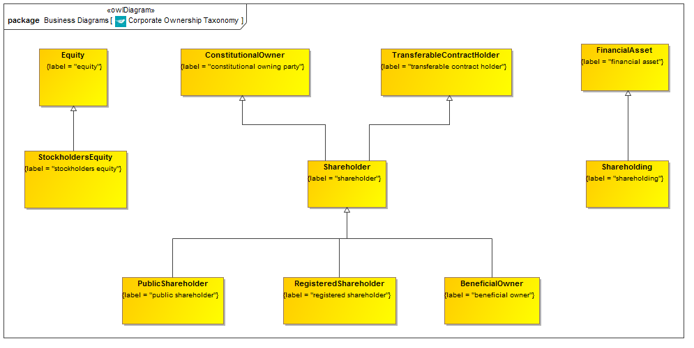

**Figure 9.6.3.1 Corporate Ownership Taxonomy**

This is the taxonomy of classes of “Thing” in the Corporate Ownership ontology along with the more general concepts of which they are a specialization.

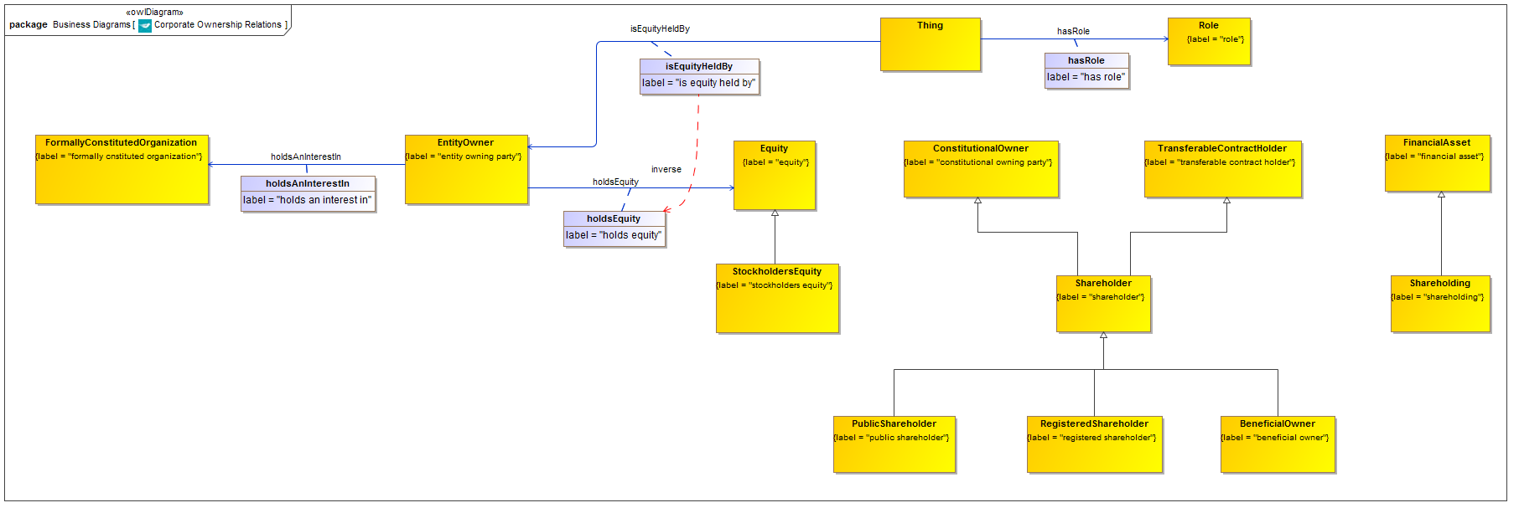

**Figure 9.6.3.2 Corporate Ownership with Relationship Properties**

Properties in (all provided elsewhere) which are refined and reused by property restrictions in this ontology, as shown in the complete diagram which follows.

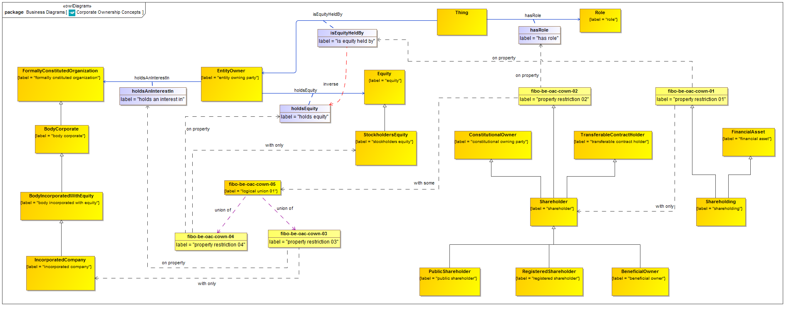

**Figure 9.6.3.3 Corporate Ownership Ontology (full diagram)**

This shows the completed ontology for Corporate Ownership. Properties defined in this ontology and elsewhere are refined or re-used to frame the properties essential to Corporate Ownership and related concepts.

Table 9-25. Corporate Ownership Details

| **Concept Type** | **Name** | **Type Of Thing** | **Property** | **Definition** | **Parent** | **Mutually Exclusive With** | **Related Thing or Type** | **Inverse Of Property** | **Multiples** | **Editorial Note** | **Explanatory Note** | **Term Origin** | **Definition Source** |
| --- | --- | --- | --- | --- | --- | --- | --- | --- | --- | --- | --- | --- | --- |
| **Class** | **BeneficialOwner** | **beneficial owner** |  | Entity that enjoys the possession and/or benefits of ownership (such as receipt of income) of a property even though its ownership (title) is in the name of another entity (called a nominee or registered owner). Use of a nominee (who may be an agent, custodian, or a trustee) does not change the position regarding tax reporting and tax liability, and the beneficial-owner remains responsible. |  |  |  |  |  |  |  |  |  |
| **Class** | **PublicShareholder** | **public shareholder** |  | a shareholder that holds publicly issued shares in a listed company |  |  |  |  |  |  |  |  |  |
| **Class** | **RegisteredShareholder** | **registered shareholder** |  | a shareholder that is registered on the shareholder registry for a company |  |  |  |  |  |  |  |  |  |
| **Class** | **Shareholder** | **shareholder** |  | An individual, group, or organization that owns one or more shares in a company, and in whose name the share certificate is issued. It is legal for a company to have only one shareholder. Also called (in the US) stockholder. |  |  |  |  |  |  |  |  |  |
| **Class** | **Shareholding** | **shareholding** |  | Legal power of stockholders (shareholders) varies in proportion to their shareholdings. Typically, ten percent and below stockholding provides no protection. Fifteen percent stockholding may give the power to petition courts against changing the shares class rights. Up to 49.9 percent stockholding normally gives power to demand calling of an extraordinary general meeting. Fifty percent and over stockholding gives power to fire a director and force out minority stockholders by acquiring their shares as per the rules of the firm. Holder of 75 percent of the stock has the power to change the articles and memorandum of association and the firms name, reduce the share capital, allow the firm to buy its own shares from other stockholders, and to shut down the business. One hundred percent stockholding of course gives total power under the corporate legislation. |  |  |  |  |  |  |  |  |  |
| Logical Union | fibo-be-oac-cown-05 | logical union 01 | union of | Logical union of the types of thing identified in the column "Related Thing or Type". |  |  |  |  |  |  |  |  |  |
| Property Restriction | fibo-be-oac-cown-01 | property restriction 01 | is equity held by | Set of things which, if they have the property shown, all participants in that relationship must be taken from the type of thing indicated. |  |  |  |  |  |  |  |  |  |
| Property Restriction | fibo-be-oac-cown-02 | property restriction 02 | has role | Set of things with the property shown, where at least one participant in that relationship must be taken from the type of thing indicated. |  |  |  |  |  |  |  |  |  |
| Property Restriction | fibo-be-oac-cown-03 | property restriction 03 | holds an interest in | Set of things which, if they have the property shown, all participants in that relationship must be taken from the type of thing indicated. |  |  |  |  |  |  |  |  |  |
| Property Restriction | fibo-be-oac-cown-04 | property restriction 04 | holds equity | Set of things which, if they have the property shown, all participants in that relationship must be taken from the type of thing indicated. |  |  |  |  |  |  |  |  |  |

### 9.6.4 Ontology: Corporate Control

This ontology defines concepts relating to corporation-specific control. These concepts are based on the general types of control (both de facto control and controlling interests), as defined in the ControlParties ontology, and are the specific examples of these concepts as they apply to companies incorporated by the issuance of shares.

Table 9-26. Corporate Control Ontology Metadata

|  |  |
| --- | --- |
| **Metadata Term** | **Value** |
| **sm:filename** | Corporate Control Ontology |
| **sm:fileAbbreviation** | fibo-be-oac-cctl |
| **OntologyIRI** | [http://www.omg.org/spec/EDMC-FIBO/BE/OwnershipAndControl/CorporateControl/](http://www.omg.org/spec/EDMC-FIBO/BE/20131101/OwnershipAndControl/CorporateControl/) |
| **owl:versionIRI** | <http://www.omg.org/spec/EDMC-FIBO/BE/20131101/OwnershipAndControl/CorporateControl/> |
| **sm:dependsOn** | http://www.omg.org/spec/EDMC-FIBO/BE/LegalEntities/LegalPersons/  http://www.omg.org/spec/EDMC-FIBO/BE/LegalEntities/FormalBusinessOrganizations/  http://www.omg.org/spec/EDMC-FIBO/BE/LegalEntities/CorporateBodies/  http://www.omg.org/spec/EDMC-FIBO/BE/LegalEntities/LEIEntities/  http://www.omg.org/spec/EDMC-FIBO/BE/OwnershipAndControl/OwnershipParties/  http://www.omg.org/spec/EDMC-FIBO/BE/OwnershipAndControl/ControlParties/  http://www.omg.org/spec/EDMC-FIBO/BE/Corporations/Corporations/ |

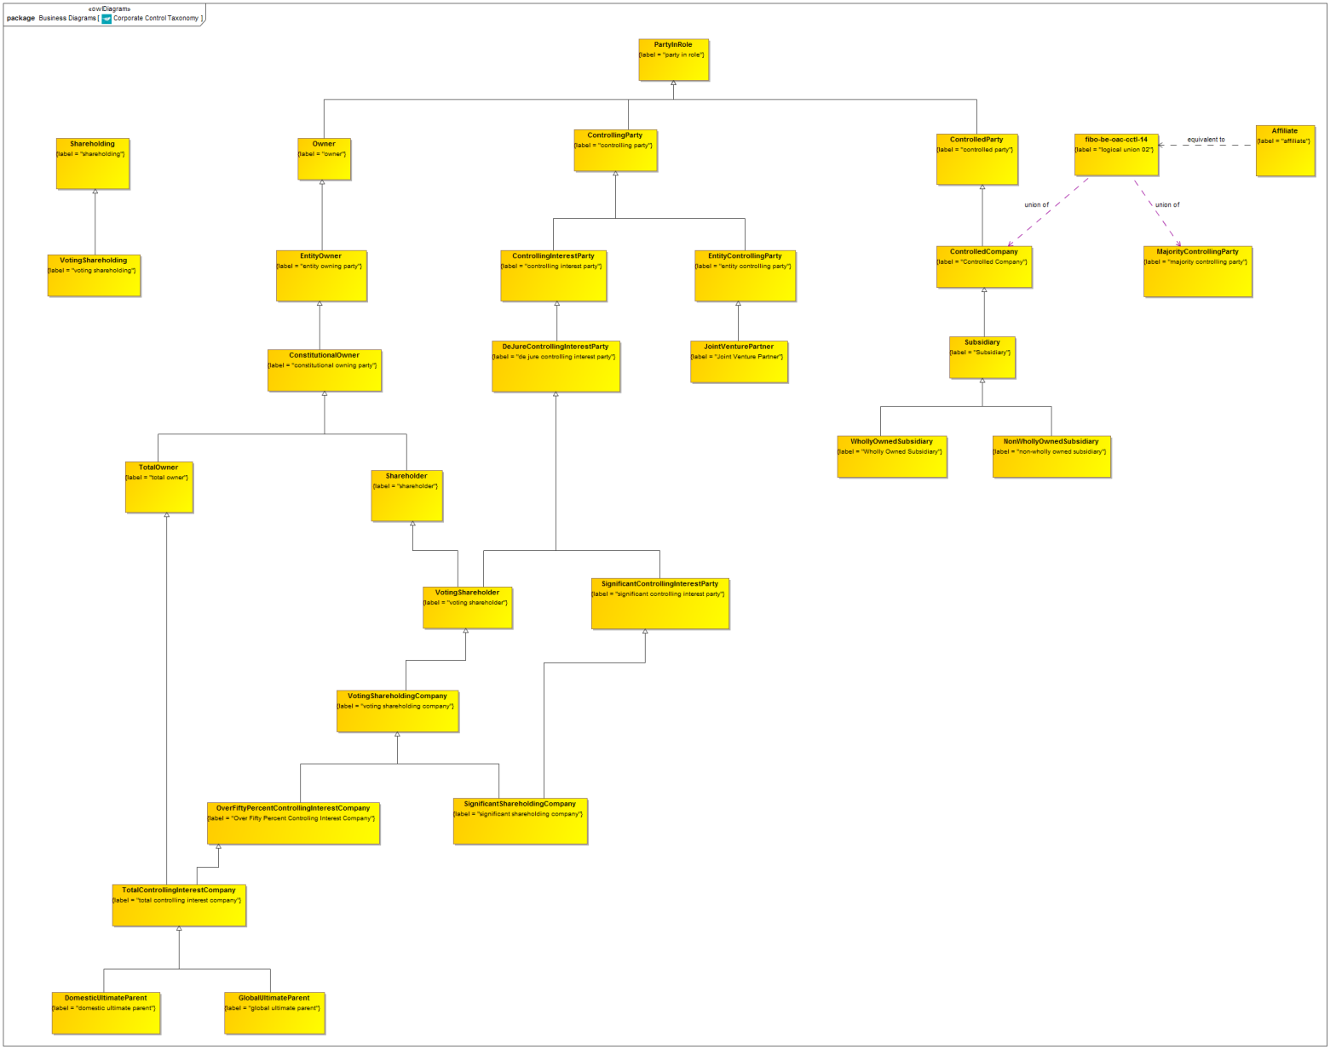

**Figure 9.6.4.1 Corporate Control Taxonomy**

This is the taxonomy of classes of “Thing” in the Corporate Controlontology along with the more general concepts of which they are a specialization.

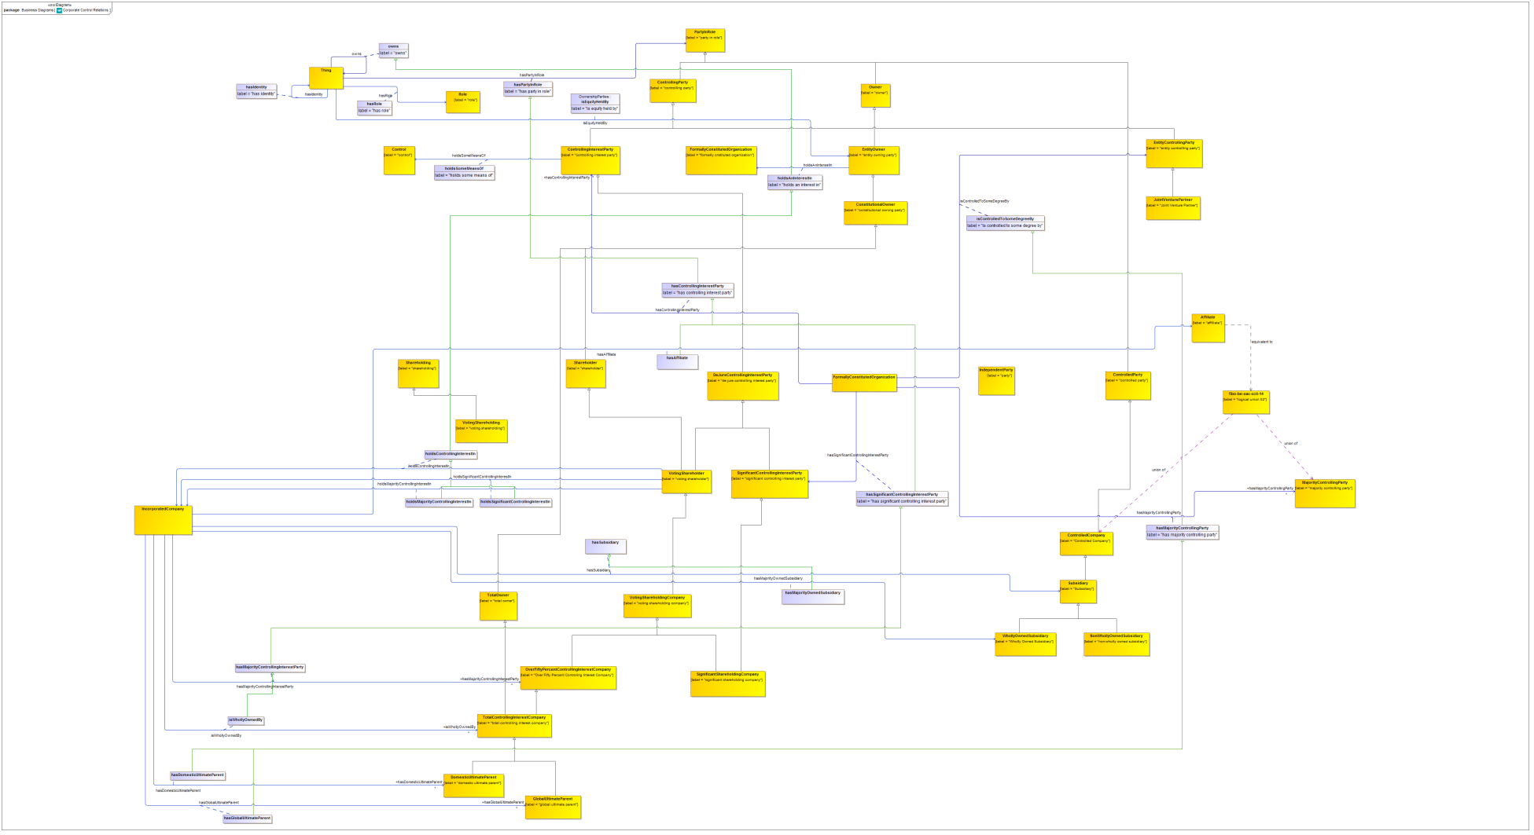

**Figure 9.6.4.2 Corporate Control Relationship Properties**

These properties in Corporate Control and elsewhere are refined and reused by property restrictions, as shown in the complete diagram which follows.

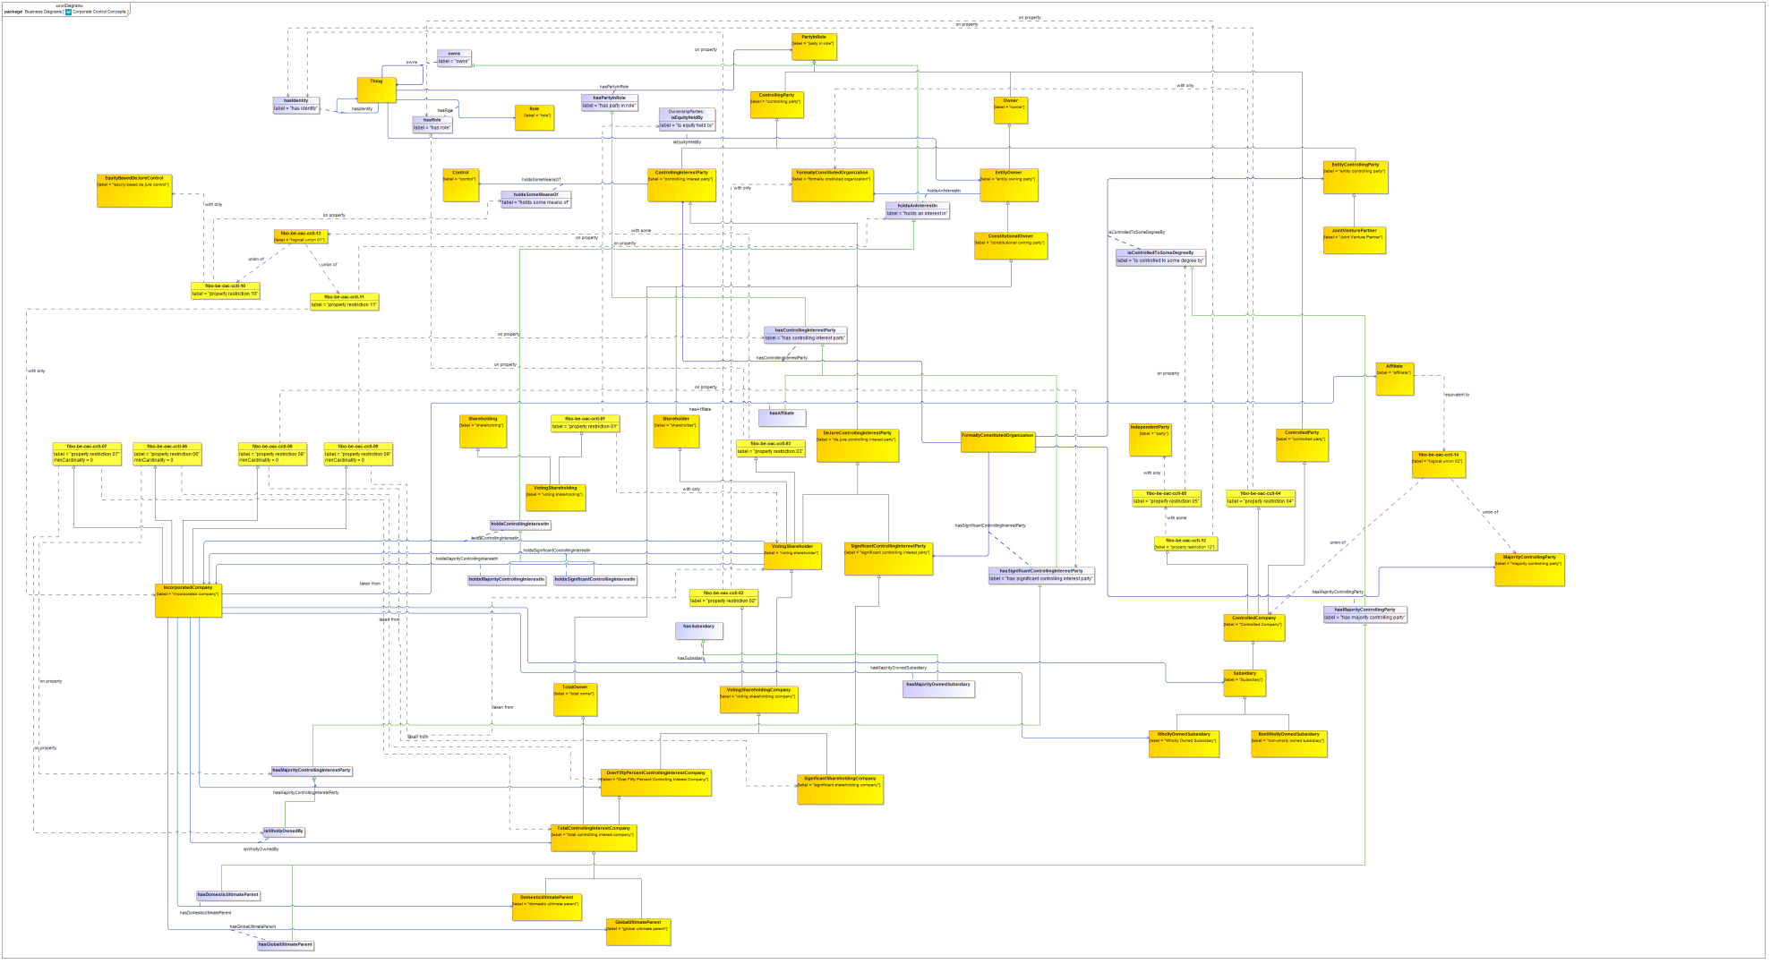

**Figure 9.6.4.3 Corporate Control Ontology (full diagram)**

This shows the completed ontology for Corporate Control. Properties defined in this ontology and elsewhere are refined or re-used to frame the properties essential to corporate control relations and their related concepts.

Table 9-27. Corporate Control Details

| **Concept Type** | **Name** | **Type Of Thing** | **Property** | **Definition** | **Parent** | **Mutually Exclusive With** | **Related Thing or Type** | **Inverse Of Property** | **Multiples** | **Editorial Note** | **Explanatory Note** | **Term Origin** | **Definition Source** |
| --- | --- | --- | --- | --- | --- | --- | --- | --- | --- | --- | --- | --- | --- |
| **proxy** | **IncorporatedCompany** | **incorporated company** |  | Proxy for the class, in order that properties or restrictions may be added locally. | property restriction 06 property restriction 07 property restriction 08 property restriction 09 |  |  |  |  |  | The restrictions defined herein extend the definition of incorporated company to link it to external entities that hold shares in it. |  |  |
| **proxy** | **IncorporatedCompany** | **incorporated company** |  | Proxy for the class, in order that properties or restrictions may be added locally. |  |  |  |  |  |  |  |  |  |
| Relationship Property | isWhollyOwnedBy | IncorporatedCompany | is wholly owned by | the formally constituted organization that has 100 percent ownership and control over a given incorporated company |  |  | total controlling interest company |  |  |  |  |  |  |
| Relationship Property | hasSubsidiary | IncorporatedCompany | has subsidiary | a subsidiary of the company, that is an affiliae controlled by the company directly, or indirectly through one or more intermediaries. |  |  | Subsidiary |  |  |  |  |  |  |
| Relationship Property | hasMajorityOwnedSubsidiary | IncorporatedCompany | has majority owned subsidiary | a majority owned subsidiary of the company, in this case, where there is above 50 percent (50 percent plus one share) ownership of the shares. |  |  | Wholly Owned Subsidiary |  |  |  |  |  |  |
| Relationship Property | hasMajorityControllingInterestParty | IncorporatedCompany | has majority controlling interest party | the parent organization of the company, if there is one. | has significant controlling interest party |  | Over Fifty Percent Controling Interest Company |  |  | This is defined as company or other Formal Organization which owns a controlling stake of greater than 50 percent (50 percent plus one voting share or above) in this company. |  |  |  |
| Relationship Property | hasGlobalUltimateParent | IncorporatedCompany | has global ultimate parent | the organization recognized as the ultimate parent of the company, if it has one | has majority controlling party |  | global ultimate parent |  |  | In the case of companies that are subsidiaries of another company that itself has a parent, this identifies the organization at the top of the hierarchy, world-wide. Adapted from consensus definition of Ultimate Parent, now that this is split into national and global parent. |  |  |  |
| Relationship Property | hasDomesticUltimateParent | IncorporatedCompany | has domestic ultimate parent | the organization recognized as the ultimate parent of the company within its country or jurisdiction of incorporation, if it has one | has majority controlling party |  | domestic ultimate parent |  |  | In the case of companies that are subsidiaries of another company that itself has a parent, this identifies the organization at the top of the hierarchy of organizations in the country of registration. Adapted from consensus definition of Ultimate Parent, now that this is split into national and global parent. |  |  |  |
| Relationship Property | hasAffiliate | IncorporatedCompany | has affiliate | has a party which directly, or indirectly through one or more intermediaries, controls, or is controlled by, or is under common control with the company. | has controlling interest party |  | affiliate |  |  |  |  |  |  |
| **Class** | **Affiliate** | **affiliate** |  | an affiliate of, or a person affiliated with, a specific person is a person that directly, or indirectly through one or more intermediaries, controls, or is controlled by, or is under common control with, the person specified. |  |  |  |  |  |  |  |  |  |
| **Class** | **ControlledCompany** | **Controlled Company** |  | A company over which another incorporated company has some degree of control by way of ownership of voting shares | property restriction 04 controlled party property restriction 12 |  |  |  |  |  |  |  |  |
| **Class** | **DomesticUltimateParent** | **domestic ultimate parent** |  | the organization which is recognized as the ultimate parent of the company within the country or jurisdiction of incorporation, this relationship may or may not be present, i.e. in the case of a company which has no parent. | total controlling interest company |  |  |  |  |  |  |  |  |
| **Class** | **GlobalUltimateParent** | **global ultimate parent** |  | The organization which is recognized as the ultimate parent of the company. This relationship may or may not be present, i.e. in the case of a company which has no parent. | total controlling interest company |  |  |  |  |  |  |  |  |
| **Class** | **JointVenturePartner** | **Joint Venture Partner** |  | A party which has the role of Joint Venture Partner to some venture. | entity controlling party |  |  |  |  | This is part of ongoing work - legal definitions sought. |  |  |  |
| **Class** | **NonWhollyOwnedSubsidiary** | **non-wholly owned subsidiary** |  | A subsidiary which is not a wholly owned subsidiary. | Subsidiary |  |  |  |  |  |  |  |  |
| **Class** | **OverFiftyPercentControllingInterestCompany** | **Over Fifty Percent Controling Interest Company** |  |  | voting shareholding company |  |  |  |  |  |  |  |  |
| **Class** | **SignificantShareholdingCompany** | **significant shareholding company** |  | a company that owns a significant voting stake in an incorporated company | voting shareholding company significant controlling interest party |  |  |  |  |  |  |  |  |
| **Class** | **Subsidiary** | **Subsidiary** |  |  | Controlled Company |  |  |  |  |  |  |  |  |
| **Class** | **TotalControllingInterestCompany** | **total controlling interest company** |  | formal organization having 100 percent ownership in the incorporated company it holds voting shares in. | Over Fifty Percent Controling Interest Company total owner |  |  |  |  |  | By virtue of holding 100 percent of the share ownership, the total controlling interest company also holds 100 percent of the controlling equity, if there is a difference. Therefore, it is both a total owner and a total controlling party. |  |  |
| **Class** | **VotingShareholder** | **voting shareholder** |  | A party owning voting shares in some company limited by the issue of shares | property restriction 03 de jure controlling interest party shareholder |  |  |  |  |  |  |  |  |
| Relationship Property | holdsSignificantControllingInterestIn | voting shareholder | holds significant controlling interest in | the incorporated company in which the voting shareholder holds a significant proportion (but not fifty percent or more) of the voting share equity. |  |  | incorporated company |  |  |  |  |  |  |
| Relationship Property | holdsMajorityControllingInterestIn | voting shareholder | holds majority controlling interest in | the incorporated company in which the voting shareholder holds fifty percent or more of the voting share equity. |  |  | incorporated company |  |  |  |  |  |  |
| Relationship Property | holdsControllingInterestIn | voting shareholder | holds controlling interest in | a company in which the voting shareholder owns some voting equity stake. | holds an interest in |  | incorporated company |  |  |  |  |  |  |
| **Class** | **VotingShareholdingCompany** | **voting shareholding company** |  | a formal business organization that holds voting shares in some incorporated company | property restriction 02 voting shareholder |  |  |  |  |  |  |  |  |
| **Class** | **VotingShareholding** | **voting shareholding** |  | a holding of some voting share | property restriction 01 shareholding |  |  |  |  |  |  |  |  |
| **Class** | **WhollyOwnedSubsidiary** | **Wholly Owned Subsidiary** |  |  | Subsidiary |  |  |  |  |  |  |  |  |
| Logical Union | fibo-be-oac-cctl-13 | logical union 01 | union of | Logical union of the types of thing identified in the column "Related Thing or Type". |  |  | property restriction 10 property restriction 11 |  |  |  |  |  |  |
| Logical Union | fibo-be-oac-cctl-14 | logical union 02 | union of | Logical union of the types of thing identified in the column "Related Thing or Type". This union is equivalent to the class"Affiliate". |  |  | majority controlling party Controlled Company |  |  |  |  |  |  |
| Property Restriction | fibo-be-oac-cctl-01 | property restriction 01 | is equity held by | Set of things which, if they have the property shown, all participants in that relationship must be taken from the type of thing indicated. |  |  | voting shareholder |  | may only be |  |  |  |  |
| Property Restriction | fibo-be-oac-cctl-02 | property restriction 02 | has identity | Set of things which, if they have the property shown, all participants in that relationship must be taken from the type of thing indicated. |  |  | formally constituted organization |  | may only be |  |  |  |  |
| Property Restriction | fibo-be-oac-cctl-03 | property restriction 03 | has role | Set of things with the property shown, where at least one participant in that relationship must be taken from the type of thing indicated. |  |  | logical union 01 |  | must be some |  |  |  |  |
| Property Restriction | fibo-be-oac-cctl-04 | property restriction 04 | has identity | Set of things which, if they have the property shown, all participants in that relationship must be taken from the type of thing indicated. |  |  | formally constituted organization |  | may only be |  |  |  |  |
| Property Restriction | fibo-be-oac-cctl-05 | property restriction 05 | is controlled to some degree by | Set of things which, if they have the property shown, all participants in that relationship must be taken from the type of thing indicated. |  |  | party |  | may only be |  |  |  |  |
| Property Restriction | fibo-be-oac-cctl-06 | property restriction 06 | has Majority Controlling Interest Party | Set of things that may have the property shown, taken from the type of thing indicated. |  |  | Over Fifty Percent Controling Interest Company |  | min 0 |  |  |  |  |
| Property Restriction | fibo-be-oac-cctl-07 | property restriction 07 | is Wholly Owned By | Set of things that may have the property shown, taken from the type of thing indicated. |  |  | total controlling interest company |  | min 0 |  |  |  |  |
| Property Restriction | fibo-be-oac-cctl-08 | property restriction 08 | has significant controlling interest party | Set of things that may have the property shown, taken from the type of thing indicated. |  |  | significant shareholding company |  | min 0 |  |  |  |  |
| Property Restriction | fibo-be-oac-cctl-09 | property restriction 09 | has controlling interest party | Set of things that may have the property shown, taken from the type of thing indicated. |  |  | voting shareholder |  | min 0 |  |  |  |  |
| Property Restriction | fibo-be-oac-cctl-10 | property restriction 10 | holds some means of | Set of things which, if they have the property shown, all participants in that relationship must be taken from the type of thing indicated. |  |  | equity-based de jure control |  | may only be |  |  |  |  |
| Property Restriction | fibo-be-oac-cctl-11 | property restriction 11 | holds an interest in | Set of things which, if they have the property shown, all participants in that relationship must be taken from the type of thing indicated. |  |  | Incorporated Company |  | may only be |  |  |  |  |
| Property Restriction | fibo-be-oac-cctl-12 | property restriction 12 | has role | Set of things with the property shown, where at least one participant in that relationship must be taken from the type of thing indicated. |  |  | property restriction 05 |  | must be some |  |  |  |  |

### 9.6.5 Ontology: Executives

This ontology defines concepts relating to executives and their formal capacities. The concepts defined in this ontology cover types of corporate officers, board members and the like, along with the capacities in terms of which those party roles are defined, and the kinds of entity (principally natural persons) that are able to perform in those roles.

Table 9-28. Executives Ontology Metadata

|  |  |
| --- | --- |
| **Metadata Term** | **Value** |
| **sm:filename** | Executives Ontology |
| **sm:fileAbbreviation** | fibo-be-oac-exec |
| **OntologyIRI** | [http://www.omg.org/spec/EDMC-FIBO/BE/OwnershipAndControl/Executives/](http://www.omg.org/spec/EDMC-FIBO/BE/20131101/OwnershipAndControl/Executives/) |
| **owl:versionIRI** | <http://www.omg.org/spec/EDMC-FIBO/BE/20131101/OwnershipAndControl/Executives/> |
| **sm:dependsOn** | http://www.omg.org/spec/EDMC-FIBO/BE/LegalEntities/LegalPersons/  http://www.omg.org/spec/EDMC-FIBO/BE/LegalEntities/FormalBusinessOrganizations/  http://www.omg.org/spec/EDMC-FIBO/BE/LegalEntities/CorporateBodies/  http://www.omg.org/spec/EDMC-FIBO/BE/LegalEntities/LEIEntities/  http://www.omg.org/spec/EDMC-FIBO/BE/OwnershipAndControl/OwnershipParties/  http://www.omg.org/spec/EDMC-FIBO/BE/OwnershipAndControl/ControlParties/  http://www.omg.org/spec/EDMC-FIBO/BE/Corporations/Corporations/  http://www.omg.org/spec/EDMC-FIBO/BE/OwnershipAndControl/CorporateOwnership/  http://www.omg.org/spec/EDMC-FIBO/BE/OwnershipAndControl/CorporateControl/ |

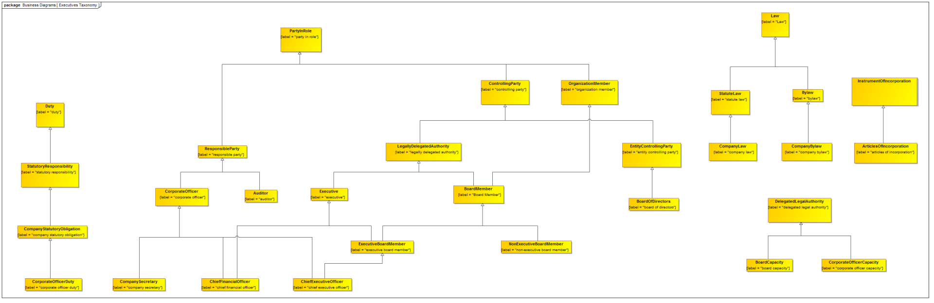

**Figure 9.6.5.1 Executi**v**es Taxonomy**

This is the taxonomy of classes of “Thing” in the Executives ontology along with the more general concepts of which they are a specialization.

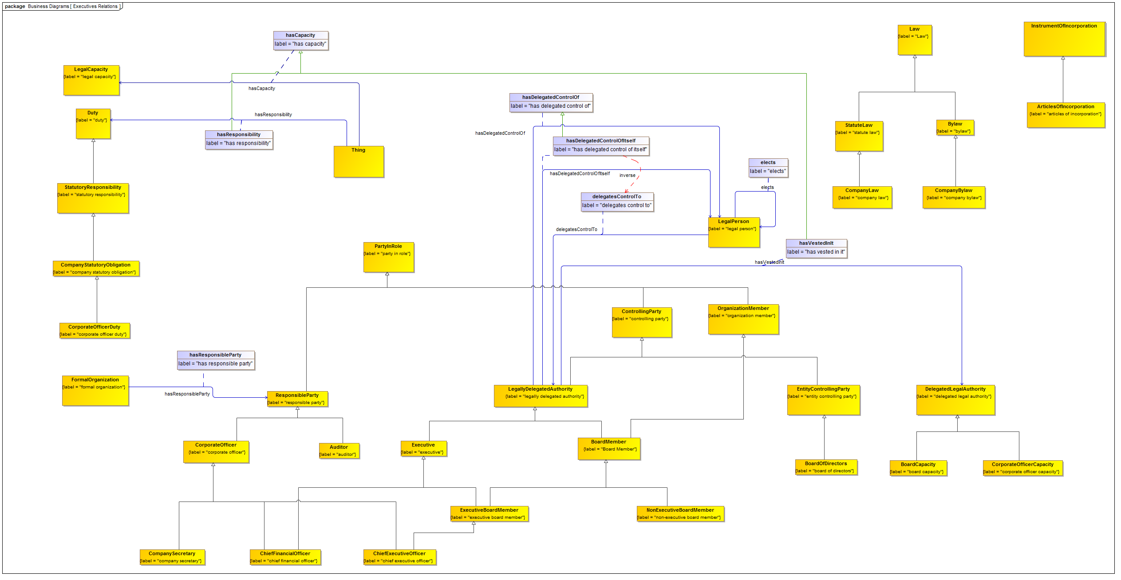

**Figure 9.6.5.2 Executi**v**es with Relationship Properties**

Properties in this ontology which are refined and reused by property restrictions, as shown in the complete diagram which follows. Properties reused from elsewhere are omitted for clarity.

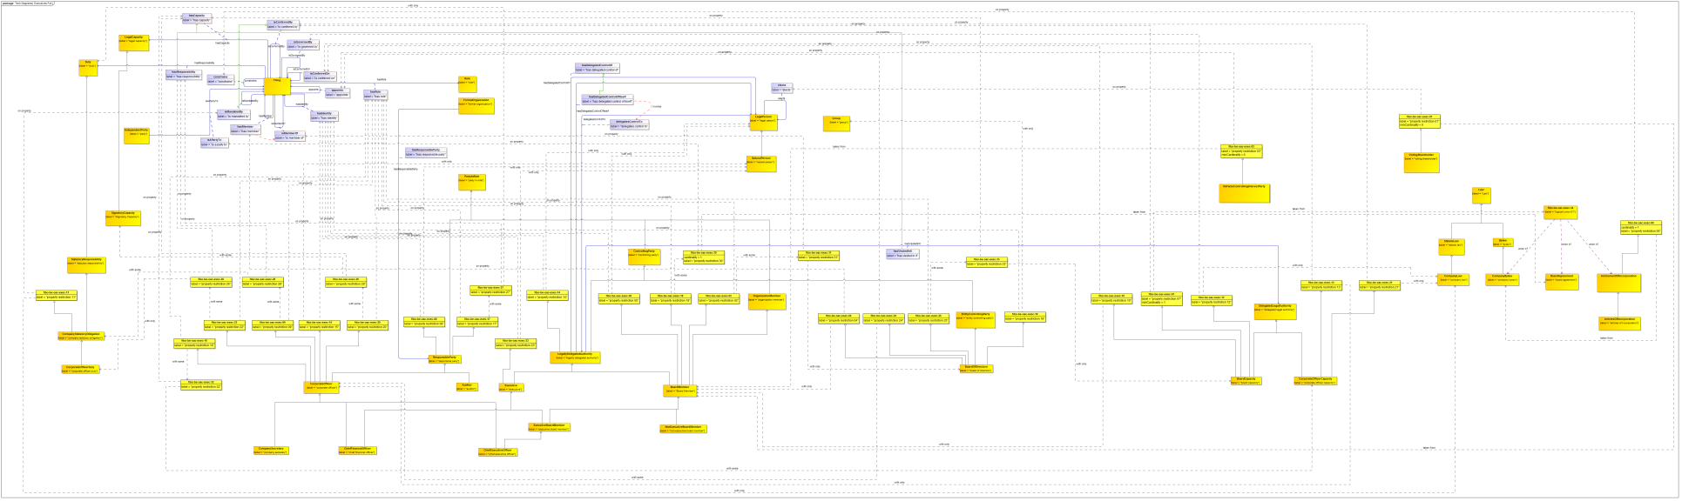

**Figure 9.6.5.3 Executi**v**es Ontology (full diagram)**

This shows the completed ontology for Executives. Properties defined in this ontology and elsewhere are refined or re-used to frame the properties essential to Executives and their related concepts.

Table 9-29. Executives Details

| **Concept Type** | **Name** | **Type Of Thing** | **Property** | **Definition** | **Parent** | **Mutually Exclusive With** | **Related Thing or Type** | **Inverse Of Property** | **Multiples** | **Editorial Note** | **Explanatory Note** | **Term Origin** | **Definition Source** |
| --- | --- | --- | --- | --- | --- | --- | --- | --- | --- | --- | --- | --- | --- |
| Relationship Property | hasResponsibility | Anything | has responsibility | identifies a particular burden of obligation upon one who is responsible | has capacity |  | duty |  |  |  |  |  |  |
| Relationship Property | delegatesControlTo | legal person | delegates control to | A party to which this legal person has delegated some authority or control | designates |  | legally delegated authority | has delegated control of itself |  |  |  |  |  |
| Relationship Property | elects | legal person | elects | chooses someone to hold office or some other position by voting | designates |  | legal person |  |  | In the case of an election for a member of the board of directors, the bylaws state the manner in which that process is effected. The candidate members may be recommended by the board or other proxy and are then elected by the shareholder. A similar process may be conducted to elect outside auditors. |  |  |  |
| Relationship Property | hasResponsibleParty | formal organization | has responsible party | some party that has some defined responsibility with respect to the formal organization | has party in role |  | responsible party |  |  |  |  |  |  |
| **Class** | **ArticlesOfIncorporation** | **articles of incorporation** |  | The articles of association are a contract (1) between the members (stockholders, subscribers) and the organization and (2) among the members themselves. It sets out the rights and duties of directors and stockholders individually and in meetings. Certain statutory clauses (such as those dealing with allotment, transfer, and forfeiture of shares) must be included; the other clauses are chosen by the stockholders to make up the bylaws of the organization. A court, however, may declare a clause ultra vires if it is deemed unfair, unlawful, or unreasonable. A copy of the articles is lodged with the appropriate authority such as the registrar of companies. Articles are public documents and may be inspected by anyone (usually on payment of a fee) either at the premises of the organization or at the registrar's office. Lenders to the organization take special interest in its provisions that impose a ceiling on the borrowings beyond which the organization's management must get shareholders' approval before taking on more debt. The usual American term is articles of incorporation. | instrument of incorporation |  |  |  |  |  |  |  | http://www.businessdictionary.com/definition/articles-of-association.html |
| **Class** | **Auditor** | **auditor** |  | An individual qualified (at the state level) to conduct audits. An auditor may be an internal auditor (an individual whose primary job function is to audit his or her own company) or an external auditor (an individual from outside the company, who typically is employed by an auditing firm who handles many different clients). | responsible party |  |  |  |  | They have power independently of the board. Power to assess the quality of the financial reports. Also has obligations to the statutory authorities in that regard. The auditor has obligations to the shareholders which are not directly to the Board. Their specific role is to supervise the board to ensure they are acting on behalf of the shareholders. To report to the shareholders on the activities of the Board. Therefore, Auditor's report is a required part of the financial reports. They are responsible for providing a true and fair view of the financial positions of the company. Election - Put up by the board. Appointed by the Board on behalf of the shareholders. Can be voted out by the shareholders at an AGM or EGM but the board can also put up a competitive process. Normally board elects them but the shareholders can override that selection. |  |  | http://www.investorwords.com/326/auditor.html |
| **Class** | **BoardCapacity** | **board capacity** |  | the capacity that resides in the board of directors of a company | delegated legal authority property restriction 07 property restriction 10 property restriction 12 |  |  |  |  |  |  |  |  |
| **Class** | **BoardMember** | **Board Member** |  | A person who is a member of the board of directors of an incorporated company. | property restriction 02 property restriction 05 organization member property restriction 19 legally delegated authority |  |  |  |  |  |  |  |  |
| **Class** | **BoardOfDirectors** | **board of directors** |  | Governing body (called the board) of an incorporated firm. Its members (directors) are elected normally by the subscribers (stockholders) of the firm (generally at an annual general meeting or AGM) to govern the firm and look after the subscribers' interests. The board has the ultimate decision-making authority and, in general, is empowered to (1) set the company's policy, objectives, and overall direction, (2) adopt bylaws, (3) name members of the advisory, executive, finance, and other committees, (4) hire, monitor, evaluate, and fire the managing director and senior executives, (5) determine and pay the dividend, and (6) issue additional shares. Though all its members might not be engaged in the company's day-to-day operations, the entire board is held liable (under the doctrine of collective responsibility) for the consequences of the firm's policies, actions, and failures to act. Members of the board usually include senior-most executives (called inside directors or executive directors) as well as experts or respected persons chosen from the wider community (called outside directors or non-executive directors). | entity controlling party property restriction 04 property restriction 18 property restriction 24 property restriction 25 |  |  |  |  |  |  |  | http://www.businessdictionary.com/definition/board-of-directors.html |
| **Class** | **Bylaw** | **bylaw** |  | Corporate bylaws are typically called Articles of Association in the United Kingdom, or Articles of Incorporation in the United States. In government usage, the term bylaws is used to describe laws, orders, regulations, rules, etc., made by a ministry, local authority (a municipality, for example), or public corporation, in accordance with the powers conferred by or delegated under a statue (called the parent act). | Law |  |  |  |  |  |  |  |  |
| **Class** | **ChiefExecutiveOfficer** | **chief executive officer** |  | Top executive responsible for a firm's overall operations and performance. He or she is the leader of the firm, serves as the main link between the board of directors (the board) and the firm's various parts or levels, and is held solely responsible for the firm's success or failure. One of the major duties of a CEO is to maintain and implement corporate policy, as established by the board. Also called President or managing director, he or she may also be the chairman (or chairperson) of the board. | corporate officer executive board member |  |  |  |  |  |  |  | http://www.businessdictionary.com/definition/chief-executive-officer-CEO.html |
| **Class** | **ChiefFinancialOfficer** | **chief financial officer** |  | Senior-most executive responsible for financial control and planning of a firm or project. He or she is in charge of all accounting functions including (1) credit control, (2) preparing budgets and financial statements, (3) coordinating financing and fund raising, (4) monitoring expenditure and liquidity, (5) managing investment and taxation issues, (6) reporting financial performance to the board, and (7) providing timely financial data to the CEO. Also called chief finance officer, comptroller, controller, or finance controller. | corporate officer executive |  |  |  |  |  |  |  | http://www.businessdictionary.com/definition/chief-financial-officer-CFO.html |
| **Class** | **CompanyBylaw** | **company bylaw** |  | The official rules and regulations which govern a corporation's management. Drawn up at the time of incorporation, along with the charter. | bylaw |  |  |  |  |  |  |  | http://www.investorwords.com/660/bylaws.html |
| **Class** | **CompanyLaw** | **company law** |  | Legislation under which the formation, registration or incorporation, governance, and dissolution of a firm is administered and controlled. | statute law |  |  |  |  |  |  |  | http://www.businessdictionary.com/definition/company-law.html |
| **Class** | **CompanySecretary** | **company secretary** |  | Officer appointed by the directors of a firm as responsible for ensuring that firm's legal obligations under the corporate legislation are complied with. His or her formal duties include (1) calling meetings, (2) recording minutes of the meetings, (3) keeping statutory record books, (4) proper payment of dividend and interest payments, and (5) proper drafting and execution of agreements, contracts, and resolutions. A company secretary is not automatically an employee of the firm and, if employed with executive responsibilities, not be its director shareholder. If a firm has only two directors, one may act as its secretary; but a sole director may not. A firm (such as of accountants) may not act as a company secretary for any firm. Called corporate secretary in the US. | corporate officer |  |  |  |  | Functionary but also a signer of documentation in the company. Does not have powes to do anything without instruction from the board. THe rol arsies from legal obligations iposed by the company. responsible to legislative authorities fo rthe company meeting those legal obligations. Role is that they gain a degree of control but only in the fact that they must report according to rules established by theirlegislative jurisdiction. Example: Delaware: you need a designated corporate secretary who is responsible for submitting certain documents etc. |  |  | http://www.businessdictionary.com/definition/company-secretary.html |
| **Class** | **CompanyStatutoryObligation** | **company statutory obligation** |  | An obligation defined in company law (statute). | statutory responsibility property restriction 11 |  |  |  |  | This is the set of laws that define the statutory obligations on public officers for the jurisdiction in which the company operates. |  |  |  |
| **Class** | **CorporateOfficerCapacity** | **corporate officer capacity** |  | the capacity vested in a public officer of a company | property restriction 13 delegated legal authority property restriction 21 |  |  |  |  | This is framed as a capacity: -an individual acts in their capacity of the role as CFO, CEO etc. but their legal liability rests in their relationship with the board itself i.e. comes from their membership on the board from a corporate standpoint. |  |  |  |
| **Class** | **CorporateOfficerDuty** | **corporate officer duty** |  | Some duty incumbent upon some officer of a company | company statutory obligation |  |  |  |  |  |  |  |  |
| **Class** | **CorporateOfficer** | **corporate officer** |  | The executives of a corporation charged with certain operational responsibilities. Typically appointed by the board of directors, the corporate officers usually include the Chief Executive Officer (CEO), Chief Financial Officer (CFO), President, and in some corporations the Chief Operating Officer. | property restriction 09 responsible party property restriction 15 property restriction 16 property restriction 20 property restriction 22 |  |  |  |  | Some party which is recognized by law as having the role and responsibilities defined for a Public Officer as described in that law. |  |  | http://www.investorwords.com/15091/corporate_officers.html |
| **Class** | **ExecutiveBoardMember** | **executive board member** |  | An individual performing the role of a board member of a company who also has executive responsibilities in the company. | Board Member executive |  |  |  |  |  |  |  |  |
| **Class** | **DeFactoControllingInterestParty** | **de facto controlling interest party** |  |  | property restriction 03 |  |  |  |  |  | A Control Owner (i.e., Control Person, per SEC regulations) may have some means or right that allows them to exercise control over board composition, other than through proxy assignment or vote. Not all Control Persons have this facility, as it is not inherent to having a significant (for example, 20 percent or more) ownership stake. |  |  |
| **Class** | **Executive** | **executive** |  | Person appointed and given the responsibility to manage the affairs of an organization and the authority to make decisions within specified boundaries. | legally delegated authority property restriction 23 |  |  |  |  |  |  |  | http://www.businessdictionary.com/definition/executive.html |
| **Class** | **InstrumentOfIncorporation** | **instrument of incorporation** |  |  | property restriction 06 |  |  |  |  |  | extends the definition of an instrument of incorporation to constrain corporate bylaws |  |  |
| **Class** | **LegallyDelegatedAuthority** | **legally delegated authority** |  | a party having some legal control of some entity | property restriction 14 controlling party |  |  |  |  |  |  |  |  |
| Relationship Property | hasDelegatedControlOfItself | legally delegated authority | has delegated control of itself | the legal person that has delegated some authority or control to this party and over which this party therefore has control | has delegated control of |  | legal person | delegates control to |  |  |  |  |  |
| Relationship Property | hasDelegatedControlOf | legally delegated authority | has delegated control of | the legal person that has delegated some authority or control to this party | controls |  | legal person |  |  |  |  |  |  |
| Relationship Property | hasVestedInIt | legally delegated authority | has vested in it | a delegated legal authority is one that has the legal capacity of delegated legal authority vested in it. | has capacity |  | delegated legal authority |  |  |  |  |  |  |
| **Class** | **NonExecutiveBoardMember** | **non-executive board member** |  | Some person performing the role of a Board Member of a company, and having no executive responsibilities towards the running of the company. | Board Member |  |  |  |  |  |  |  |  |
| **Class** | **ResponsibleParty** | **responsible party** |  | A party to which some responsibility has been given. | property restriction 08 property restriction 17 party in role |  |  |  |  | The responsibility may be defined in terms of specific instruments such as laws, bylaws or contracts, or by some other means. These instruments would mandate certain obligations on the part of the party, for example statutory obligations. |  |  |  |
| **Class** | **VotingShareholder** | **voting shareholder** |  |  | property restriction 01 |  |  |  |  |  | A voting shareholder may exercise control over board composition by (1) attending a shareholder meeting and voting directly, (2) assigning a proxy to vote on their behalf, either as specified in the recommendations made in the proxy card or as indicated in a manner that deviates from those recommendations but is detailed on the proxy card, (3) by rejection of the proxy, either implicitly or explicitly, or (4) through a direct ballot that they create themselves. |  |  |
| Logical Union | fibo-be-oac-exec-34 | logical union 01 | union of | Logical union of the types of thing identified in the column "Related Thing or Type". |  |  | company bylaw board agreement instrument of incorporation |  |  |  |  |  |  |
| Property Restriction | fibo-be-oac-exec-01 | property restriction 01 | elects | Set of things that may have the property shown, taken from the type of thing indicated. |  |  | Board Member |  | min 0 |  |  |  |  |
| Property Restriction | fibo-be-oac-exec-02 | property restriction 02 | has role | Set of things with the property shown, where at least one participant in that relationship must be taken from the type of thing indicated. |  |  | property restriction 31 |  | must be some |  |  |  |  |
| Property Restriction | fibo-be-oac-exec-03 | property restriction 03 | appoints | Set of things that may have the property shown, taken from the type of thing indicated. |  |  | Board Member |  | min 0 |  |  |  |  |
| Property Restriction | fibo-be-oac-exec-04 | property restriction 04 | has member | Set of things which, if they have the property shown, all participants in that relationship must be taken from the type of thing indicated. |  |  | Board Member |  | may only be |  |  |  |  |
| Property Restriction | fibo-be-oac-exec-05 | property restriction 05 | has identity | Set of things which, if they have the property shown, all participants in that relationship must be taken from the type of thing indicated. |  |  | legal person |  | may only be |  |  |  |  |
| Property Restriction | fibo-be-oac-exec-06 | property restriction 06 | constrains | Set of things that have the property shown, in the multiples given, taken from the type of thing indicated. |  |  | company bylaw |  | exactly 1 |  |  |  |  |
| Property Restriction | fibo-be-oac-exec-07 | property restriction 07 | is conferred by | Set of things that have the property shown, in the multiples given, taken from the type of thing indicated. |  |  | logical union 01 |  | min 1 |  |  |  |  |
| Property Restriction | fibo-be-oac-exec-08 | property restriction 08 | has identity | Set of things which, if they have the property shown, all participants in that relationship must be taken from the type of thing indicated. |  |  | natural person |  | may only be |  |  |  |  |
| Property Restriction | fibo-be-oac-exec-09 | property restriction 09 | has role | Set of things with the property shown, where at least one participant in that relationship must be taken from the type of thing indicated. |  |  | property restriction 28 |  | must be some |  |  |  |  |
| Property Restriction | fibo-be-oac-exec-10 | property restriction 10 | is conferred on | Set of things which, if they have the property shown, all participants in that relationship must be taken from the type of thing indicated. |  |  | Board Member |  | may only be |  |  |  |  |
| Property Restriction | fibo-be-oac-exec-11 | property restriction 11 | is mandated by | Set of things which, if they have the property shown, all participants in that relationship must be taken from the type of thing indicated. |  |  | company law |  | may only be |  |  |  |  |
| Property Restriction | fibo-be-oac-exec-12 | property restriction 12 | is governed by | Set of things which, if they have the property shown, all participants in that relationship must be taken from the type of thing indicated. |  |  | company law |  | may only be |  |  |  |  |
| Property Restriction | fibo-be-oac-exec-13 | property restriction 13 | is conferred on | Set of things which, if they have the property shown, all participants in that relationship must be taken from the type of thing indicated. |  |  | corporate officer |  | may only be |  |  |  |  |
| Property Restriction | fibo-be-oac-exec-14 | property restriction 14 | has identity | Set of things which, if they have the property shown, all participants in that relationship must be taken from the type of thing indicated. |  |  | legal person |  | may only be |  |  |  |  |
| Property Restriction | fibo-be-oac-exec-15 | property restriction 15 | has identity | Set of things which, if they have the property shown, all participants in that relationship must be taken from the type of thing indicated. |  |  | natural person |  | may only be |  |  |  |  |
| Property Restriction | fibo-be-oac-exec-16 | property restriction 16 | has role | Set of things with the property shown, where at least one participant in that relationship must be taken from the type of thing indicated. |  |  | property restriction 32 |  | must be some |  |  |  |  |
| Property Restriction | fibo-be-oac-exec-17 | property restriction 17 | has role | Set of things with the property shown, where at least one participant in that relationship must be taken from the type of thing indicated. |  |  | property restriction 27 |  | must be some |  |  |  |  |
| Property Restriction | fibo-be-oac-exec-18 | property restriction 18 | has identity | Set of things which, if they have the property shown, all participants in that relationship must be taken from the type of thing indicated. |  |  | group |  | may only be |  |  |  |  |
| Property Restriction | fibo-be-oac-exec-19 | property restriction 19 | has role | Set of things with the property shown, where at least one participant in that relationship must be taken from the type of thing indicated. |  |  | property restriction 30 |  | must be some |  |  |  |  |
| Property Restriction | fibo-be-oac-exec-20 | property restriction 20 | has role | Set of things with the property shown, where at least one participant in that relationship must be taken from the type of thing indicated. |  |  | property restriction 29 |  | must be some |  |  |  |  |
| Property Restriction | fibo-be-oac-exec-21 | property restriction 21 | is conferred by | Set of things which, if they have the property shown, all participants in that relationship must be taken from the type of thing indicated. |  |  | company law |  | may only be |  |  |  |  |
| Property Restriction | fibo-be-oac-exec-22 | property restriction 22 | has role | Set of things with the property shown, where at least one participant in that relationship must be taken from the type of thing indicated. |  |  | property restriction 26 |  | must be some |  |  |  |  |
| Property Restriction | fibo-be-oac-exec-23 | property restriction 23 | has identity | Set of things which, if they have the property shown, all participants in that relationship must be taken from the type of thing indicated. |  |  | natural person |  | may only be |  |  |  |  |
| Property Restriction | fibo-be-oac-exec-24 | property restriction 24 | appoints | Set of things with the property shown, where at least one participant in that relationship must be taken from the type of thing indicated. |  |  | corporate officer |  | must be some |  |  |  |  |
| Property Restriction | fibo-be-oac-exec-25 | property restriction 25 | has role | Set of things with the property shown, where at least one participant in that relationship must be taken from the type of thing indicated. |  |  | property restriction 33 |  | must be some |  |  |  |  |
| Property Restriction | fibo-be-oac-exec-26 | property restriction 26 | has responsibility | Set of things which, if they have the property shown, all participants in that relationship must be taken from the type of thing indicated. |  |  | corporate officer duty |  | may only be |  |  |  |  |
| Property Restriction | fibo-be-oac-exec-27 | property restriction 27 | has responsibility | Set of things which, if they have the property shown, all participants in that relationship must be taken from the type of thing indicated. |  |  | duty |  | may only be |  |  |  |  |
| Property Restriction | fibo-be-oac-exec-28 | property restriction 28 | has responsibility | Set of things with the property shown, where at least one participant in that relationship must be taken from the type of thing indicated. |  |  | company statutory obligation |  | must be some |  |  |  |  |
| Property Restriction | fibo-be-oac-exec-29 | property restriction 29 | has capacity | Set of things with the property shown, where at least one participant in that relationship must be taken from the type of thing indicated. |  |  | Signatory Capacity |  | must be some |  |  |  |  |
| Property Restriction | fibo-be-oac-exec-30 | property restriction 30 | is a party to | Set of things that have the property shown, in the multiples given, taken from the type of thing indicated. |  |  | board agreement |  | exactly 1 |  |  |  |  |
| Property Restriction | fibo-be-oac-exec-31 | property restriction 31 | is member of | Set of things which, if they have the property shown, all participants in that relationship must be taken from the type of thing indicated. |  |  | board of directors |  | may only be |  |  |  |  |
| Property Restriction | fibo-be-oac-exec-32 | property restriction 32 | has capacity | Set of things with the property shown, where at least one participant in that relationship must be taken from the type of thing indicated. |  |  | corporate officer capacity |  | must be some |  |  |  |  |
| Property Restriction | fibo-be-oac-exec-33 | property restriction 33 | has capacity | Set of things which, if they have the property shown, all participants in that relationship must be taken from the type of thing indicated. |  |  | board capacity |  | may only be |  |  |  |  |

## 9.7 Module: Functionally Defined Business Entities

Table 9-30. Functionally Defined Business Entities Module Metadata

|  |  |
| --- | --- |
| **Metadata Term** | **Value** |
| **sm:moduleName** | Functional Entities |
| **sm:moduleAbbreviation** | FIBO-BE-FCT |
| **sm:moduleVersion** | 1.0 |
| **sm:moduleAbstract** | This module includes ontologies describing entities which are defined according to their function, as opposed to their form. These include special purpose vehicles, banks, business versus non-profit etc., as well as entities described in terms of their function in some process, such as clearing houses, settlement entities and the like. |

### 9.7.1 Ontology: Functional Entities

This ontology defines the fundamental concepts for entities defined by their function, such as the relationship to the various forms which one or another functionally-defined entity may take. It also includes a number of basic types of entity defined by function, such as business and non-profit. The concepts in this ontology are intended to be extensible in other ontologies which may be dedicated to specific kinds of functionally-defined business entity or organization.

Table 9-31. Functional Entities Ontology Metadata

|  |  |
| --- | --- |
| **Metadata Term** | **Value** |
| **sm:filename** | Functional Entities Ontology |
| **sm:fileAbbreviation** | fibo-be-fct-fct |
| **OntologyIRI** | [http://www.omg.org/spec/EDMC-FIBO/BE/FunctionalEntities/FunctionalEntities/](http://www.omg.org/spec/EDMC-FIBO/BE/20131101/FunctionalEntities/FunctionalEntities/) |
| **owl:versionIRI** | <http://www.omg.org/spec/EDMC-FIBO/BE/20131101/FunctionalEntities/FunctionalEntities/> |
| **sm:dependsOn** | http://www.omg.org/spec/EDMC-FIBO/BE/LegalEntities/LegalPersons/  http://www.omg.org/spec/EDMC-FIBO/BE/LegalEntities/FormalBusinessOrganizations/  http://www.omg.org/spec/EDMC-FIBO/BE/LegalEntities/CorporateBodies/  http://www.omg.org/spec/EDMC-FIBO/BE/Corporations/Corporations/ |

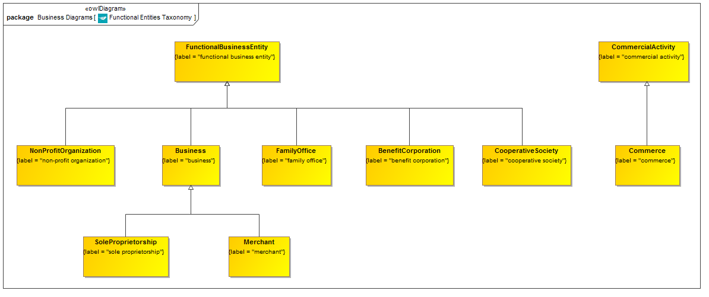

**Figure 9.7.1.1 Functional Entities Taxonomy**

This is the taxonomy of classes of “Thing” in the functionally defined entities ontology along with the more general concepts of which they are a specialization.

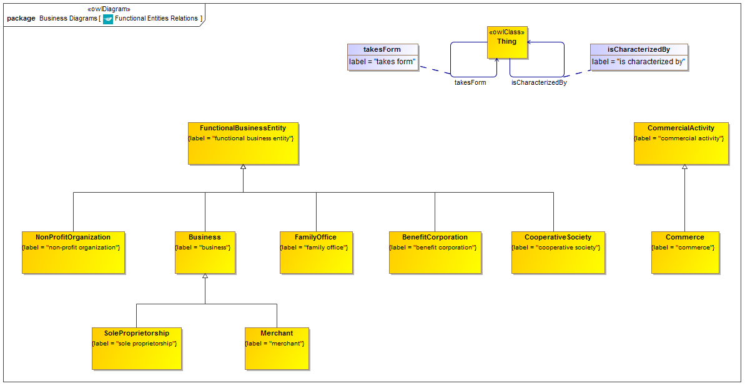

**Figure 9.7.1.2 Functional Entities Relationship Properties**

These are all the properties which are refined and reused by property restrictions, as shown in the complete diagram which follows. Of these, the property “is characterized by” is defined in this ontology.

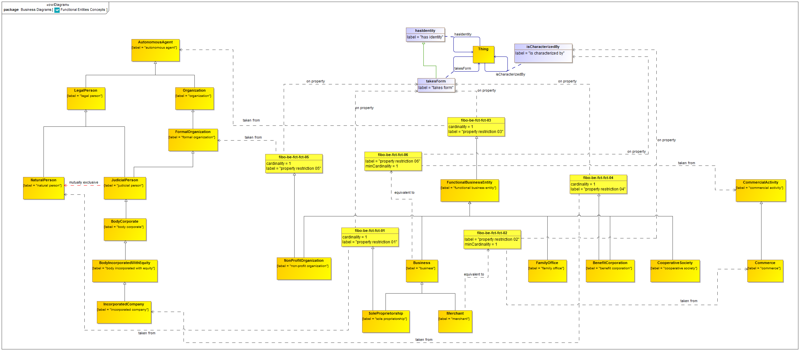

**Figure 9.7.1.3 Functionally Defined Business Entities Ontology (full diagram)**

This shows the completed ontology for entities defined by their function. Properties defined in this ontology and elsewhere are refined or re-used to frame the properties essential to functionally defined business entities and their related concepts.

Table 9-32. Functional Entities Details

| **Concept Type** | **Name** | **Type Of Thing** | **Property** | **Definition** | **Parent** | **Mutually Exclusive With** | **Related Thing or Type** | **Inverse Of Property** | **Multiples** | **Editorial Note** | **Explanatory Note** | **Term Origin** | **Definition Source** |
| --- | --- | --- | --- | --- | --- | --- | --- | --- | --- | --- | --- | --- | --- |
| Relationship Property | isCharacterizedBy | Anything | is characterized by | that context in which a contextually defined thing is defined |  |  |  | characterizes |  |  |  |  |  |
| **Class** | **BenefitCorporation** | **benefit corporation** |  | Corporation set up under specific state legislation to provide some stated societal benefit, and with some corresponding relaxation of the obligation to maximize shareholder return. | property restriction 04 functional business entity |  |  |  |  |  | This is a US-specific type of entity defined in new and emerging legislation in the US states of California, Hawaii, Virginia, Maryland, Vermont, New Jersey. Additional upcoming legislation (as at November 2011) in Colorado, New York, North Carolina, Pennsylvania, Michigan. Much of the description is framed in terms of the role of the entity rather than its nature, however the legislation specifically relaxes or otherwise changes the basic parameters of the Incorporated Company structure (for example relaxing the requirement to maximize shareholder return) It may therefore be more correct to define this as a type of Incorporated Company not a role that one sits in. Having said this, B Corporations are certified by a certifying body (B Lab), which impies that they already exist and are granted a status in a similar way to that granted to non profit enterprises. Therefore at present this is defined as a status which an Incorporated Company may attain. | www.bcorporation.net |  |
| **Class** | **Business** | **business** |  | An organization or economic system where goods and services are exchanged for one another or for money. Every business requires some form of investment and enough customers to whom its output can be sold on a consistent basis in order to make a profit. Businesses can be privately owned, not-for-profit or state-owned. An example of a corporate business is PepsiCo, while a mom-and-pop catering business is a private enterprise. | functional business entity |  |  |  |  |  |  |  | http://www.businessdictionary.com/definition/business.html |
| **Class** | **Commerce** | **commerce** |  | The activity of buying and selling goods. | commercial activity |  |  |  |  |  |  |  |  |
| **Class** | **CommercialActivity** | **commercial activity** |  | The context of carrying out trade and other comercial i.e. for-profit activities. |  |  |  |  |  |  | This is the context which distinguishes "businesses" or commercial organizations from organizations in general, the latter including government, trans-national and non profit organizations. Note that these distinctions are usually made with reference to these kinds of context and are not necessarily reflected in the structure of those organizations. |  |  |
| **Class** | **CooperativeSociety** | **cooperative society** |  | A commercial enterprise owned and managed by and for the benefit of customers or workers. | functional business entity |  |  |  |  |  |  |  |  |
| **Class** | **FamilyOffice** | **family office** |  | Family Office as defined in the relevant legislation. | functional business entity |  |  |  |  |  |  |  |  |
| **Class** | **FunctionalBusinessEntity** | **functional business entity** |  | A business entity defined in terms of its function. | property restriction 03 |  |  |  |  |  | The key distinguishing feature of a Functional Business Entity is that it may itself be constituted as some kind of Business Entity or Legal Entity, but the definition of this entity does not depend on it always having one specific legal structure (for exanple always being a limited company). This would define for example a bank, a special purpose vehicle, most government bodies and so on. |  |  |
| **Class** | **Merchant** | **merchant** |  | A business entity engaged in a trading activity. | business |  |  |  |  |  |  |  |  |
| **Class** | **NonProfitOrganization** | **non-profit organization** |  | An organization which exists for some purpose other than to make a profit for its participants. | functional business entity property restriction 05 |  |  |  |  |  | A non profit or charitable public or private foundation is a legal entity Action; needs a relationship to Legal Entity. Which is not a human being. Need non human legal entity scope formally defined. Probably has a board of directors. |  |  |
| **Class** | **SoleProprietorship** | **sole proprietorship** |  | A business structure in which an individual and his/her company are considered a single entity for tax and liability purposes. | property restriction 01 business |  |  |  |  |  | A sole proprietorship is a company which is not registered with the state as a limited liability company or corporation. The owner does not pay income tax separately for the company, but he/she reports business income or losses on his/her individual income tax return. The owner is inseparable from the sole proprietorship, so he/she is liable for any business debts. |  | Investorwords.com |
| Property Restriction | fibo-be-fct-fct-01 | property restriction 01 | takes form | Set of things that have the property shown, in the multiples given, taken from the type of thing indicated. |  |  | natural person |  | exactly 1 |  |  |  |  |
| Property Restriction | fibo-be-fct-fct-02 | property restriction 02 | is characterized by | Set of things that have the property shown, in the multiples given, taken from the type of thing indicated. |  |  | commerce |  | min 1 |  |  |  |  |
| Property Restriction | fibo-be-fct-fct-03 | property restriction 03 | takes form | Set of things that have the property shown, in the multiples given, taken from the type of thing indicated. |  |  | autonomous agent |  | exactly 1 |  |  |  |  |
| Property Restriction | fibo-be-fct-fct-04 | property restriction 04 | takes form | Set of things that have the property shown, in the multiples given, taken from the type of thing indicated. |  |  | incorporated company |  | exactly 1 |  |  |  |  |
| Property Restriction | fibo-be-fct-fct-05 | property restriction 05 | takes form | Set of things that have the property shown, in the multiples given, taken from the type of thing indicated. |  |  | formal organization |  | exactly 1 |  |  |  |  |
| Property Restriction | fibo-be-fct-fct-06 | property restriction 06 | is characterized by | Set of things that have the property shown, in the multiples given, taken from the type of thing indicated. |  |  | commercial activity |  | min 1 |  |  |  |  |

# Annex A: Deliverables Included with this RFC

(normative)

The FIBO ontologies are delivered as (1) RDF/XML serialized OWL (normative and definitive), (2) UML XMI, serialized from UML with the ODM profiles for RDF and OWL applied (normative), (3) ODM XMI, serialized based on the ODM MOF metamodels for RDF and OWL (normative), and (4) Visual Ontology Modeler (VOM) model files, based on the VOM plug-in to MagicDraw (informative). If there are differences between the OWL files, ODM XMI, and UML XMI, the OWL files take precedence, followed by the UML XMI, and finally the ODM XMI.

Regardless of their form, each of the ontologies included in Business Entities makes normative reference to the DCMI Dublin Core Metadata Terms[1], W3C Simple Knowledge Organization System (SKOS) Recommendation[2], and the OMG Architecture Board’s Specification Metadata Recommendation[3], which are not part of this specification.

The individual RDF/XML files are organized by module (directory), and within a given module, alphabetically by name, as shown in the URI structure for each individual OWL file. These files are UTF-8 conformant XML Schema files that are also OWL 2 compliant, and may be examined using any text editor, XML editor, or RDF or OWL editor. They have been verified for syntactic correctness via the W3C RDF Validator and University of Manchester OWL 2 Validator. They have also been checked for logical consistency using the Pellet OWL 2 reasoner from Clark & Parsia as well as the HermiT OWL 2 reasoner from Oxford University. It is anticipated that the OWL ontologies will be dereference-able, together with technical documentation (HTML) from the OMG site once the specification is adopted.

1. http://www.dublincore.org/documents/dcmi-terms/
2. http://www.w3.org/TR/2009/REC-skos-reference-20090818/
3. http://www.omg.org/techprocess/ab/SpecificationMetadata/